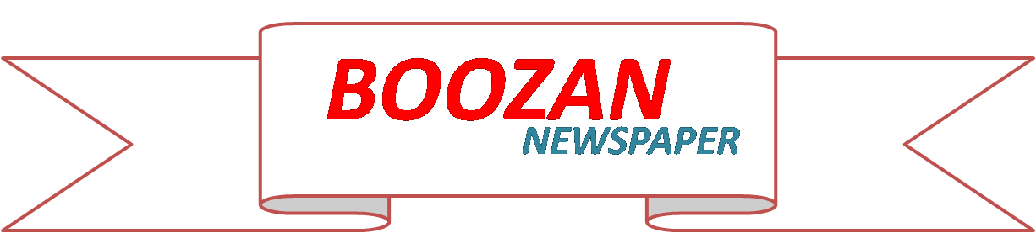
Editor: Ibrahim Karim 25/October/2013

2 THINGS YOU NEED TO KNOW ABOUT IRON
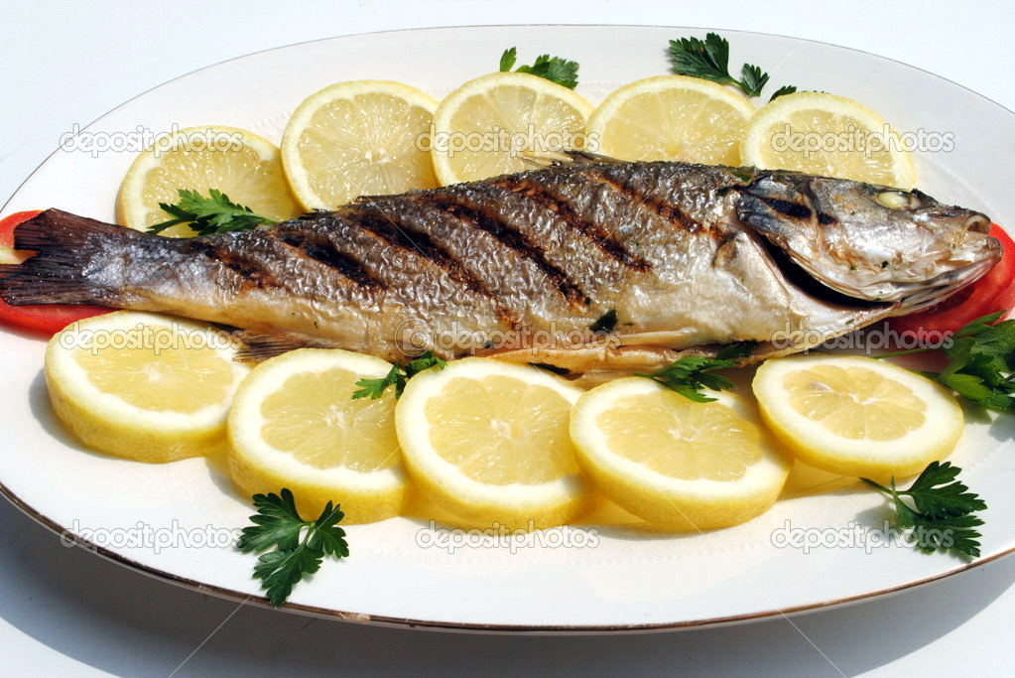
Iron plays key role in keeping your body healthy, but how can you tell if you're getting enough? Here are two things you need to know about are two things you need to know about iron.

1.Your whole body needs iron
We need iron to make hemoglobin forour red blood cells,which deliver oxygenfrom the lungs to every cell in our bodies.iron is brain function.

2.You're probably not getting enough iron
The recommended for intake adult women is 18 mg per day, and for men it's 8 mg per day. It's rare for people to concume too much iron, women are at risk of iron deficiency because they eat less meat than (and less food overall) men. Vegetarian, people who don't eat a lot of red meat.

