
u u
THE TIMES
NEWSPAPER

Newspaper Editor: ASİA AHMAD Date:27 October 2013
ABDULBASIT ABDULSAMED
HEADLINE :
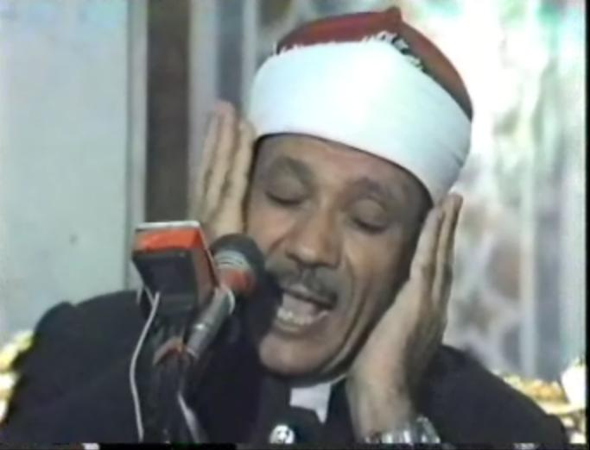
He was a reader Quran of Egypt. He was one of the best reads of Quran. He was born in 1927 in Egypt. His father was Kurd and his mother was from Egypt.
When he was seven, he could memorize everything easily and when he was ten he memorized all of Quran. His father was one of the ideologists in his city, and his father attended to his son’s reading and his nice voice. Than his father send him to Armed.
In there he learned to read the Quran. And his teacher whose name was Mohammed Salim admired his ability. When he was 15, he was very famous in his country. Everybody called him to his or her religious party.
A gentleman called al Zubae called him to read Quran in a radio program. But he did not accept it at first. Than he decided to work and he started to work there in 1951.

He married his wife at 1952 and they left Armed and they went to Cahier, he left İmam Sufi’ s mosque at 1981 and he went to İmam Hussein’s mosque then he went to France at 1952 to reveal a night of Ramadan and King Mohammed told him to go and live in west. But he did not want to go and he said I cannot leave my life and my friends. Two persons affect his life their names were Sir Mohammed Rafat and Sir Mustafa İbrahim two readers of Quran.
His death
He had a failing liver but it did not have trepidation for his life. When he was 61, he was dead.

