BIG CHOICE NEWSPAPER
Newspaper Editor: M. ÇEVİK Date:Thursday, October 24, 2013
“ADANALIYIK” –“WE ARE FROM ADANA”

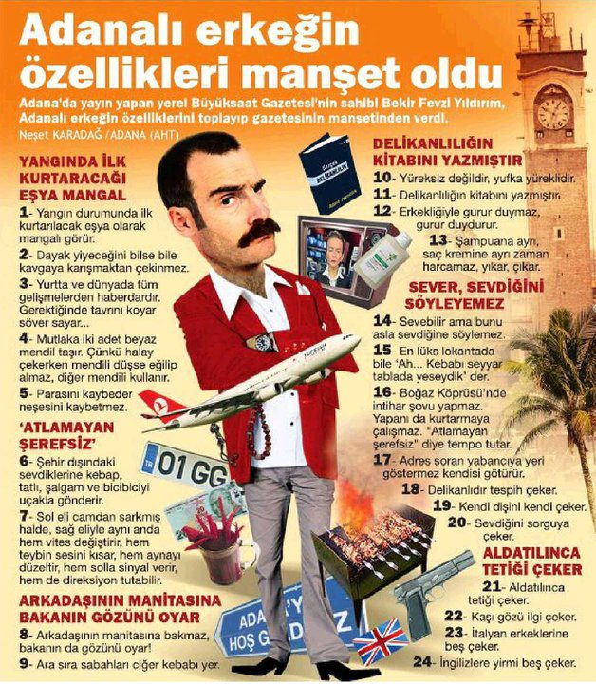
Adana is a city in Turkey. Adana’s number-plate is 01. Çukurova is it’s the other name. Adana’s people are very original. Their famous sentences are “Adanalıyık. Allah’ın adamıyık. salgam içer, bici bici yerik.” These sentences are very important for them. Their meanings are “ We are from Adana. We are God’s men. We drink turnip and eat bici bici.”
Adana’s men look tough, but they are very kind and understding. For the last thing, they say “ Empty bus but to stand.” This is very different for us. But this is not different for them because they are “God’s Men” :)
TOM AND JERRY
Tom and Jerry is a very famous cartoon in Turkey. The children like this cartoon very much. It is a funny cartoon.
William Hanna and joseph Barbera wrote this cartoon many years ago. They wrote “Tom and Jerry” at 1940 first time.
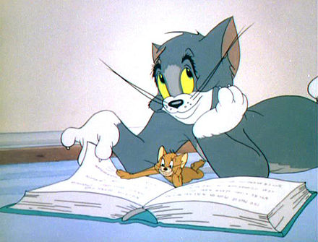

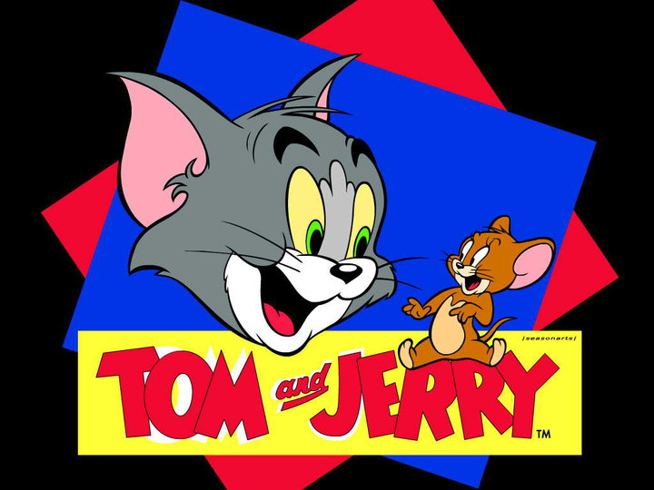
Tom is a Russian cat. It is angry, huffy and clumsy. Jerry is a brown home mouse. It is free, intelligent, active, artful and opportunist. They live in same house. Jerry is more intelligent than Tom. They fight everytime because Tom doesn’t like Jerry. Tom never catches Jerry.

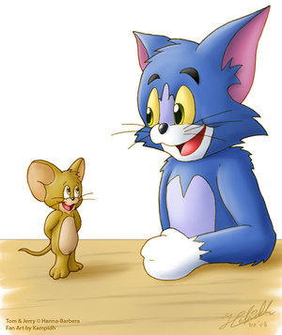
They always fight together but they rarely move together when they are in danger.
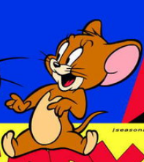

There are the other characters in Tom and Jerry. Spike and his son Tyke are in the first picture. And Jerry is in the second picture. They always help Jerry. Jerry is very lucky.
By the way the cartoon doesn’t have voice. So that music and pictures are very important for cartoon. Even so Tom and Jerry is very nice.
