FINAL EXAM CONTENT (40%)

‘Reading’ thoughts and Nations

PAGE | TOPIC  PARTS  - Questions  - Comprehension: True/False/ No Information
14 | Pencils and Pens
64 | Great Athletes
81 | The Puffer
84 | Foods from around
164 | The History of Money

Only two reading text will be asked.

READING PASSAGES
Passage 1- page 14: PENCILS and PENS
No one knows who invented pencils or when it happened. A Swiss described a pencil in a book in 1565. He said it was a piece of wood with lead inside it. (Lead is a very heavy, soft, dark gray metal.) Pencils weren't popular, and people continued to write with pens. They used
bird feathers as pens.
Then, in 1795, someone started making pencils from graphite, and they became very popular. Graphite is like coal. (Coal is black, and we burn it for heat and energy.) Today, people make pencils in the same way. They grind the graphite, make it into the shape of a stick, and bake it. Then they put it inside a piece of wood. One pencil can write 50,000 English words or make a line 55 kilometers long.
People wrote with feather pens and then used pens with metal points. They had to dip the point into ink after every few letters. Next, someone invented a fountain pen that could hold ink inside it. A fountain pen can write several pages before you have to fill it again.
Two Hungarian brothers, Ladislao and Georg Biro, invented the ballpoint pen. They left Hungary and started making ballpoint pens in England in 1943, during World War II. English pilots liked the pens. They couldn't write with fountain pens in airplanes because the ink leaked out.
Later, a French company called Bic bought the Biros' company.
Some people call ballpoint pens "Bics." Australians call them "biros." Whatever we call them, we use them every day.

Passage 2- Page 65 Great Athletes
You might think that Olympic athletes are the .healthiest people in the world. It's true that many are. However, it's also true that quite a few Olympic athletes had to overcome illnesses early in their lives.
One excellent .example is Wilma Rudolph. She competed in track-and-field events in the 1960 Olympics. She didn't win just one gold medal. She won three. At the time, people called her "the fastest woman in the world.”
As a young child, Wilma Rudolph could not Participate in sports. She had a series of serious Illnesses, and then, at the age of 4, she got polio. She lost the use of her left leg, and the doctors said she would never walk again. The people in Rudolph's family did everything they could to help her walk again,
Wilma and her mother frequently traveled 100 miles to get treatments for her leg. Her brothers and sisters took turns giving her leg a daily massage. Four times a day, they helped her do special exercises for her leg. Amazingly, by the time Rudolph was 9 years old, she was able to walk again. Before long, she started playing basketball and running. In high school, she was a track star, and then she went to the Olympics.
Wilma Rudolph retired from her career as a runner when she was 22 years old. She then became a teacher and track coach. Her story encouraged many people to work hard and to overcome difficulties.

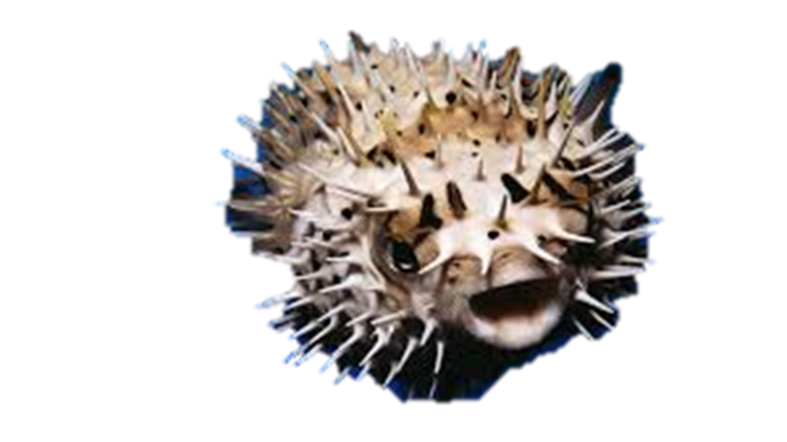
Passage 3- Page 81: The Puffer Fish

Most people avoid eating dangerous foods. They don't want to get sick. However, there is one food that can be deadly, yet some people eat it on purpose. It's called the puffer fish.
This kind of fish, called fugu in Japanese, lives in the Pacific Ocean. Some people die every year from eating fugu. In fact, the Emperor of Japan is not allowed to touch it. Why? Well, the insides of the puffer fish are very poisonous. They contain a poison 275 times more powerful than the deadly poison cyanide.
Usually nothing bad happens when fugu is on a restaurant's menu. Customers feel great after the meal. That's because chefs are trained to remove the insides of the puffer fish before they give it to customers. If they miss even a small amount, the fish is not safe to eat.
Puffer fish is very expensive. A plate of fugu costs more than $200 in some restaurants in Tokyo. Besides being dangerous to eat, the fish is very ugly, with spines all over its body. Also, it can puff, or blow, itself up to double its normal size. Why don't the Japanese risk so much for such an ugly and deadly fish? Well, some people like taking risks. And fugu tastes wonderful.

Passage 4- Page 86: Foods from Around the World
Foods that are well known to you may not be familiar to people from other countries. Tourists and other travelers almost always get to try some unfamiliar food. That is part of the fun of traveling. Here are four people’s experiences with foreign food.
Shao Wong is a student in France. He comes from China. “I never had cheese or even milk before I came to France. Cattle are rare in my part of China, so there are no dairy products. I drank some milk when I first arrived in France. I hated it! I tried cheese, too, but I didn’t like it. I love ice cream, through and that’s made from milk.”
Birgit is from Sweden. She traveled to Australia on vacation. “I was in a restaurant that specialized in fish, and I heard some other customers order flake. So I ordered some, too, and it was delicious. Later, I found out that flake is an Australian term for shark. Now, whenever I see a new food, I try it on purpose. You know why? I remember how much I enjoyed flake.”
Chandra is a dentist in Texas. She is from India. “I’m afraid to try new foods because they might contain beef. I’m a Hindu, and my religion forbids me to eat meat from the cow. That’s why I can’t eat hamburgers or spaghetti with meatballs.”
Nathan is from the United States. He taught for a year in China. “My friends gave me some 100-year-old eggs to eat. I didn’t like their appearance at all. The eggs were green inside, but my friends said the color was normal. The Chinese put chemicals on fresh eggs. Then they bury them in the earth for three months. So the eggs weren’t really very old. Even so, I didn’t want to touch them.”
Life in new country can be scary but it also can be fun. Would you eat a 100-year-old egg? Would you order shark in a restaurant?
Passage 5- Page 165: The History of Money

Today, currency is a mixture of coins and paper money. But it wasn't always that way. Before people had metal coins and paper bills, they used a lot of unusual things for money. In one part of the world, for example, people used sharks' teeth for money. In some places, brightly colored feathers and rare seashells were money.
People in one area even used the hair from elephants' tails for money.

No one knows for sure when people started using metal coins for money. The oldest coins are over 2500 years old, so we know that people used coins a very long time ago. At first, people used precious metals, such as gold and silver, to make coins. They stamped the shape of a person or animal on each coin to indicate its value.

In the 13th century, people in China used iron coins for their currency. These coins weren't worth very much, and people had to use many of them to buy things. Because it was inconvenient to carry so many of these coins, the government started making paper receipts. People took these receipts to banks and traded them for coins. This was the first example of paper money.

Today, most countries use a mixture of coins and paper bills for their currency. In the United States, the paper bills are all the same size and color. For example, the $1 bill is the same size and color as the $100 bill. In many other countries, the bills have different sizes and colors. The smaller bills are worth less money. This makes it easier for people to tell the value of their money.

In 2002, twelve European countries started using a completely new currency. It's called the euro. Many Europeans miss their old currencies, but now it's easier to move money from one country to another.

Vocabulary List

- able to
- affect
- alert
- alike
- behave
- blow
- broom
- careful
- chew
- continent
- dead
- earn
- employee
- enemy
- enough
- environment
- even
- expensive
- extra
- farm
- freeze
- goal
- grass
- highway
- injure
- insects
- interested
- lose
- loud
- mountain
- nearby
- ordinary
- organized
- pass out
- pay
- probably
- rock
- roof
- rug
- sandal
- somehow
- still
- vacation
- vary

