Eclectic News
Newspaper Editor Ahzad Halshoy Date: 22/10/2013_____________ No: 1
Some saying The Weather in Halsho Networking

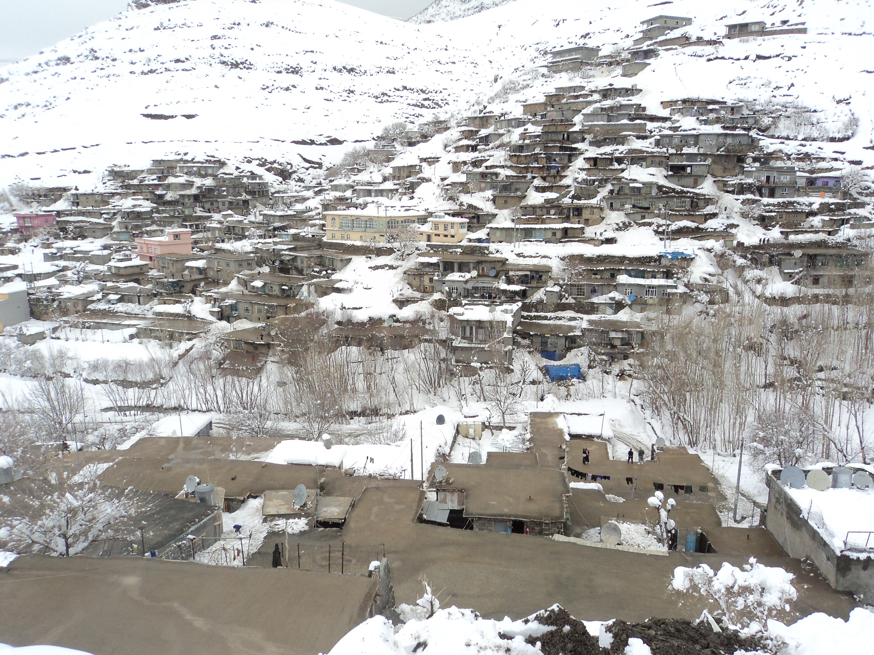
Networking is the concept of sharing resources and services a network of Computers is a group of interconnected system sharing resources and interacting Using a shared communication link. A network therefore is a set of interconnected systems with something to share. the shared resource can be data a printer a fax modern or service such us a data base or an email system the individual systems must be connected through a path way (called the transmission medium) that is used to transmit the resource or service between the computers all systems on the pathway must follow asset of common communication rules for data to arrive at its intended destination and for the sending and receiving systems to understand each other. the rules governing computer communication are called protocols.in summary all networks



In Halsho it is don’t very hot in Summer. You must not wear you hats. In Autumn it is very cool and it is very windy, In winter it is very very cold.




QUOTE of the MONTH
If you can HEAR
If you can SEE
IF you can TALK
I you can WALK
Thanks Allah

