LEARNING and RECORDING NEW VOCABULARY
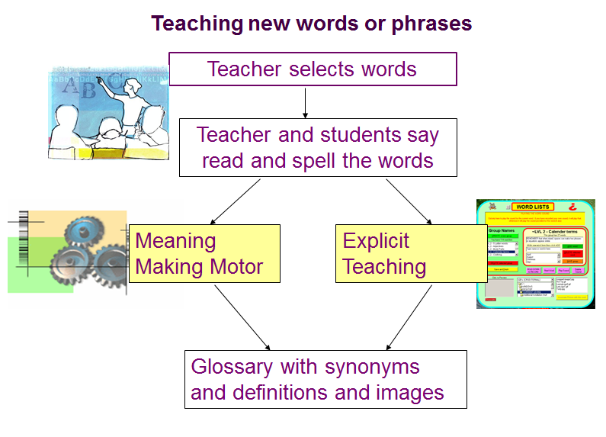
When can we say we have learnt a new word or phrase? Usually, learning a new word means that you:
- know what it means
- know how to say it
- know how to spell it
- know when and when not to use it
- know the grammar of the word (e.g. Which word must follow it). (2003, BBC World Service)

When you teach vocabulary, you teach students to
- say words accurately,
- read words accurately,
- spell and write the words
- understand the meaning of words
- understand what they are reading
- work out the meaning of words in familiar and unfamiliar contexts
- see how new words came from words they already know. (John Munro)

Because so much is involved in learning a new word or phrase, it is useful to use an idea or ideas to help yourself remember them. In this work, we look at several different ideas for recording vocabulary and help you choose which you find most useful. Don’t forget, however, that how you learn best is a matter of personal choice. If you find that one idea isn’t effective for you, try another! (2003, BBC World Service)

TYPES OF TEACHING WORDS

Students or teachers select the key word
- say, read, spell aloud
- say or write the word for spelling
- say or write the word for pronunciation
- work out what new word means
- write key words and meanings in glossary
- find synonyms for the key word
- visualize images to remind students of the meaning of new word
- use the new word

IDEA 1 – Select the key words

Look at the text in front of you. Scan down the page and identify key words and phrases.
OR
Scan the page and circle any words you don’t understand.


IDEA 2 – Say, read, spell aloud
‘Communication’
Everyone repeat the word: com-u-nu-ca-tion --- communication

IDEA 3 – Saying or writing for pronunciation and definition
‘Communicate’ com-u-nu-ca-te.
- Its pronunciation:
/kəˌmjuːnɪˈkeɪʃən/
- Dictionary meaning:
to share information with others by speaking, writing, moving your body, or using other signals
- Part of speech: n
- Sample sentences:
He can't communicate with his parents.
New word or phrase | Part of speech and Pronunciation | Dictionary Meaning | Sample Sentences: | Other Information (synonyms, antonyms, other parts of speech...)
Communicate | n. /kəˌmjuːnɪkeıt/ | to share information with others by speaking, writing, moving your body, or using other signals | He can't communicate with his parents. | speak, be in contact, correspond

IDEA 4 – Write key words and meanings in glossary
Copy the words ‘happy’, ‘crazy’ and ‘present’ into your wordlist.
Copy down the definitions we worked out.
In your own words write a definition.

Word | Class Definition | My Definition

IDEA 5– JOB VOCABULARY
Focusing on job titles and its source
JOB (NOUN) | VERB
presenter | to present
producer | to produce
reporter | to report
editor | to edit
correspondent | to correspond (with)

Practice: Use these organizers to record the names of different jobs, and the verbs which show what each person does.

JOB (NOUN) | VERB

JOB (NOUN) | VERB

IDEA 6 - WORD FAMILIES

Word families are groups of words which share the same base or root. For example, earlier we saw that a presenter is someone who presents programs on the radio. Here, ‘present’ is the root, and other words are created by adding pieces to the root. So, we can ‘present information ’by ‘giving a presentation’. Look at this example:
ROOT: photo n.
photograph n. (thing) photographic adj.
photograph v. photo n. (abbreviation)
photographer n. (person)
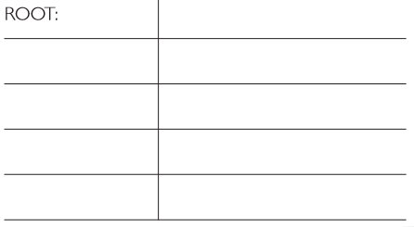
ROOT: sing v.
singer n. (person)
song n. (thing)
singing n. (activity)

IDEA 7 – RECORDING COLLOCATIONS

A collocation generally refers to a group of words that are habitually spoken or written together. Such phrases as "hot coffee," "by the way," "unbearable pain," and "burst into tears."
Part of learning a new word is learning which words surround it. In English, it is useful to learn word partnerships or collocations. Is your new verb usually followed by a particular preposition? Is the new noun you have noted always linked to a specific adjective? Remember to ask yourself: What does this word collocate with?
For example:
Every day I listen to the radio. (‘listen to’ is a frequent collocation)

Which phrasal verbs collocate with ‘radio’?

 | the radio
switch on | the radio
tune in | the radio
turn up | the radio

Practice: LEXICAL SETS
How many words can you add to your lexical set on the topic of ‘The News’?

Word Meaning
e.g. headline
TOPIC: NEWS
WORD | MEANING
headline | the short summary of a story in a few words

IDEA 8 – MIND MAPS

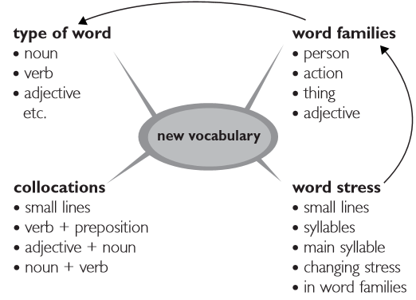
Usually, we record new information in lists may help us remember the information. However, lists don’t work for everyone. One alternative is to make a mind map. A mind map is like a picture which links together the ideas in a topic. At the centre is the main idea, and all the related ideas lead from it, just like a map. So, looking back at our learning vocabulary ideas we could plan them in a mind map like this:
Practice:
Use this page to make a mind map of all of the vocabulary you can remember associated with the word ‘radio’.

radio

IDEA 9 – Meaning Making Motor
Working out what new words mean using your Meaning Making Motor (1)
What do you think the word “sociology” means?
How can you work out the meaning?
What words or stems can you see in that word and do you know other words that use those stems? Can you put two stems together to make a meaning?
- “socio”: social, society, sociopath.
- “ology”: biology, physiology, theology etc. (ology: the scientific study of a particular subject)


IDEA 10 – Visualize Images
Visualize images to remind students of the meaning of new words.
- When I say the word ‘happy’ what pictures appear in your head?
- Say the word ‘happy’ in a meaningful sentence.
- Where else would you use this word? Now use the word ‘happy’ in a different sentence.
- In 10 minutes, write a short story using the words we’ve just added to our glossary.


IDEA 11 – Reviewing the Vocabulary and the Topic

Use each word in a sentence to show its meaning.
Write a paragraph using the words.

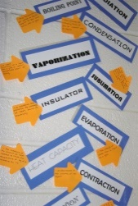
Use a chart to organize new words, terms, synonyms and sentences
Match key words with their synonyms found in different texts

IDEA 12 – Vocabulary Tools
- Word Wall e.g. students write one word/phrase and then read / Say aloud each new word/phrase.
- A series of words related to topic or letter pattern.
- Acting out the meaning
- Scrabble, Boggle (throw, astonish)
- Draw a picture
- Use analogies (similarities, equivalences)
- Visualize
- Dictation

