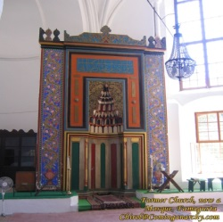
OCTOBER NEWSPAPER
Newspaper Editor: NIYAZI AKBABADate: 21.10.2013 -1
The Mosque of Umm Haram
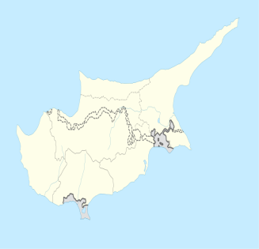
Hala Sultan Tekke or the Mosque of Umm Haram (Turkish: Hala Sultan Tekkesi) is a Muslim shrine at Alykes, Cyprus near Larnaka City . Umm Haram (Turkish: Hala Sultan) was the us prophet Hz. Muhammed’s (sav) wet nurse and the wife of Ubada bin al-Samit. Hala Sultan Tekke complex is composed of a mosque, maoseloum, minaret, cemetary, and living quarters for men and women. The term convent (tekke) applies to a building designed specifically for gatherings of a Sufi brotherhood, or tariqa, and may have referred to an earlier feature of the location. The present-day complex, open to all and not belonging to a single religious movement, lies in a serene setting on the shores of the Larnaca Salt Lake, which appears to be an important site also in prehistory. Hala Sultan Tekke is a listed Ancient Monument.
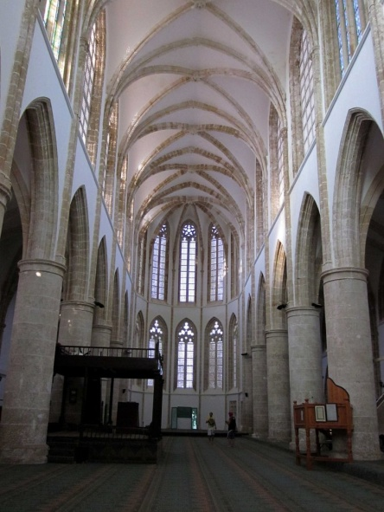
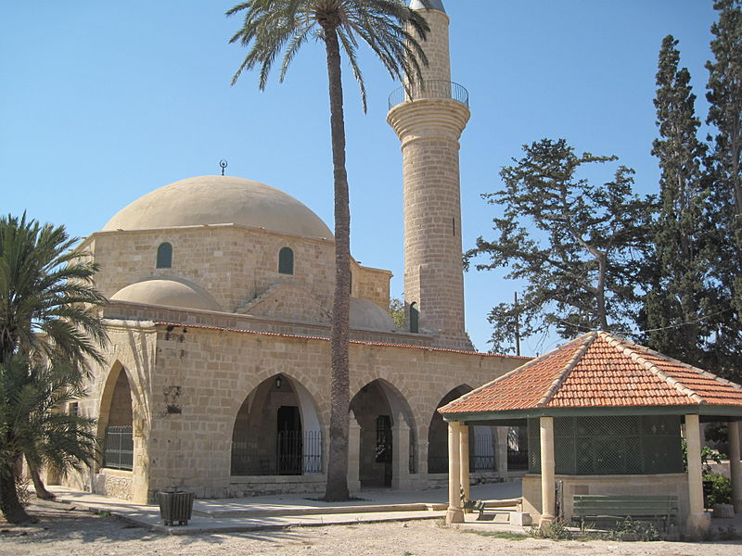
The Lala Mustafa Pasha Mosque
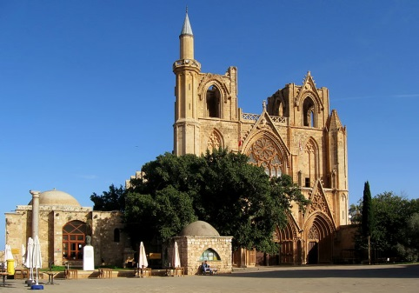
The Lala Mustafa Pasha Mosque originally known as Saint Nicholas's Cathedral and later as the Ayasofya (Saint Sophia) Mosque of Magusa, is the largest medieval building in Famagusta, Northern Cyprus. Built between 1298 and c. 1400, it was consecrated as a Catholic cathedral in 1328. The cathedral was converted into a mosque after the Ottoman Empire captured Famagusta in 1571 and it remains a mosque to this day.

