MY MATH STORY

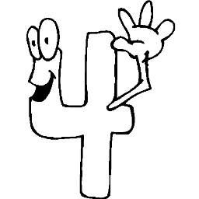
MY FAVORITE NUMBER: 4
4 is my favorite number. I love it. It is alway my best friend. I always feel it sitting next to me when I eat something. When I go shopping, I buy 4 pieces of everything.
My friend 4 is very strong. It’s like me. A lot of people know it. They take its photos.
4 sometimes walks with its friend “0”. When they walk together, people call them “forty”. When he walks with other zeros, they become “four hundred” or “four thousand”.
4 has twinis when they stay together. Their family calls them, “forty four”
Asia



I am not 6 Anymore

6 is a good child. He is smart, active, and polite. He thinks about his future all the time. He always wishes to get older as soon as possible.
One day while he was thinking on a subject, he suddenly fell over on the steps of his department. He stood up and walked in the street, but there was something strange. Nobody recognized him because he changed into “9”. Then he started crying and said, “Oh, nooo, I don’t want to get older anymore, I want to be “6” again!!!”
Asia
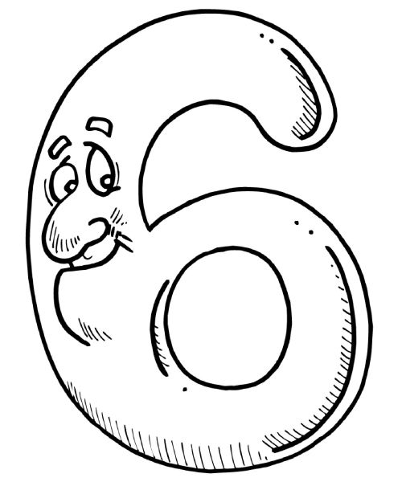
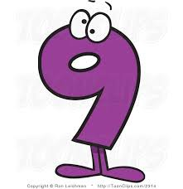
A + into x
 was a good man. He was a very hard worker. He used to add things to things. Tha was his job. He worked for years and years without stopping. But one day, he got very angry. He said, “That is enough. I am very tired, I don’t want to work anymore”.
Suddenly, his mother walked into his office and asked, “What are you talking about?, Are you crazy, son?” Then she slapped him strongly.
His shape changed into  . Since then he has been working for shorter periods, but more effectively. Asia

