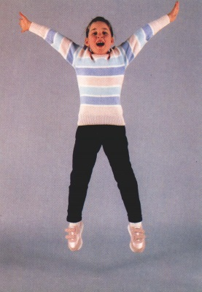

Interview with a Classmate
My classmate’s name: _________________ His Age: ______
3rd Step
Questions | Answers
- What is your name? | _________________________________________________  __________________________________________________
- How old are you? | _________________________________________________  __________________________________________________
- Where is your school? | _________________________________________________  __________________________________________________
- Is your father a pilot? | _________________________________________________  __________________________________________________
- Is your mother a housewife? | _________________________________________________  __________________________________________________
- What colour is your house? | _________________________________________________  __________________________________________________
- What’s your favourite animal? | _________________________________________________  __________________________________________________
- What’s your favourite colour? | _________________________________________________  __________________________________________________
- What’s your favourite story book? | _________________________________________________  __________________________________________________
- What’s your favourite fruit? | _________________________________________________  __________________________________________________
- What’s your favourite lesson? | _________________________________________________  __________________________________________________
- Who’s your best friend? | _________________________________________________  __________________________________________________
- What do you like? | _________________________________________________  __________________________________________________

4th Step
Change My her and I she
My name is Mary. I am seven years old. My school is in Erbil. My father is a doctor and my mother is a housewife. My favourite colour is red and my favourite animal is lion. My favourite book is The Little Red Hen. My best friend is Seda. I like my house.
__________________________________________________________________________________________________
__________________________________________________________________________________________________
__________________________________________________________________________________________________
__________________________________________________________________________________________________
__________________________________________________________________________________________________
__________________________________________________________________________________________________
__________________________________________________________________________________________________
__________________________________________________________________________________________________
__________________________________________________________________________________________________
__________________________________________________________________________________________________
__________________________________________________________________________________________________
__________________________________________________________________________________________________
__________________________________________________________________________________________________
__________________________________________________________________________________________________
__________________________________________________________________________________________________
__________________________________________________________________________________________________
__________________________________________________________________________________________________
__________________________________________________________________________________________________
__________________________________________________________________________________________________
__________________________________________________________________________________________________
__________________________________________________________________________________________________

