INTERVIEW
project
“Meet a Person”
Name: ______________ Class:_______ Date: _________
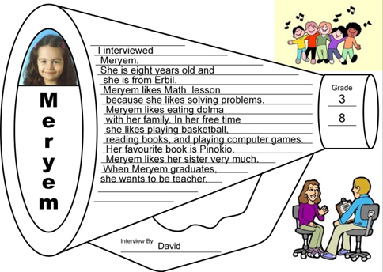



Interview
My name: ____METIN_____ Class: ____2____ Date: 6 December 2014

1. Interview questions and answers.
Questions | Answers
What is your name? | My name is Meryem.
What do you do? | I am a teacher at Birayati Primary School.
How old are you? | I am 25 years old.
Where do you live? | I live in Erbil.
What do you do in the morning? | I get up early and prepare breakfast
What do you have at breakfast? | I eat bread, cheese and yogurt and I drink milk.
How do you go to work? | I go to school by my car.
What do you like eating at lunch? | I like eating sweets.
What do you do in the evening? | I cook dinner and watch TV.
What do you do at night? | I check my students’ homework, write emails and read books.
What time do you go to bed? | I go to bed early and I get up at 5 o’clock.
What do you do at the weekends? | I have meeting and visit my grandma. I go shopping.
Can you play a musical instrument? | No, I can’t. But I have a music lesson every Saturday.
What do you do in your free time? | I draw pictures and help my family.
What is your favourite sport? | I like swimming.
What is your favourite animal? | It is lion.

2. Read the paragraph about the most interesting things that you learned about the person.

PLAN
A HAPPY TEACHER: MERYEM
Title

Who?

Morning

Evening

Weekends

Free time

Opinion

I interviewed Meryem. She is twenty-five years old and she is a teacher at Birayati Primary School. She lives in Erbil.

In the morning, Meryem gets up early and prepares breakfast. She eats bread, cheese, and yogurt and she drinks milk. She goes to school by her car. She likes eating sweet at lunch time.

In the evening, she cooks dinner and watches TV. At night, she checks her students’ homework, writes emails and reads books. She goes to bed early and she gets up at 5 o’clock.

At the weekends, Meryem has meeting and visits her grandmother and she goes shopping. Meryem can’t play a musical instrument, but she has a music lesson every Saturday.

In her free time, Meryem draws pictures and helps her family. Meryem’s favourite sport is swimming and she likes lions.

I think Meryem is a very happy and interesting person.


Interview
My name: ________________________________ Class: ____________________

4. Interview with one of your friends, teachers, or relatives. Write the answers in the right the column.

Questions | Answers
What is your name?
What do you do?
How old are you?
Where do you live?
What do you do in the morning?
What do you have at breakfast?
How do you go to work?
What do you like eating at lunch?
What do you do in the evening?
What do you do at night?
What time do you go to bed?
What do you do at the weekends?
Can you play a musical instrument?
What do you do in your free time?
What is your favourite sport?
What is your favourite animal?

5. Write a paragraph about the most interesting things that you learned about the person.

______________________________
_____________________________________________________________________________________________________________________________________________________________________________________________________________________________________________
_______________________________________________________________________________
____________________________________________________________________________________________________________________________________________________________________________________________________________________________________________________________________________________________________________________________
_______________________________________________________________________________
____________________________________________________________________________________________________________________________________________________________________________________________________________________________________________________________________________________________________________________________
_______________________________________________________________________________
______________________________________________________________________________________________________________________________________________________________
_______________________________________________________________________________
______________________________________________________________________________________________________________________________________________________________
_______________________________________________________________________________
______________________________________________________________________________________________________________________________________________________________

