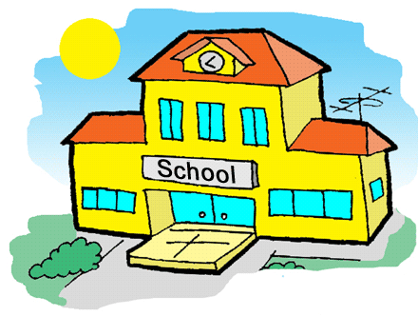
SCHOOL JUST SCHOOL

School we need it

school, friends

school you have teachers

school is great

school you might find your true friends

new experiences everyday

school, activities

school just school

school is fun

school, projects

school, classes

school, math, science, computer classes

school is great love it

school just school

we need school

kerri king

