CLASSROOM LANGUAGE KNOWLEDGE TEST - SAMPLE

PART 1
- How would you set homework in English? (Write 4 of them)
- Get your homework checked / signed by your parent (s).
- Are there any questions you couldn’t answer in the homework? Let’s do it then.
- Complete the exercise at home.
- Did you do all of this homework by yourself?
- Do exercise 10 on page 23 for your homework.

- How many ways can you think of for saying goodbye? (Write 4 or 5 of them)
- See you.
- See you tomorrow afternoon.
- Goodbye, everyone.
- See you again next Wednesday.
- See you in room 7 after the break.

- How many different ways can you think of for saying Good? (Write 4 or 5 of them)
- Amazing!
- Aren’t you proud of yourself?
- Awesome! (AE)
- Congratulations!
- That’s better than ever

- How would you encourage your students? (Write 4 or 5 of them)
- All your hard work is paying off.
- You have all made a lot of progress.
- You're getting better all the time.
- You've improved no end.
- I'm really impressed with your progress.

- Expand the following abbreviated Yes/No questions into full questions.
- Understood? Have you all understood?
- No pencil? Don’t you have a pencil?
- Problems? Are you having problems?
- Finished? Have you finished?
- Anybody done question 7? Has anybody done question?

PART 2
Complete the following
- Don’t be afraid to make mistakes.
- Last time, we talked about importance of education, today we will continue with how to apply new ideas on the same topic.
- Work together with a friend.
- Did you do all of this homework by yourself?
- Don’t forget to bring your homework.
- Have you done your homework?


PART 3

- Which is correct:
- at page 20,
- on page 20 - c
- in page 20

- What do you say when you want your students to do this?
- Put your hand up if you know the answer. - c ("Put your hand up" or "put up your hand")
- Rise your hand if you know the answer.
- Put your hand in the air if you're knowing the answer.
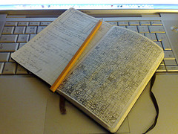
- You want your students to look at page 33. Which is correct?
- Open your book in page 33.
- Now please turn on page 33.
- Turn to page 33 please. -c
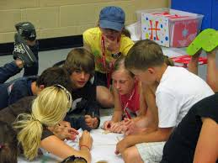
- You don't want students to do this exercise together. What do you say?
- Be individual.
- Work alone. -c
- Please work lonely.


- Not allowed in class!

- No chew here.
- Put your chewing gum in the bin. -c
- Spit it out!


- Your student has done some very good work. Which one of these wouldn't you say?
- Well done!
- Good try! -c
- That's great!
- You've done really well.
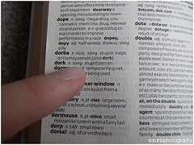
- You don't want your students to use their dictionaries yet. Which one of these wouldn't you say?
- You can look the words up later.
- Try to guess the meaning of words you don't know. -C
- Dictionaries are bad!
- We'll look at vocabulary later. So no dictionaries just yet please.

8. Computers are more interesting than teachers!!! So if you are working in the computer lab, when you want your students' attention for a while it's a good idea to tell them...
A. Turn off your computer and listen to me.
B. Turn off your monitor and look this way please. -C
C. If anyone touches their computer while I'm speaking we'll all go back to the classroom and do some grammar exercises.

References:
http://www.proprofs.com/quiz-school/story.php?title=classroom-language-english-teachers

