

LOCAL NEWS

Newspaper Editor: Halil sahin Date: 21.10.2013
Tarzan of Manisa
His real name is Ahmeddin Carlak, but everyone calls himTarzan of Manisa. He was born in 1899 in Samarra. He attends independence war in Gaziantepe, Kilis, and west battle fronts in Turkey. He sees burning of the forest by enemies’ soldier in Manisa. He decides to live in Manisa. He grows trees. He is successful to grow the trees. He lives in cottage in Spil Mountain. He wears only short durıng the life of Manisa. He is climber and first Naturalist in Turkey. He makes a sculpture by mountain climbing club in Manisa.
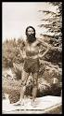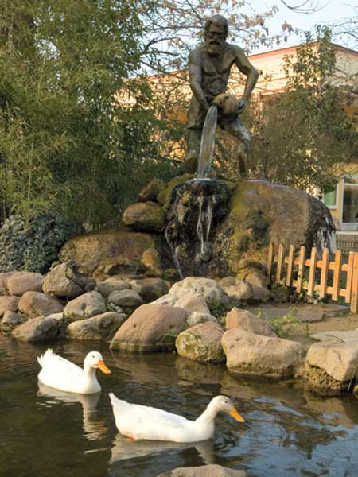

Make of grape molasses
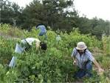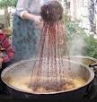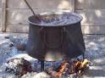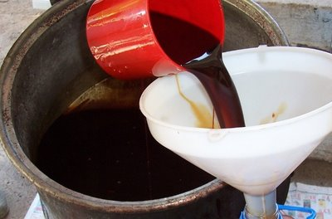
We make grape molasses ours village. We collect grape and put into sacks or special places. We put special soil. We crush grapes by our feet to put out grape juice. First boiling, we boil grape juice big cauldron and to filter soil. Second boiling, we boil it during in the tray 2 or 3 hours. During the 2 or 3 hours, we wait and mix to condense grape juice. We put in the clean cauldron to become grape molasses. This process finishes totally a few days. It is very good to taste. It can protect your throat from cold.

