

SEDA’S NEWSPAPER

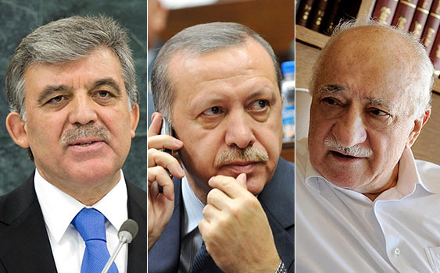
_______Newspaper Editor__ Seda BİŞGİN Date__ October 2013______
‘’ May You Recover Soon’’ at the Phone Fethullah Gulen Hodja from Summint at the Goverment
President of a republic Abdullah Gül and Prime Minister Tayyip Erdoğan called Fethullah Gülen to be informed about his health.
Tayyip Erdoğan called Hodja before his Ankara- Istanbul travel Erdoğan said’’May you recover soon’’ Hodja gratitude to Mr. Gül and Mr. Erdoğan for delicacy too.
So many famous people and political people said ‘’May you recover soon’’ to Fethullah Gulen from online specially via Twitter.
From Twitter Disclosure

Fethullah Gülen’s bewildered worried. He went to hospital because of Hodja’s heart of spoil rhythm. He was good 12 hours later. His friends said in Twitter:’’Fethullah Gulen Hodja went to hospital because of heart and suddenly high blood pressure. He has medical treatment for 12 hours. His healthy is normal at the moment. He is resting at his home.
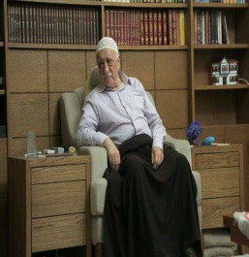
We present with pray…..
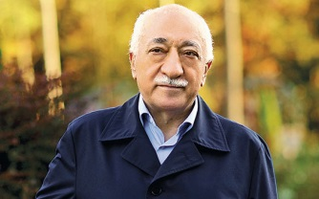
This is his healthy picture.

