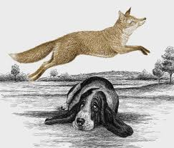
HOW to WRITE a SHORT STORY

A LAZY DOG
Title

The beginning
- (When) Time
Once upon a time
- (Who) Characters
A dog and a fox
- How can you describe the characters?
Fox:quick Dog: lazy

The middle
- Problems
The dog is very lazy.

The End
- The dog is lazy, but it saves people’s lives

Once upon a time there were a brown fox and black dog.
The fox was quick, but the dog was lazy.
"You are a lazy dog," said the fox.
"Yes, I am a lazy dog," said the dog.
"Why are you a lazy dog?" asked the fox.
"Why not?" asked the dog.
"My owner feeds me.
My owner takes me out for walks.
My owner loves me. I eat.
I go out for walks.
I sleep. I'm a lazy, happy dog."
"But don't you have any ambition?" asked the fox.
"Ambition? Ambition to do what?
I'm just a dog," said the dog.
"Lassie was a dog.
She saved people's lives," said the fox.
"I'm too lazy to save people's lives," said the dog.
"Let Lassie save people's lives."

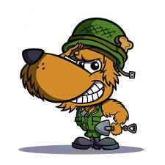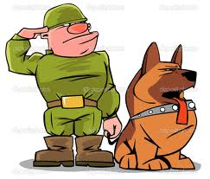

2cm

DAVID’S FLOWER

David is a good student. He is seven years old. His family has got a garden outside his house. They have got breakfast and dinner together in this lovely garden. There are a lot of plants, such as roses, trees, and some vegetables in the garden.

David likes playing in their garden. One day, his flower wilted but he did not know. He went to the garden and saw that his flower had died. He was very sad.

His mum saw David crying in the garden. She said to him, "It is OK; I can grow another flower for you. David, please don't cry."
David stopped crying. He was happy again.

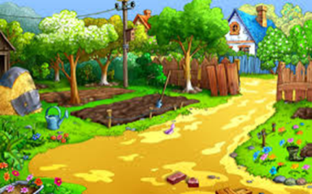

2 cm

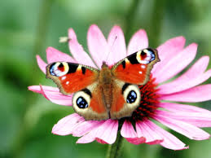
2 cm

see -saw
go -went
Say -said
wilt -wilted
Stop -stopped
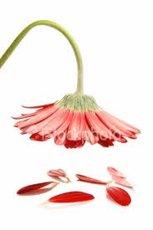

2 cm

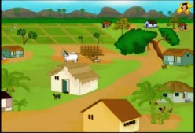
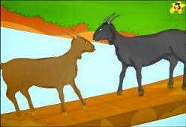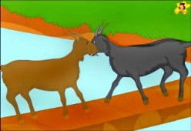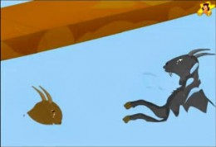
TWO SILLY GOATS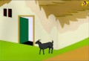

Once upon a time there were two silly goats in a village. They looked like each other, but they were both very selfish and proud. Each of them thought themselves to be very great.
The two silly goats lived in this lovely village. The village was a lovely one, and a beautiful river flowed past the village. There was a bridge on that river to cross. But the bridge was very narrow. It was so narrow that only one person or animal
But it wasn’t problem for people and some other animals. When two people came across on the bridge at the same time, one would just wait a minute until the other one crossed over, and then they would cross over safely. All the animals of the village also followed that rule.
However these two silly goats were quite different! One day they came to the opposite ends of the bridge at the same time. Although they saw each other at the opposite ends, they just continued to try to cross the bridge at the same time. Each in its own pride thought they it had the right of way and that the other goat should yield way. Naturally the silly goats met in the middle of the bridge. And what do you think happened?
Each goat refused to move. They both stood their ground, neither wanted to take back and make way for the other. "Hey, you," cried the first goat, "get out of my way. Don't you see I am trying to cross the bridge." "You silly fellow! Who do you think you are talking to. You make way for me at once," cried the second one. They yelled and started pushing each other.
When the two silly goats started pushing and shoving each other, they got into a big fight right on the narrow bridge. They both fell down into the river and died.
Look-looked
Think: thought
Flow- folloed
look - looked cross - crossed want -wanted fall -fell
continue -continued come -came cry -cried get -got
think -thought see -saw yell -yelled die -died
live -lived refuse -refused start - started
come

http://www.english-for-students.com/Animal-Stories.html

