Now and Then
My Grandparents

HOMETOWN – HOUSE
- Were you born in a hospital or at home?
- Did you live in the city or in town?
- How was your house? Can you describe it?
FAMILY
- Did your family have big family? Can you give some information about them?
- Can you describe your mum and dad?
- What do you remember best about your parents?
- Did you have a favorite aunt/uncle?
- Was your family financially comfortable?
- What did your parents do for a living?
- Did you know your grandparents or great-grandparents?
- What were their names?
- Where did they live?
- Were you very religious?

SCHOOL
- Did you go to school? Did you like it? (Why didn’t you go to school?)
- Where was your school?
- How did you get to school?
- Did you have to walk to school?
- What did you learn at school?
- How long did you attend school?
ACTIVITY
- What were your favorite games and activities?
- Did you have a bicycle when you were a child?
- Did you have a radio or TV?
- When did you get your first radio/TV?
- Which are the main differences between children now and then?
YOUNG LIFE
- What time did you use to get up in the morning?
- What did you use to do after work?
- Tell me about some important news or facts that happened when you were young
- Did you have to travel to another country to work there?
- Which country did you go to?
- What difficult things did you have to do when you were young?
- Were there wars, natural disasters, or political changes?
- How was your life different after the war?
- Which are your best memories?
- Which are your worst memories?
WORK
- When did you start to work?
- What was your first job?
- How did you get to work?
ADULT LIFE
- When did you get married? How old were you?
- How many children did you have?
- Have you accomplished (succeeded) what you wanted in life?
- What advice would you like to give me?
SAMPLE INTERVIEW PARAGRAPH
- An interview with my Grandma…
I always wonder my grandparents’ life. Their lives must be different than ours. We have fast car, television, the Internet, cell phone and so on. How about them?
I had the chance to sit down with my grandmother, Mary. I asked her many questions about her life.

- First a little background:
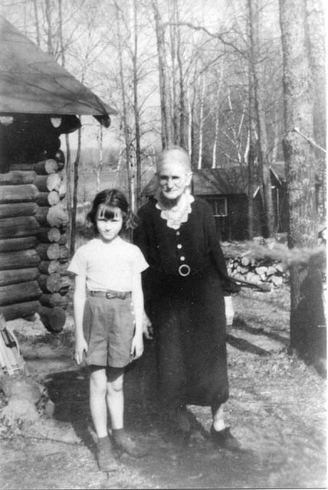
My grandma was born in a small village. She lived there forty five years. My grandma was married at the age of 19. I only have four children, and they keep me busy, so I can’t imagine seven! She said she always wanted to have a big family. She doesn’t remember her grandparents.

- NOW and THEN
She told me big differences between then and now. They didn’t have any television, the Internet and even radio! There weren’t any shopping malls in the city. There were very small groceries.
The first three kids.
When she was 21 years old, she had her first child. And when she was 35 years old, she had five children.
Some more notes
My grandma also said that they had dinner together as a family every evening. She helped her husband on the farm. She also sewed most of her children’s clothes herself.
Activities
At her time there weren’t many sports and activities for kids to do. Mostly the children would just play outside with the neighborhood kids. We also had mosque activities.

- My grandparents with the first three kids.
Me: For you, what is one of the hardest things about being a mom?
Grandma: When you feel that a child of yours is not walking with the Lord as you hoped they would.
Me: What is one of the most rewarding things about being a mom?
Grandma: The love that your kids give you. Undeserved, unrequested, just given freely.
Me: What tips do you have for today’s moms?
Grandma: Teach your children to have responsibility for their things and for their actions. Teach them to understand that there are consequences in life. I feel that I fell short on giving affirmation I wish I would have done more of that. I think it’s important to give some praise, but not too much, so it’s about finding a good balance. I also wish I would have told my children that I loved them more often.
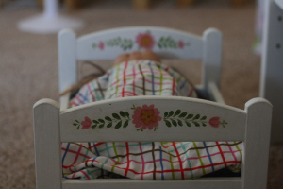
A doll bed my grandma painted for Charlotte.
My grandma is an amazing, Godly woman. She is also a very talented toll painter and I have many hand-painted treasures that she has given me over the years. During her most recent visit she painted these rain gutter bookshelves for my daughter’s room. She also made quilts for each of her fourteen grandchildren for when each of us get married. She is a wonderful cook and makes the most delicious coffee bread. I’ve never attempted it myself but I will one of these days.
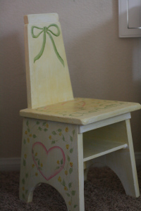
This was a chair that my mom's grandfather made her when she was young. My grandma painted it for Charlotte.
I think out of everything she said, what I appreciate most was her advice to praise your children and tell them how much you love them.
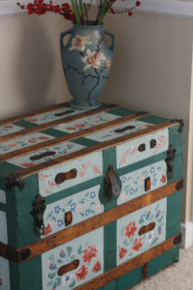
A trunk my grandmother painted.
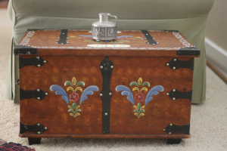
Another trunk my grandma painted.
- My Opinion about My Grandmother
My grandmother really knows many kinds of meals. When I visit her on Friday dinners at her house, her table could seat twelve, and that sucker was FILLED with food. Fried chicken and mashed potatoes were probably her specialty--except for desserts, of course. Iced box cake. Lemon meringue pie. Blackberry cobbler. Date pinwheels. Pecan pie. Pumpkin pie. Peach cobbler. Not to mention all the holiday candies she made... Divinity. Fudge. Peanut butter fudge. English toffee. Peanut brittle.
That list could go on and on and on. But here's what really sticks out in my mind... One time Grandma told me about her life on the farm.
She was married to a dairy farmer. And he served in the military for a least five years during WW2. During that time, she carried additional responsibilities on the farm. I guess the farm had quite a few hired hands. Probably seven to ten. Part of their wages was lunch. My grandmother made a full Sunday spread for seven to ten hungry men every day that she was on that farm. Even when my grandfather was overseas helping to fight a war. Oh, and in her spare time she made the occassional wedding cake. And she made sugar bells by hand and piped everything (no fondant back then!).
Now, I don't mean to brag. I learned a few things from Grandma, and I think I can hold my own in the kitchen. But when I try to imagine feeding the mouths of ten hungry men for lunch on a daily basis, I get a little squeamish. And, she made several pies per day, too. I don't make one pie per week, let alone several per day!
So, yes, my grandmother knew her way around the kitchen. I love the sign in her kitchen that read, "No matter where I serve my guests, it seems they like my kitchen best." I sure did
***

