

ORAN NEWSPAPER

Newspaper Editor _HASAN ORAN___________________________ Date _21.10.2013___ 1_____
HOUSES OF MARDIN
Different stones are used for Mardin’s houses than other houses. This stone is named as the lime stone. This stone has got light and yellow colour. This stone is broken down very easily. This stone are always used every route. Stones are cleaned after it knits wall.
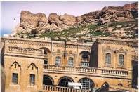

_

THE TURNIP
The turnip is a member the radish family. The turnip is grown in Çukurova region. Adana, Mersin and Osmaniye are main growing areas of it. The turnip is red and it tastes sour. It gives appetite. Digestion is easy. It is useful for stomach, liver, heart, and eyes.
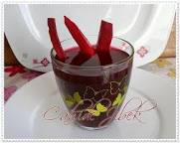
______________________________________________________________________________________________
by ____________________________

