SCHOOL THINGS
Learn the name of the subjects.
NOTEBOOK | PEN | PENCIL CASE | BAG
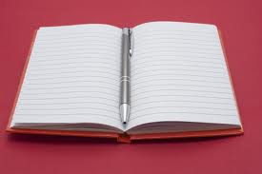 | 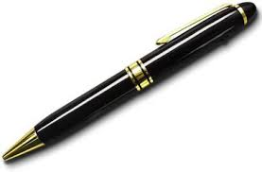 | 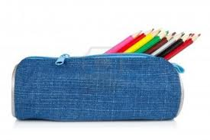 | 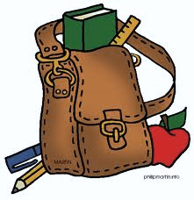
ERASER | RULER | PENCIL | BOOK
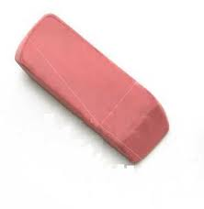 | 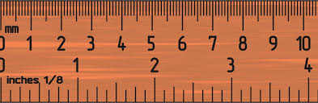 | 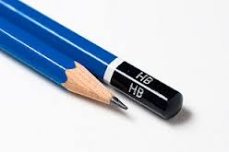 | 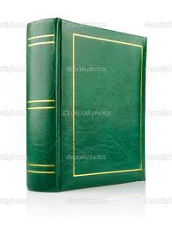

Name: ________________________________________ Class: ___________________ Date: ________________
SCHOOL THINGS

Write the given paragraph exactly.
Look at my school things. My bag is brown. My book is in the bag. It is a green book. My notebook is big. My pencil is on the notebook. The pencils are in the pencil case. My pencil case is blue. My rubber is pink. My favourite colour is pink.
__________________________________________________________________________________________________
__________________________________________________________________________________________________
__________________________________________________________________________________________________
__________________________________________________________________________________________________
__________________________________________________________________________________________________
__________________________________________________________________________________________________
__________________________________________________________________________________________________
__________________________________________________________________________________________________
__________________________________________________________________________________________________
__________________________________________________________________________________________________
__________________________________________________________________________________________________
__________________________________________________________________________________________________
__________________________________________________________________________________________________
__________________________________________________________________________________________________
__________________________________________________________________________________________________
__________________________________________________________________________________________________
__________________________________________________________________________________________________
__________________________________________________________________________________________________
__________________________________________________________________________________________________
__________________________________________________________________________________________________
__________________________________________________________________________________________________
__________________________________________________________________________________________________
__________________________________________________________________________________________________
__________________________________________________________________________________________________

