
uu

SEVDE’S NEWSPAPER

Newspaper Editor: Sevde Nur YILDIRIM Date: 26.10.2013
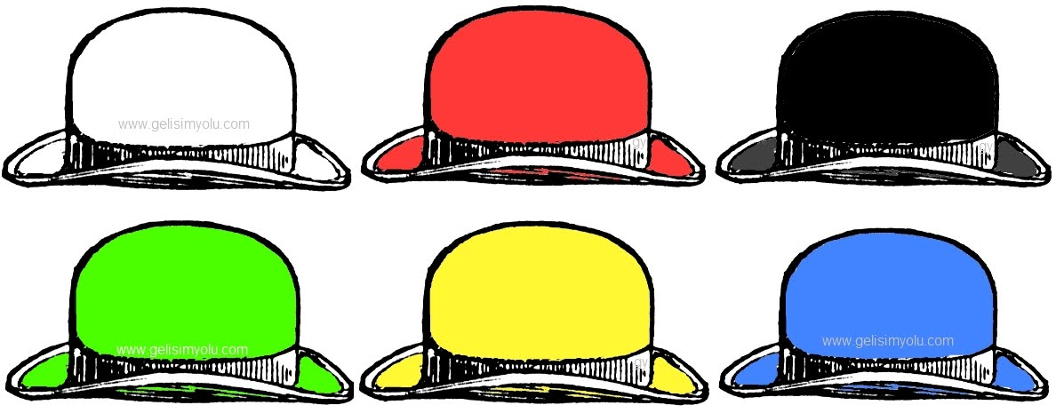

SIX THINKING HATS
Six Thinking Hats, is the book Edward Bono wrote in 1985. In this book, Edward Bono introduces another way of thinking. He describes six different ways for solving problems and he uses symbols for them. These are :
White Hat (Blank Page): This is a neutral hat (objective). White hat exposes clear informations and reports
Red Hat (Fire): This is an emotional hat (subjective). This hat say emotions and ideas of people.
Yellow Hat (Sun): This is an opsimistic hat (objective). This hat exposes advantages of a work. It tells about positive thinking.
Black Hat (The Judge’s Robe): This exposes bad thoughts, critiques and something that will be a problem in future.
Green Hat (Planet): This is a modernist hat(speculative). Researches alternative and new ways about every subject.
Blue Hat (Sky): This is a calm hat.(evaluation) .

