POWER TEACHING

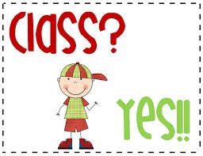

What is Power Teaching Power Teaching ?
Power Teaching is brain based education, developing lessons that engage students in
- seeing,
- hearing,
- doing,
- speaking, and
- feeling ... while they're having lots of fun.

As the year progresses, you may notice that our classroom doesn’t run like other classrooms. We will be learning through Power Teaching, a research based system that utilizes/uses all areas of the brain, keeps children engaged throughout their lessons, and helps them retain or keep much more information than the standard lecture-discussion model.
Power Teaching is a highly interactive form of instruction that delivers information to students in short pieces.
Kids then teach what they have just learned to their partners,
using hand-gestures to help remember specific vocabulary.
While students teach each other, the teacher walks around the room to discover who understands the lesson and who needs more instruction.
Research shows that children retain/remember more information when they have an opportunity to put it into their own words and use gestures to emphasize key instructional units …plus, it’s amazingly fun!

What are the principles behind power teaching?
There have not been any extensive research- based studies on the effects of whole brain teaching in the classroom.
Power Teaching promotes the idea that the most effective learning takes place when a student engages the brain’s primary cortices visual, auditory, language production and motor as the same time.
What I like about wbt
- It is an active and lively for students to learn.
- It meets the needs of different learning styles.
- You can pick and choose the strategies and techniques that work for you.
- PT is a great classroom management tool.
- It provides students leadership and student led teaching at an early age.
- It helps students develop critical thinking skills.
- It is fun to teach.
- It is designed to be used from kindly to high school.
- Students enjoy well- designed learning games.
- We can make outstanding educational progress in the proper settings.

Power Teaching is one of the fastest growing education reform movements.
Power Teaching is a popular, education reform movement begun in 1999 by three Yucaipa, California teachers:
Chris Biffle (a philosophy professor at Crafton Hills College),
Jay Vanderfin (elementary school) and
Chris Rekstad (elementary school).
The three of them realized that they all had the common problem of flagging/ weakening student engagement, and worse, it was becoming epidemic/widespread. Everywhere they looked, everyone they talked to, the story was the same. Something had to be done.
They decided a radical change in approach was warranted/ guaranteed/declared. They set out to learn more about how students should learn as opposed to the traditional ways teachers typically use. Research into whole brain learning, and applying what they learned was the answer.
Power Teaching was the result. Power Teaching is a method that integrates an effective classroom management system with learning approaches that tap the way your brain learns best. This approach is amazingly effective, and fun for both you the teacher, and the students.
Power Teaching rests upon the principle that teachers at every level share the same difficulties:
- students lack discipline,
- background knowledge and fundamental problem solving skills.
From kindergarten to college, teachers face students who have difficulty with reading and writing. Nonetheless, our students respond to challenges, enjoy well-designed learning games, and can make, in the proper setting, astonishing educational progress.
Their goal is to create peaceful classrooms full of orderly fun. Thousands of teachers believe they're on the right track.
At the root of Power Teaching is a large amount of highly structured.
Students learn the most when they are having fun. Power Teaching classrooms are full of task-focused laughter.
Humor and games are used to increase the number of times students repeat core information and practice basic skills.
Our classes are highly disciplined and tightly organized because students have more fun following our rules, than ignoring them.
In the last 10 years they have given seminars to over 6,000 educators representing over 300,000 students. Though they are centered in Southern California, they've been contacted by teachers from across the United States, Europe, Asia and Africa. Typically, our free seminars, offered three times a year at Crafton Hills College, attract over 400 instructors.

http://wholebrainteaching.com/index.php?option=com_k2&view=item&layout=item&id=135&Itemid=105

GETTING STUDENTS’ ATTENTATION
Power Teaching contains methods that are amazingly effective in classroom management. For the first step let’s get their attention, shall we?

How many times have you started class, called for your class to get quiet, only to have a few kids comply/obey, and several others continue chatting, apparently oblivious to your request?
You ask for their attention again, a bit louder.

At this point you can feel your blood pressure rising, right?
Then why don't they listen? Why don't you already have their attention?

You have teaching to do. They persistently hang onto the conversations they are in, even as your voice rises ...
Now you are headed into a bad mood/temper and the annoying class is only just beginning. To top it off, some of your lovely children are acting as though giving you their attention is a gigantic imposition (obligation). Now both you and your students are in a hostile (aggressive) mood, and no one has learned anything yet.
Does any of this sound familiar?

Power Teaching is educational foolish or silly behavior) based on brain based learning. The technique to consistently catch the attention of your class is simple. It is so simple, and effective that I kicked myself for not having thought of it myself years ago, and have lamented/grieved many times since the instructional time I lost for not having known this.
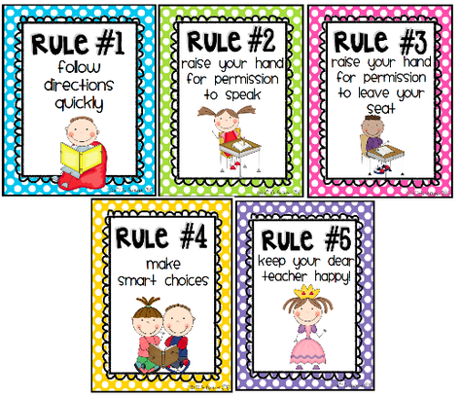

Five Classroom Rules
The following are five classroom rules that will make your life amazingly easier.
One of them is nuclear power in your hands!
If rules are only posted on your board, they are not really a part of your class.
You must have the rules running around in your students’ heads for them to be effective.
It will also help you quiet extra talking in the class. Look for that as you read.
TEACH THEM AS FOLLOWS:
Rule One:
Follow directions quickly!
(the gesture: make your hand shoot forward like a fish)
Rule Two:
Raise your hand for permission to speak!
(the gesture: raise your hand, then pull it down next to your head and make a talking motion. This rule will be the most commonly violated..)
Rule Three:
Raise your hand for permission to leave your seat.
(the gesture: raise your hand, and then make a little walking figure with your index and middle finger.)
Rule Four:
Make smart choices!
(the gesture: tap one finger to your temple as you say each word.)
Rule Five:
Keep your dear teacher happy! (the gesture: hold up each thumb and index finger out like an “L” framing your face; bob your head back and forth with each word and smile really big!)

WHOLE BRAIN TEACHING: 4 BASIC RULES
- CLASS - YES
1.
T: Class!
Ss: Yes!
T: Classity-class-class!
Ss: Yessity-yes-yes!’
To get my classes’ attention
I simply say ‘Class!’ and
then they reply ‘Yes!’.
If I say ‘Classity-class-class!’, they have to say ‘Yessity-yes-yes!’. If I say it loudly, they have to respond loudly. If I whisper, they respond in a whisper.
They have to match my tone and intensity/power.
Simple, hunh? It is amazing how effective this approach is. I used to be the teacher I described above. With middle schoolers in particular it was almost impossible to get their attention.
Too often, I would find myself frustrated by my students’ behavior.
Whole Brain Teaching uses a very simple and effective approach to overcome this resistance opposition/struggle. Whole Brain Teaching injects fun back into the classroom for both you and your class.
Why is the Class-Yes, in terms of brain structure, so effective?
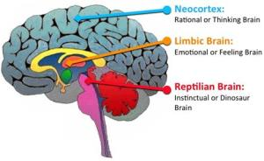
The neo-cortex, the part of your brain behind your forehead, controls, among other things, decision making. Think of the neo-cortex as an executive/decision-making organizing other brain areas for complex tasks. When the teacher says, "Class!" and students respond "Yes!," you have, in effect focused your students' neo-cortices on what you're going to say next. In other words, their brain's executives/directors are ready to take directions from your brain's executive. That's wonderful! Your neo-cortex is the CEO of all your kids' neo-cortices. We call that, Teaching Heaven.

2. Whole Brain Developer: TEACH-OK
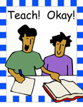
Next, you should use the most important of the Power Instruction's learning methods,
TEACH-OK
When you are instructing your students about foundational/initial concepts, it's time to step out/stay put from behind the worksheets!
Open your students’ brains and give them a learning experience that is both effective, and fun.
TEACH-OK is the component/ element that accomplishes this.
This technique allows you to simultaneously/at once/ altogether engage your students in all four learning modes -- seeing, saying, hearing and doing.
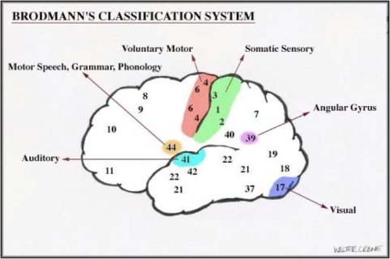
Twenty years of education research tells us that the most effective learning takes place when a student engages the brain's primary cortices- visual, auditory, language production and motor- at the same time.
Further, as students enjoy the experience, their limbic systems become involved. This is the portion of the brain that controls emotional engagement.
As you involve all four learning modes at once, and attach a positive emotional experience, students form deep and lasting anchors/presenters for the information they are acquiring.

Ben Franklin (and an ancient Chinese proverb) said
- Tell me, I'll forget (hearing and listening are not one of the stronger senses in brain and nervous systems)
- Show me, I'll remember (seeing is one of the strongest senses in the central nervous system. [brain])
- Involve me, I'll understand (this would include all of the senses possible....skin, hearing, seeing, feeling, touching, smelling, taste and etc....also involvement means in most cases experiential learning. Which indeed means, Involve me, I'll understand.)
Additionally, learning research indicates that teachers, as a general rule, TALK TOO LONG!
The longer we talk, the more students we lose.
Short term memory for most people is limited to 3 to 7 items. As new information is added to short term memory, recently acquired information is dropped. You can only fill the cup so full and then it overflows/pour out your students have small cups! What we do in Power Instruction is that we focus our lessons into groups of two, three or at most four points. We are teaching to short term memory, a small cup, which quickly fills. Teaching for shorter periods of time and presenting fewer points, takes some practice ... but it is easier than it seems.
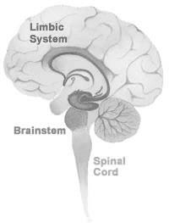
LIMBIC SYSTEM:
Limbic System supports a variety of functions, including emotion, behavior, motivation, long-term memory, and all faction. It appears to be primarily responsible for our emotional life, and has a great deal to do with the formation of memories.

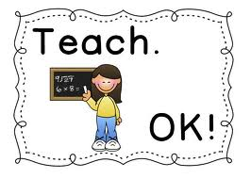
TEACH-OK works like this:
Divide your class into teams of two.
One student is a One, the other member of the team is a Two.
You want students to do a large amount of the teaching.
- Present a small amount of information, complete with gestures.
- When you finish, look at the class and clap two times, say “TEACH!”
- Your students clap twice and respond “OK!”
(Look at our Power Teachers videos for examples of this approach.)Teach your students to copy your gestures (kinesthetic*) and mimic the emotion in your tone of voice (limbic).
- As your students teach each other, move around the room listening to what they are saying. This is an excellent opportunity to monitor student comprehension.
- Then, call them back to attention with the CLASS-YES!
If you are not convinced your students have understood your lesson, repeat it. Otherwise, go on to the next small group of points.

You can either let your students find their own natural way of determining/ defining/ settling who speaks or listens, or provide more structure using "Switch!" described later.

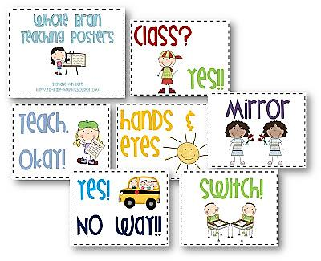
*KINESTHETIC LEARNING (also known as tactile learning) is a learning style in which learning takes place by the student carrying out a physical activity, rather than listening to a lecture or watching a demonstration. People with a preference for kinesthetic learning are also commonly known as "do-ers"

3. Focuser: HANDS AND EYES
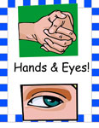
Whenever you want your students to pay close attention to an important point, say, "HANDS AND EYES!"
Your students respond, "HANDS AND EYES!," fold/ bend their hands and stare at you intensely. We have found that this command is also very effective if you have said, "CLASS!" and your kids are not entirely focused on you when they respond, "Yes!" Follow up with "HANDS AND EYES!" and you'll be delighted at the quality of attention you receive.
Amazingly enough, Hands and Eyes works as well with high school students as with kindergartners.
In actual practice, you will use Class-Yes anywhere from 20 to 30 times an hour, especially when you are involved in direct teaching and Hands and Eyes about 5 to 10 times.

"MIRROR MY GESTURES," is also a very useful command. As you teach with gestures, you will know who is engaged in the lesson simply by seeing who is copying your hand motions. A more advanced version is to say,
"MIRROR!" and
your students respond "MIRROR!"
and snap their hands into the air, ready to mimic your gestures.
In the critical thinking Power Teacher video (click on Power Teacher videos), Jay Vanderfin's class does an excellent job of demonstrating this technique.

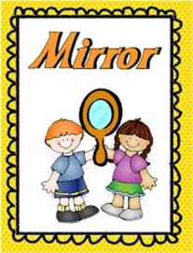
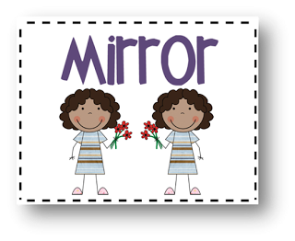
4. MIRROR
Mirror is one of WBT’s simplest and most powerful techniques.
You say “MIRROR” and your students respond “MIRROR.”
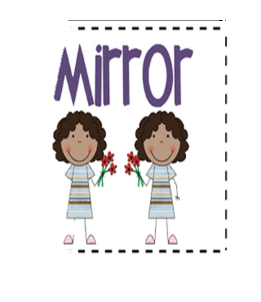
They then pick up their hands ready to mimic your gestures. The gesture for mirror is holding up both hands. As students imitate your motions, their motor cortex, the brain’s most reliable memory area, is automatically engaged.
Use mirror when telling a story, giving directions, describing the steps in a procedure, demonstrating a process ... anytime you want your class locked in to what you are saying.
Mirror allows the kids to repeat your gestures as if they are your mirror as you teach a new concept. You teach a little with gestures, they gesture along with you. One thing to remember- mirrors don't talk!- so the focus is on your motor & visual cortexes (seeing and doing) and linking movement to their learning.
If you do want your kids to repeat words and gestures,
you would say "MIRROR WORDS AND GESTURES" and this time, kids would repeat what you said and your movements. This engages their motor and visual cortex as well as their Broca's and Wernicke's Areas. (doing, seeing, saying and hearing cortexes)
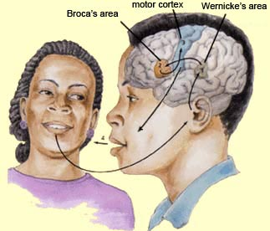

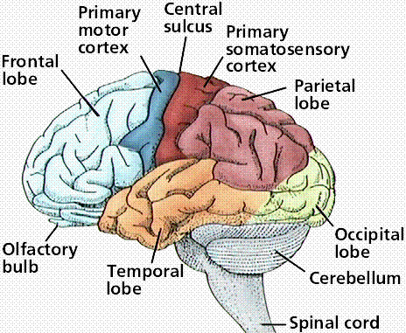

5. SWITCH!
When you are using Teach/Okay you'll notice that you have some students who are chronic talkers and some who are chronic listeners.
We want the talkers to learn to listen and the listeners to come out of their shells and talk! This is where the Switch command comes in handy.
Divide your class so that your top students are paired with your bottom students and your middle students with your middle students (of course, you don't reveal the basis for the pairing to your kids.)
Next, count off your students in ONES and TWOS.
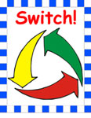
When you are ready for your class to teach each other, explain that you want the ones to teach the twos. When you call out "Switch", they should respond "Switch!" Then the twos will teach the ones. Thus, you are guaranteed that every student in class is equally involved in speaking and listening.

A key feature of this interaction is that both the talkers and the listeners should be using gestures. The talkers illustrate what they are saying with gestures and the listeners, so that they stay focused, silently mirror the talker's gestures.

As students teach each other, walk around the room and either praise or prompt/ encourage/ each group. When both partners are gesturing, praise them. If one or both partners are not gesturing, prompt them by saying, "Please use gestures."
1.
T: Class!
Ss: Yes!
T: Classity-class-class!
2
T: Teach
Ss: OK
3
T: Hands and eyes!
Ss: Hands and eyes!
4.
T: Mirror!
Ss: Mirror!
5.
5. Switch

If you’ve read through all the articles in this menu, “First Steps,” then you’ve learned about Whole Brain Teachings “Big Seven,” our core instructional techniques.

