What is happening when we are doing origami?
Body level: Your hands are made active, they give impulses to your brain, and activate your left and right hemispheres. Tactile, motor and visual brain's zones are made very active.
Soul level: Your emotions are painted with joy, satisfaction, and pride in your own work. They broaden your emotional self-image.
Mind level: Your memory, non-verbal thinking, attention, 3D-comprehension, imagination are working hard.

What ages are good for origami?
Origami is good for any age: from kids, those who start learning all by themselves, to persons of mature years who don't stop developing their own individuality.

For whom is Origami?
For everyone who is able to be surprised, for all who love challenge, for all who want to study something new, for all who love beauty, and for all who like to do something with their hands.

What aspects of applications of origami are there?
Educational, Developmental, Therapeutic

Who can use origami for these aspects?
Educator, Teacher, Psychologist, Physician, Parents

10 Reasons to be involved in Origami

1. Development of fine 'motor skills' of both hands.
2. Development of intellectual abilities.
3. Development of creative abilities.
4. Activation of the Right and Left hemispheres of the brain.
5. Development of imagination.
6. Development of attention.
7. Development of memory.
8. Development of patience.
9. Emotional and aesthetic experiences.
10. Joy, satisfaction and pride in your own work!

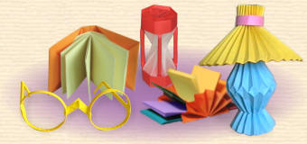

BENEFITS  Did you know that when you practice origami, you are activating your whole brain? It has long been known that origami has many benefits like developing eye hand co-ordination, sequencing skills, attention skills, patience, temporal spatial skills, math reasoning etc. but according to the latest research on the brain and the work of Doctor Katrin Shumakov and Yuri Shumakov, when both hands are engaged, impellent motor impulses activate the language portion of the brain. To read more about this click here. |  |  | 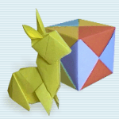
 | Below is a list of just some of the benefits of using origami.
 | * Reading Skills  * Writing Skills  * Processing Skills  * Visual Motor  * Temporal Spatial  * Logical Reasoning  * Attention Skills  * Concentration  * Sequencing | * Math Concepts  * Measurement  * Geometry  * Proportion  * Fractions  * Symmetry  * Problem Solving  * Science Principles  * Ecology | * Creativity  * Oriental Culture  * Independent Study  * Social Skills  * Self Confidence  * Library Skills  * Manual Dexterity  * Speech Language  Development
USEFUL MODELS
Besides being fun to make, many origami models can be useful. You'll find some of them in the "Fun Folds" section and many more in the "Links" if you search diligently.
Uses for origami include:
Boxes
Package decorations
Cups to drink from or hold things
Party decorations
Organizers for paper clips, rubber bands etc.
Wallets and card cases
Flowers
Stationery and envelopes
Hats and Slippers
Toys
And many more!

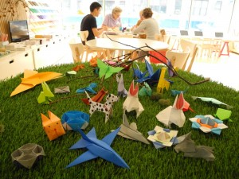
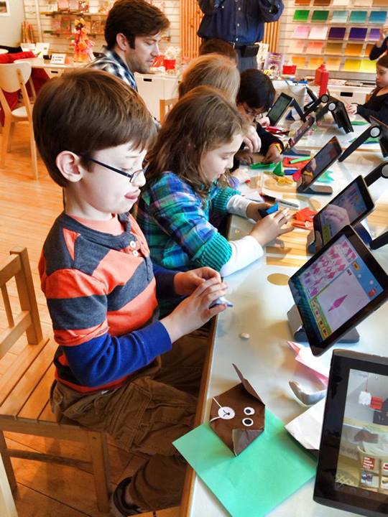

Taro's Origami Studio, Park Slope, Brooklyn NY

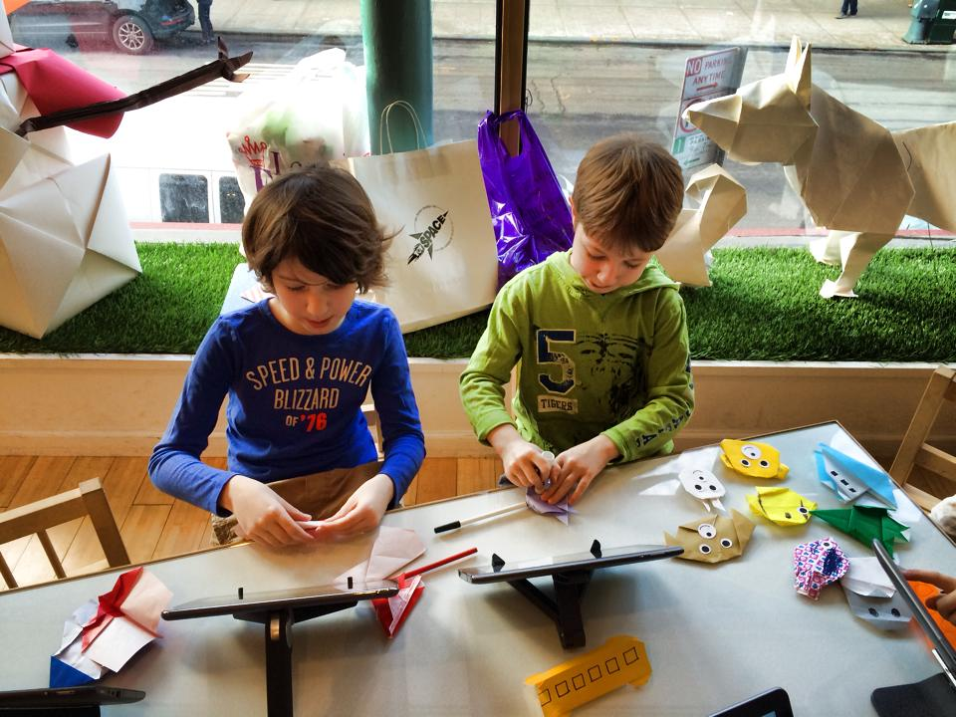

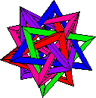
Math teachers have found that they can use origami to develop math lessons in geometry, fractions, andproblem solving. Language Arts teachers have found that they can use origami to introduce units in literature,poetry, and creative writing. Science and social studies teachers are using origami to introduce lessons as well. As you can see, origami has become a very useful teaching tool in education.


