GRAPHIC ORGANISER

What is graphic organiser?

Graphic Organizers connect content in a meaningful way to help students gain a clearer understanding of the material (Fountas & Pinnell, 2001, as cited in Baxendrall, 2003).

A graphic organizer (also known as a concept map, visual maps, mind mapping, visual organizers or relationship chart) is usually a one-page form with blank areas for learners to complete with ideas and information which are connected in some way.

There are a lot of different kinds of graphic organizers for different kinds of subjects. Students can use graphic organizers for their class projects – just pick the kind they want to use.

Through the use of the organizers, students can also make more abstract comparisons, evaluations, and conclusions.

Why is graphic organizer?

Graphic organizers are a helpful way to organize information. They enable teachers to show and explain relationships between content and subcontent and how they in turn relate to other content areas. Graphic organizers are helpful because:
- They help students understand how things go together. Graphic organizers provide the learner with a different way of seeing and thinking about information.
- They help students remember information better.
- They make it easier to write your final draft.
- They help organize any type of subject.
- They have visual displays that they convey complex information in a simple-to-understand manner.

Graphic organizers also provide the learner with a different way of seeing and thinking about information:
- Analytical, critical, planning and creative thinking skills are developed.
- A lot of information can be converted into a structured, easy-to-read, graphic display. A large amount of information can be displayed to provide the "big picture" of a topic.
- Changes can easily be made to allow learners to take different perspectives and clarify their thoughts. Organisers are easy to edit, revise, and add to.

In short, graphic organizers allow students an active role in their learning.

When do I use a graphic organizer?

A graphic organizer can be used at any time during the learning process. You can use graphic organizers at the beginning of a task to help students plan their learning or they can be used to support a student at any point in her or his learning process.

Strategies to Teach Graphic Organizers

- Outlining the lesson
- Previewing
- Modeling with a think aloud
- Guided practice
- Independent practice
- Check for understanding

Types of Graphic Organizers

Graphic organizers can be classified either in terms of their design or their function. Functionally, graphic organizers can be grouped into two categories: those that depict basic information structures (whole-to-part, cause/effect, etc.) and those that serve specialized needs (project planning, goal setting). Some more common graphic organizers include:

- Cause and Effect,
- Classifying
- Clock,
- Cluster/Word Web,
- Comparing and contrasting
- Decision making
- Describing
- Describing Wheel,
- E-Chart,
- Fact and Opinion,
- Five W's Chart,
- Flow Chart,
- Four-Column Chart,
- Goal-Reasons Web,
- Hierarchy chart,
- Idea Wheel,
- KWL/KWHL Chart,
- Ladder,
- Observation Chart,
- Persuasion Map,
- Planning Chart,
- Progress Report,
- Sequence Chart,
- Sequencing
- Spider Map,
- Step-by-Step Chart,
- Story Map,
- T-Chart,
- Time Line,
- Tree Chart,
- Venn Diagram.

Graphic Organizer Samples:

Classified Graphic Organizer

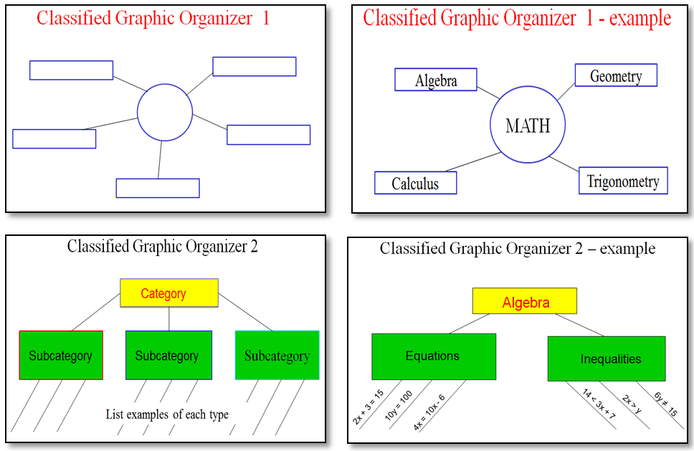

Venn Diagram

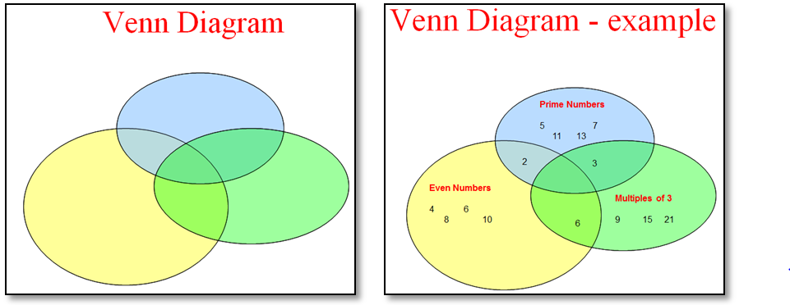

Compare and Contrast Graphic Organizer

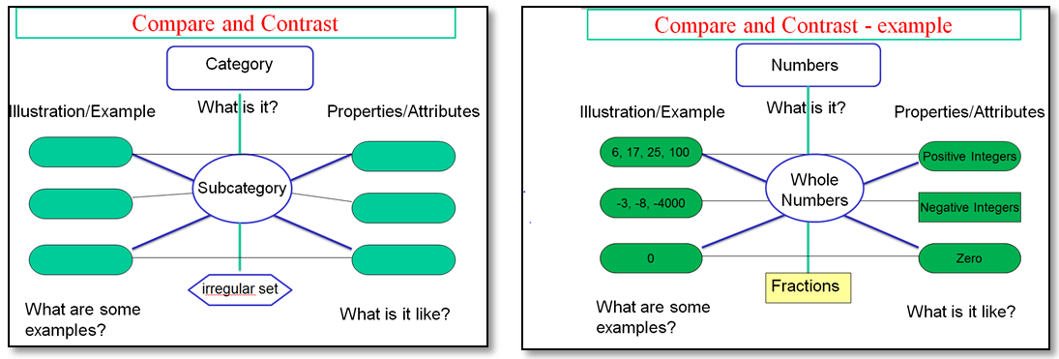

Multiple Meaning Graphic Organizer

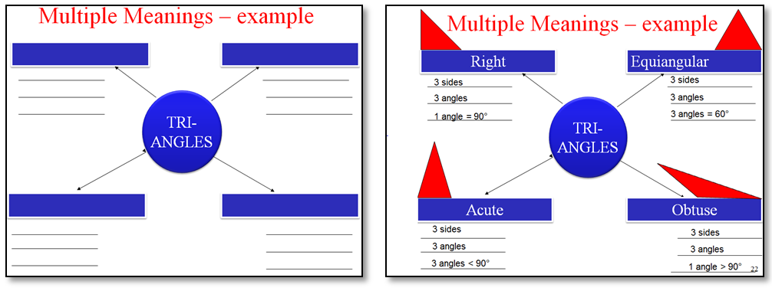

Four-Square Graphic Organizer

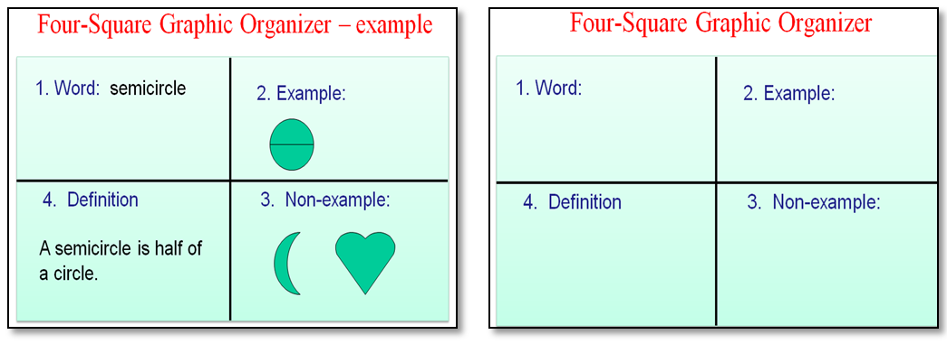

Main Idea and Supporting Detail
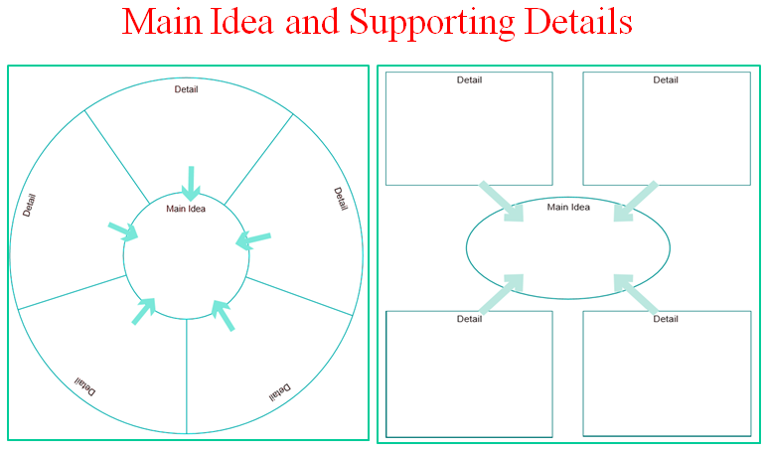

Most of the graphic organizers can be used to support topics from any subject.

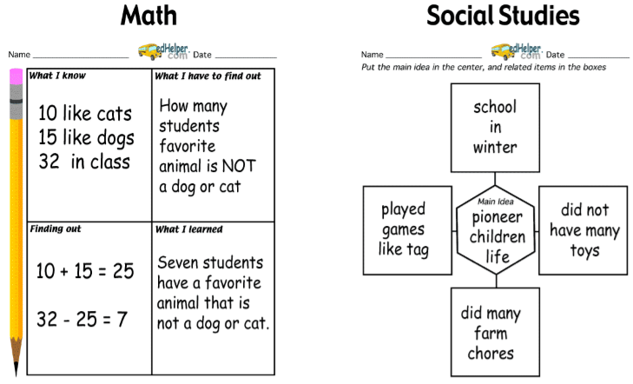

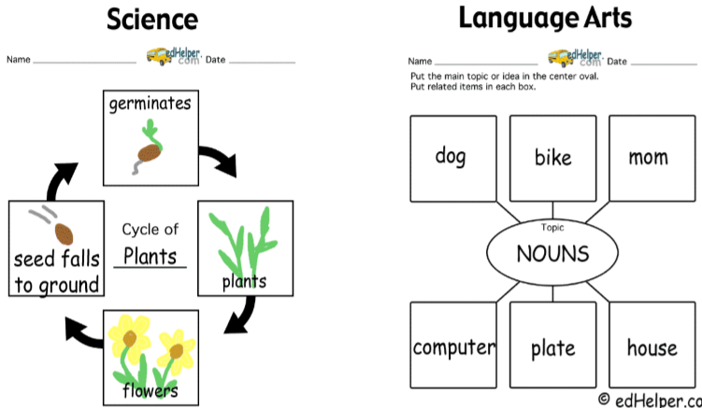

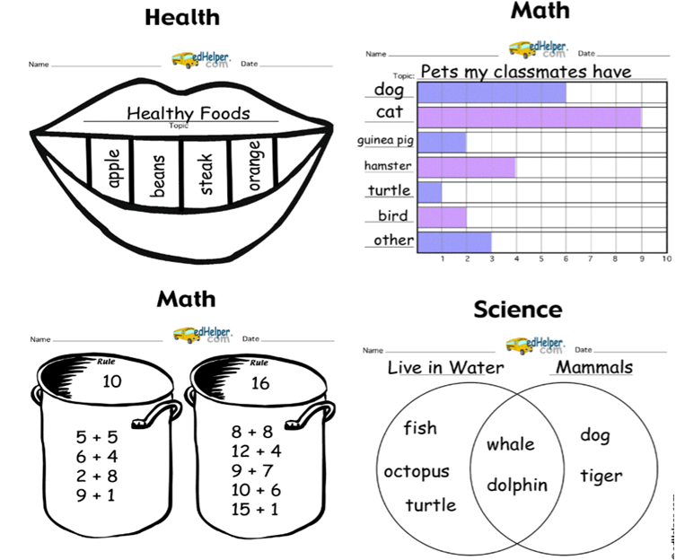

More Examples:

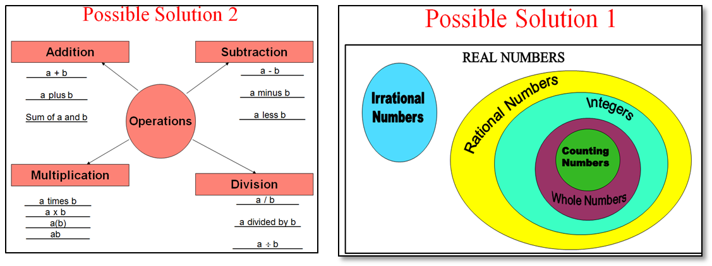

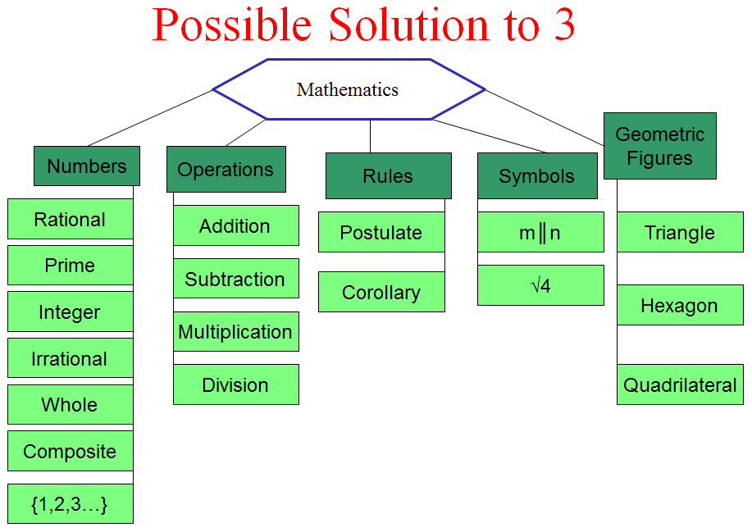

Source:

- Maccini, P., & Gagnon, J. C. (2005). Math graphic organizers for students with disabilities. Washington, DC: The Access Center: Improving Outcomes for all Students K-8. Available at

http://www.k8accescenter.org/training_resources/documents/MathGraphicOrg.pdf
- Eduplace: http://www.eduplace.com/graphicorganizer
- EdHelper: http://edhelper.com/teachers/graphic_organizers.htm
- Education Oasis: http://www.educationoasis.com/curriculum/graphic_organizers.htm
- Freeology: http://freeology.com/graphicorgs/
- Graphic.org: http://www.graphic.org/goindex.html
- Region 15: http://www.region15.org/curriculum/graphicorg.html
- Webenglishteacher: http://www.webenglishteacher.com/graphic.html
- Tap: http://eduscapes.com/tap/topic73.htm

