
k
World newspaper
Newspaper Editor: Zeynep BOLAT Date:27.10.2013 No: 1
A SERIES TO REMEMBER_

THE PERSON OF İNTEREST
This series is our favorite in dormitory. We usually watch this series together every evening. There are different events in each part. I am writing interesting sentences from The Person Of Interest for you.
“You’re being watched.”
“The government has a secret system.”
“I know because, I built it.” You’ll never find us.”
“But victim or perpetrator if you’re Number’s up, we’ll find you“
Aren’t they interesting?

BIOLOGICAL LIFE
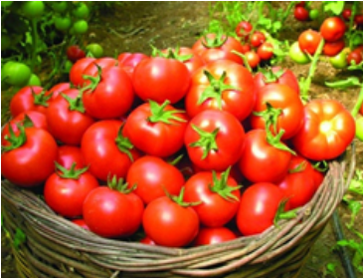
The tomatoes which are grown up by journalist ibrahim Yüksel was very interesting for the other people. They did this project last year. In this picture the tomato’s weight is exactly 1 kg.

CORNER of INTERESTING THINGS

Some people forget elevator in the skyscrapers
in Spain. This project is the biggest project of Europe. The project is called IN TEMPO TOWERS


