

MOST GOOD NEWSPAPER

Newspaper Editor : KEMAL ÖZDEMİR
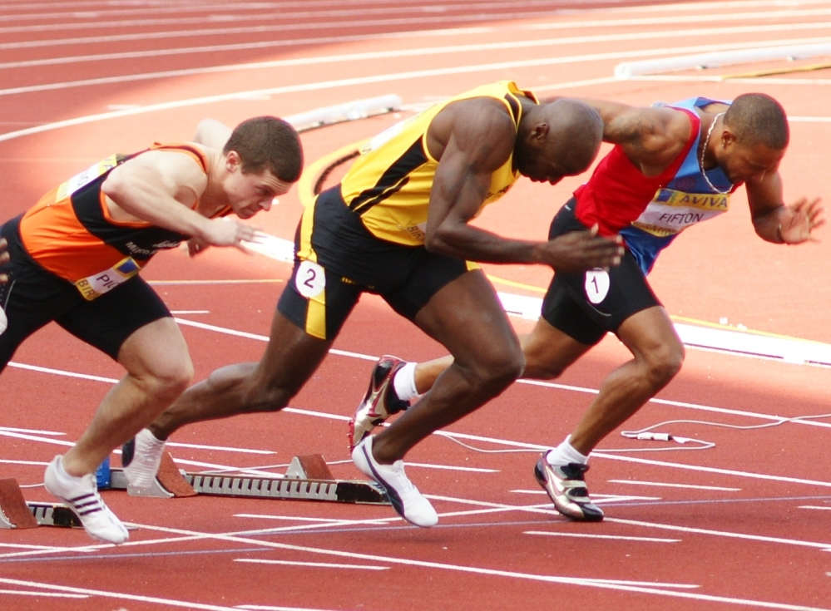
Date : 22/10/2013 No: 1
ATHLETICIS, 100 METERS
1OO Meters world run most short. Athlete men run 100 meters innate very more to whit muscle (quick muscle). Good a athletic, 100 meters 10:00 second runs. But he must work a lot . He lifts weight and does must speed test everyday.100 meters 19. Century most running 10:14 second it is now 9.70 running. Is record 9.58 he is Usain bolt.

My Roommate: Ilker Mengucek
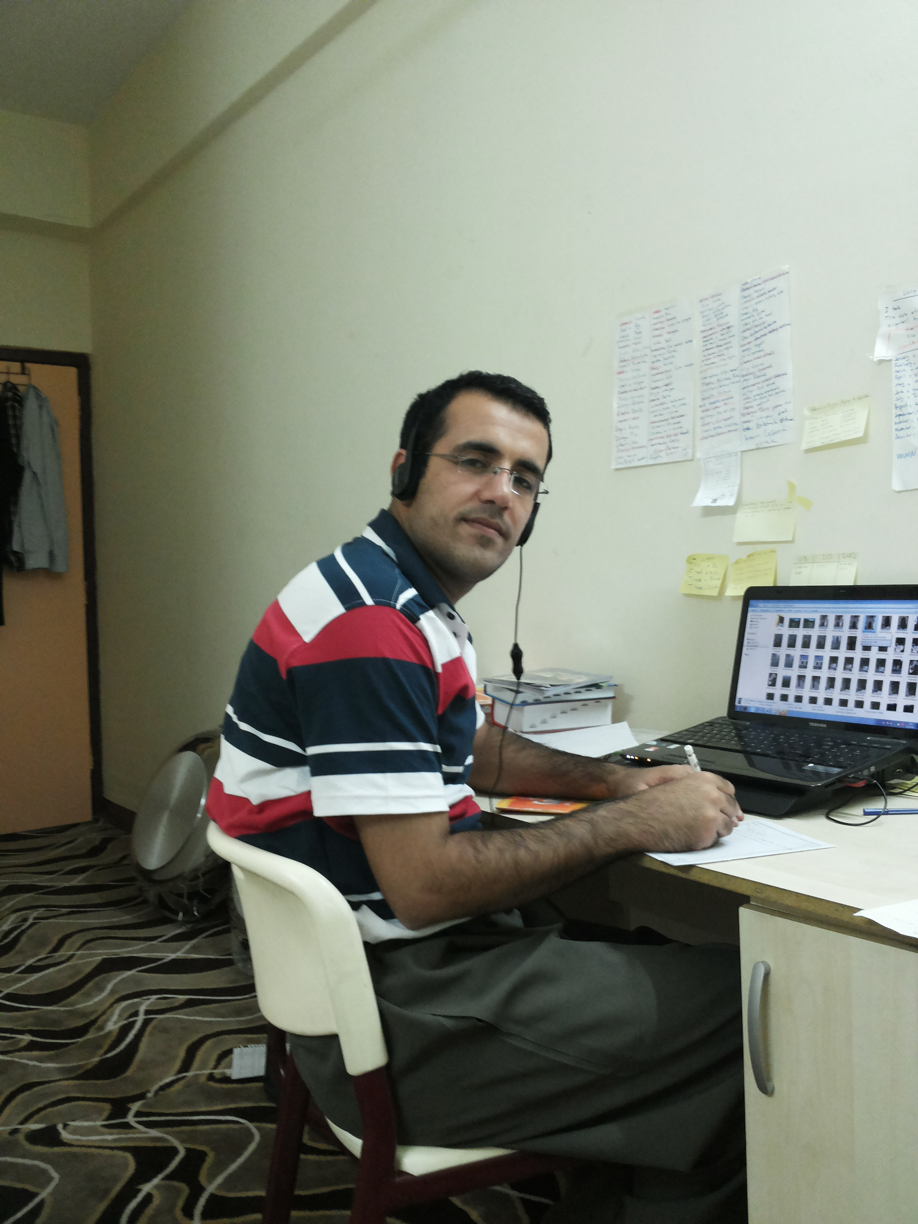
My my roommate is name Ilker Mengucek. He was born in Kars. He graduated from Van University. Ilker studied mathematics. He is in Iraq, in Erbil now. He is learning English. Ilker is very optimistic. He is kind.
by : Ozdemir Kemal

He is tall. Ilker is very funny and he likes making jokes. He is a very well-behaved person. I am very lucky having such a friend.

