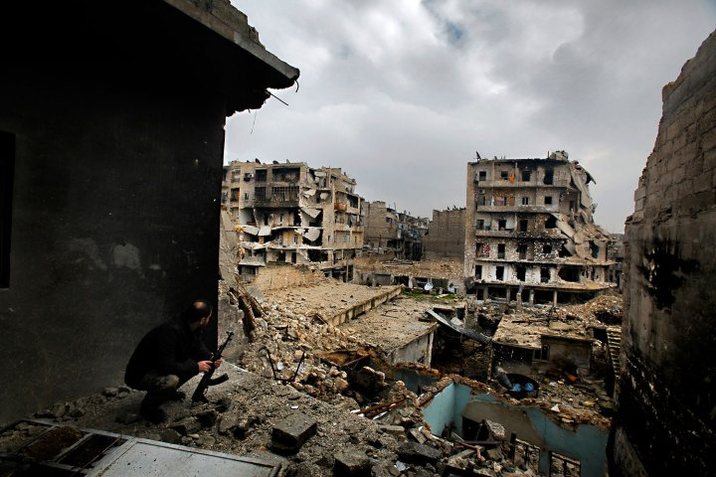
Written by: [Murat Kaymaz] October - 1
Written by: [Murat Kaymaz]
SYRIA’S WAR

TODAYS LEARN

The Syrian civil war, also known as the Syrian uprising^{[64]} or Syrian crisis (Arabic: الأزمة السورية‎),^{[65]} is an ongoing armed conflict in Syria between forces loyal to the Ba'ath government and those seeking to oust it. The unrest began on 15 March 2011, with popular demonstrations that grew nationwide by April 2011. These demonstrations were part of the wider Middle Eastern protest movement known as the Arab Spring. Protesters demanded the resignation ofPresident Bashar al-Assad, whose family has held the presidency in Syria since 1971, as well as the end of Ba'ath Party rule, which began in 1963.
In April 2011, the Syrian Army was deployed to quell the uprising, and soldiers fired on demonstrators across the country.^{[66]} After months of military sieges,^{[67]} the protests evolved into an armed rebellion. Opposition forces, mainly composed of defected soldiers and civilian volunteers, resisted without central leadership.^{[68]} The conflict isasymmetrical, with clashes taking place in many towns and cities across the country.^{[69]} Late 2011 marked growing influence of the Islamist group al-Nusra Front within the opposition forces. In 2013 Hezbollah entered the war in support of the Syrian army.^{[70][71]} The Syrian government is further upheld by military support from Russia and Iran, while Qatar and Saudi Arabia transfer weapons to the rebels.^{[72]} By July 2013, the Syrian government controls approximately 30–40 percent of the country's territory and 60 percent of the Syrian population.^{[73]} A late 2012 UN report described the conflict as "overtly sectarian in nature"^{[74]} between Alawite shabiha militias and other Shia groups fighting largely against Sunni-dominated rebel groups,^{[75]} though both opposition and government forces denied that.^{[76][77]}
According to the United Nations, the death toll surpassed 100,000 in June 2013, and reached 120,000 by September 2013.^{[46][78]}
In addition, tens of thousands of protesters have been imprisoned and there are reports of widespread torture and terror in state prisons.^{[79]} International organizations have accused both government and opposition forces of severe human rights violations.^{[80]} The UN and Amnesty International's inspections and probes in Syria determined both in 2012 and 2013 that the vast majority of abuses are done by the Syrian government, whose are also largest in scale.^{[81][82][83][84][85]}
Chemical weapons have also been used in Syria on more than one occasion, triggering strong international reactions.^{[86]}

