MY NEWSPAPER
Newspaper Editor _________________________________ Date: _________________________________ No: 1

A Famous School in Erbil
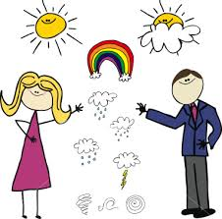
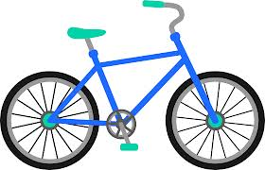
Gulan Primary School is a very famous school in Erbil. It has got a lot of students and classrooms. There are many teachers, too. Students are very friendly in this school. They can speak English, Kurdish, Turkish and Arabic.
Gulan Primary School is the best in Erbil.

The Weather in Erbil A Wonderful Bike!
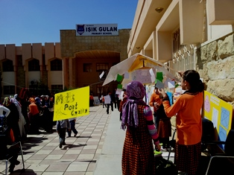

In Erbil it is very hot in Summer. You can wear you hats. In Autumn it is sometimes windy. When it is windy, you can fly your kite. In winter it isn’t very cold.

This bike is green and blue. It’s got one seat. It’s a good bike for children aged 8-9. You can ride it at the beach. This bike is very fast and fun.

QUOTE of the MONTH
If you can HEAR
If you can SEE
IF you can TALK
I you can WALK
Thanks Allah

