BUILD A HAND CRANK WINCH SIMPLE MACHINE STEM IDEA
March 30, 2016 by littlebins 1 Comment
3.4k
Shares
http://littlebinsforlittlehands.com/build-a-winch-simple-machine-recycled-stem-activity/

If you are like me, then you have a big container of recycled materials and cool items you can’t bear to get rid of! Thats exactly how we built this winch simple machine.Using recycled items for STEM activities is an awesome way to re-use and re-purpose common items you would normally recycle or throw away. Saving these items is a great way to do STEM on a budget!

BUILD A WINCH SIMPLE MACHINE STEM IDEA
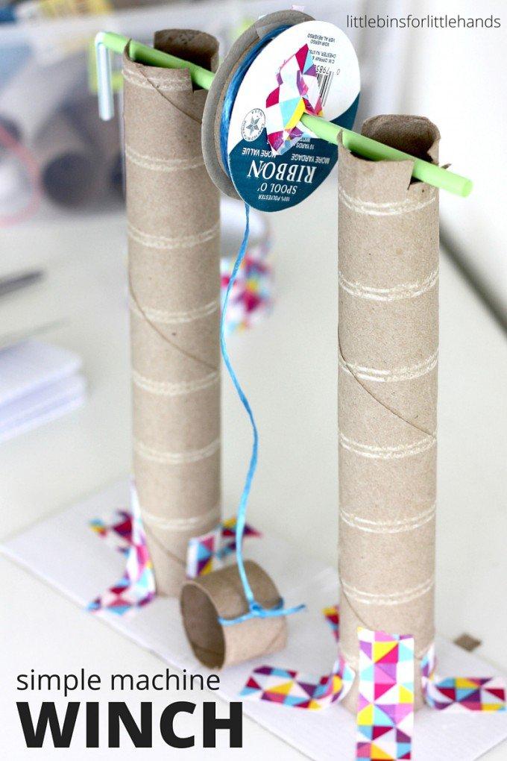
Building simple machines with kids is a great way to show them how stuff works! Our winch simple machine building activity is truly an easy STEM activity with big impact. Using recycled items to make cool things allows awesome STEM challenges to be accessible to ALL kids! Plus any activity that uses recycled materials is great for the environment!

SUPPLIES FOR BUILDING A WINCH SIMPLE MACHINE ACTIVITY
Cardboard Tubes
Spool {can be optional, see below}
Straw or Pencil
String
Tape, Scissors
Small Basket {object to attach to string}
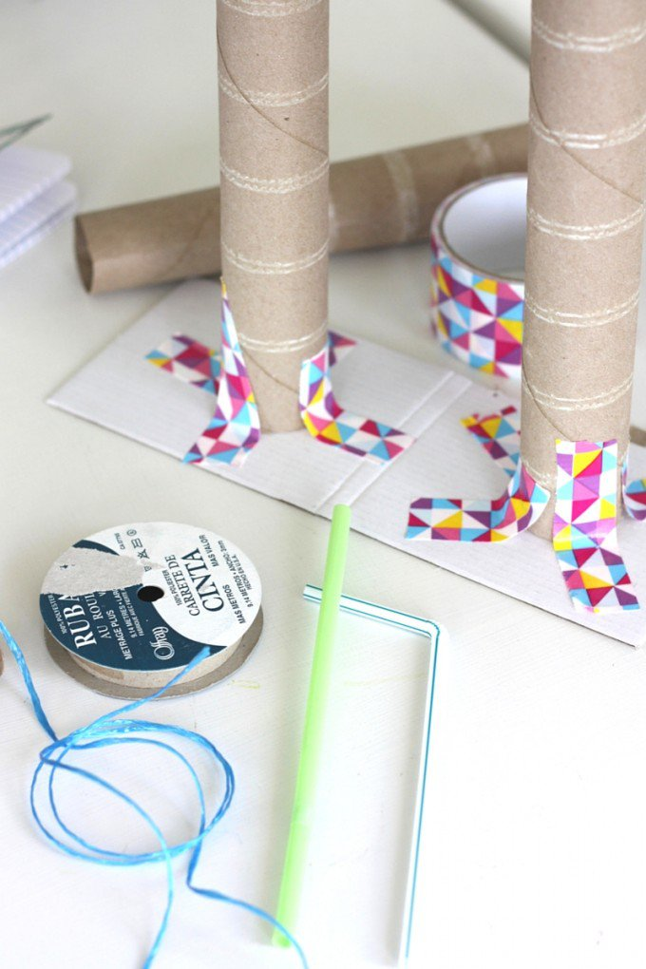

HOW TO BUILD YOUR WINCH SIMPLE MACHINE ACTIVITY
Here’s the picture diagram of the four major steps to building this winch simple machine. I will describe the steps below the picture. Make sure to check out our STEM on a budget to check out all our favorite STEM materials!
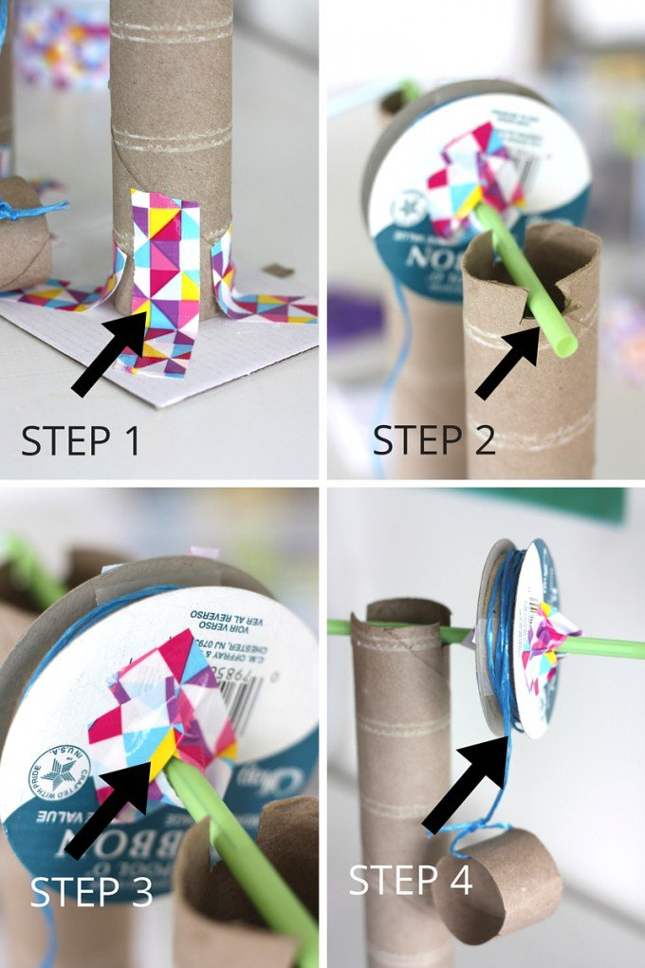
STEP 1
Tape 2 cardboard tubes to a solid surface. Use your straw as a reference tool for how far apart they should be placed from each other.
STEP 2
Make 2 cuts at the top of each cardboard tube just big enough of the straw or pencil to rest and be able to spin.
STEP 3
Put your spool on the straw or pencil. Now if you don’t have a spool, you can simply secure your rope to the straw or pencil with a piece of tape. You still have a hand crank winch! If you do use a spool make sure to secure it with tape to the straw or pencil. What if you don’t secure it? The spool just spins around the straw and their is no ending up of string! We learned this concept with our rubber band car too!
If you are using a straw, you can even thread another straw into it and use the bendy part to make a handle!
STEP 4
Secure your rope or string to spool with a piece of tape {or to straw directly if you don’t have a spool} and tie your basket or object to the bottom of the string.
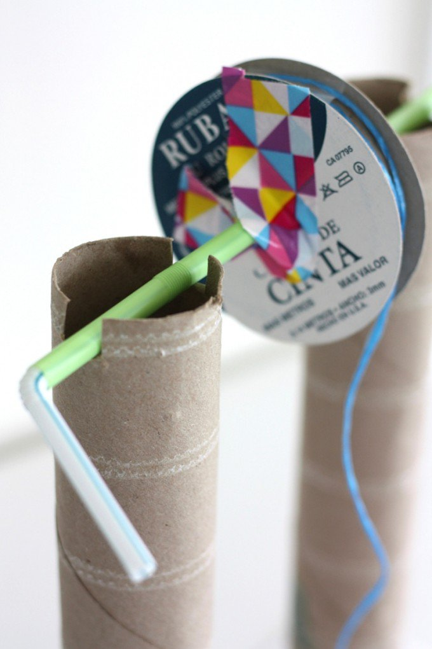
Go ahead and test out your hand crank winch simple machine. What can you pull up with it? Do you think it makes lifting heavy things easier. Another great idea is test out a pulley simple machine!
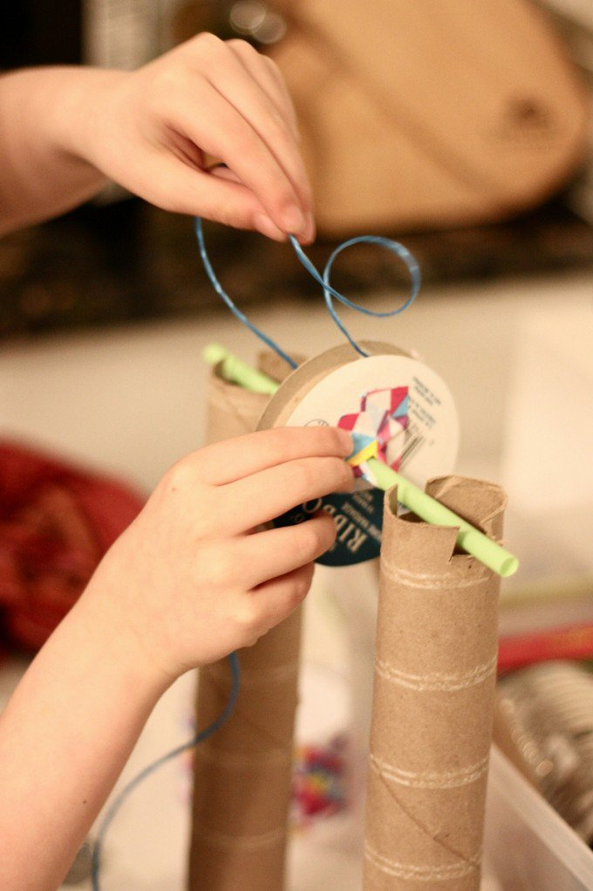
A simple machine such as this winch is used to raise and lower weight. An example of a winch that is pretty easy to get a picture of is a bucket in a well!

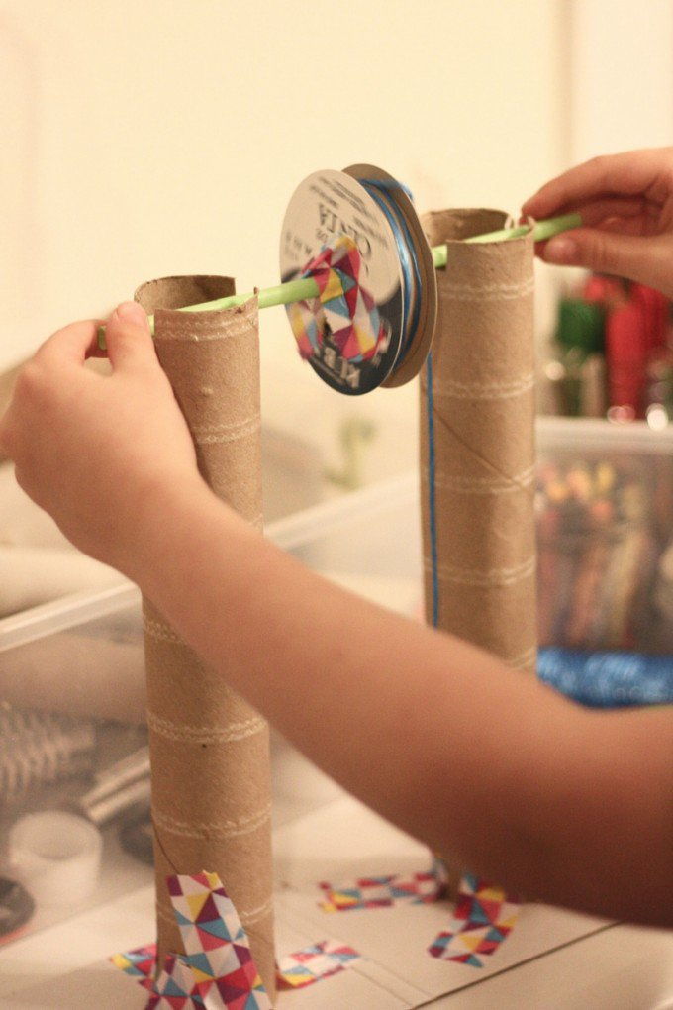
He chose to sketch his simple machine all on his own.
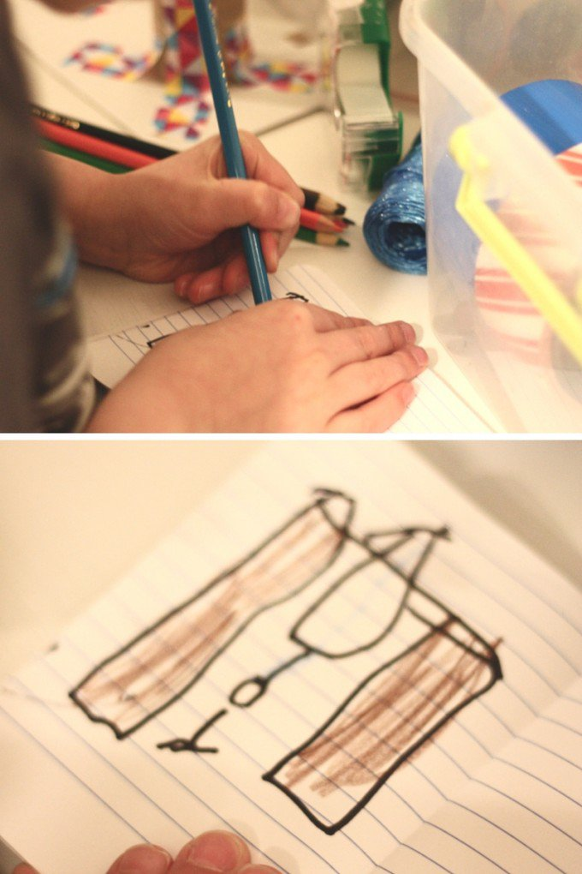
Building simple machines with kids is tons of fun and gives them a great chance to trouble shoot problems and come up with creative solutions. Raid the recycling bin to make your simple machines this year. Building machines makes an awesome STEM challenge for a variety of age groups too.

BUILD
http://littlebinsforlittlehands.com/build-a-winch-simple-machine-recycled-stem-activity/

