
THE SPORT NEWSPAPER____
Editor: Ercan Fırat 22. October 2013
EMRE’s FOOTBALL CAREER
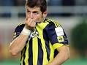
His full name is Emre Belözoğlu. He is a football player. Emre was born in İstanbul on 7 September 1980. His father name is Mehmet and his mother name is Fatma. Emre is playing football in Fenerbahce sport club now. He starts playing football at Zeytinburnuspor. Emre plays football from 1992 to 1995 at Zeytinburnuspor. He pays attentions Galatasaray sport club. He was transfered to Galatasaray in 1995. He plays good football very well. He had a lot of champions at Galatasaray. Because of this, Galatasaray’s fans like Emre. He stays at Galatasaray from 1996 to 2001.

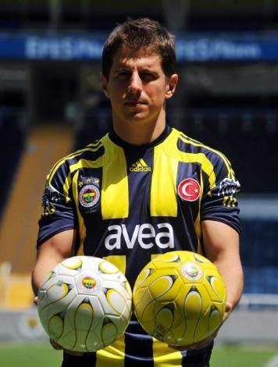
After that famous clubs want to transfer him and Emre transfers to internazionel Milan in 2001. He becomes successful at inter. But Emre injures a lot of times. Because of this, he leaves from Inter. After 4 years later he was transfered to Newcastle United. He played football 3 years in Newcastle united. Emre comes back to turkey at 2008. And be comes player Fenerbahce. First year plays a little at Fenerbahce. But after that very good plays football at Fenerbahce. Emre plays 4 years in Fenerbahce. Than transfers to Atletico Madrid. He stays half season in Atletico Madrid. He comes back to Fenerbahce again. And he is playing football in Fenerbahce now.

