The Camping Trip

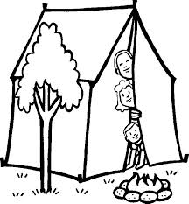
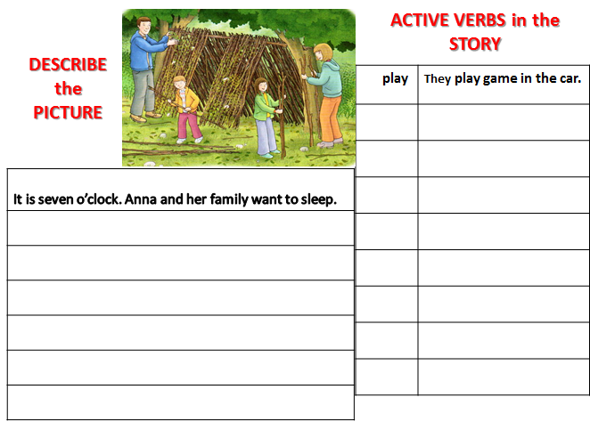
Name: _____________________________ Class: ____________________________________ Date________________

