2. LISTING and ADDING POINTS

TIME ORDER WORDS
First, Second, Third, Next, Then, Finally,

First, SeconD, Third, FINALLY

1. Owning a car has some advantages. First, it gives you comfort. Second, it saves you a lot of time. Third, it gives you great freedom of movement.
2. Becoming the prime minister of Turkey, first, you need to become a leader of a political party. Second, you need to win a seat in the parliament. Third, your party must have a majority of seats. Finally, after all these steps, you can call yourself the prime minister.
3. First of all, pour a half-cup of milk in the bowl; second, add two eggs; and third, stir the mixture.

Your sentence: ………………………………………………………………………………………………….…………………………………………………………………………………………………

PRACTICE 1: Put the sentence in order.

- Finally, Canada's cities are clean and effectively managed. Canadian cities have many parks and lots of space for people to live.
- First, Canada has an excellent health care system.
- Second, Canada has a high standard of education.
- There are three reasons why Canada is one of the best countries in the world.
- All Canadians have right of entry to medical services at a reasonable price.
- As a result, Canada is a attractive place to live.
- Students are taught by well-trained teachers and are encouraged to continue studying at university.

…………………………………………………………………………………………………………………………………….………………………………………………………………………………………………

…………………………………………………………………………………………………………………………………….………………………………………………………………………………………………

…………………………………………………………………………………………………………………………………….………………………………………………………………………………………………

…………………………………………………………………………………………………………………………………….………………………………………………………………………………………………

…………………………………………………………………………………………………………………………………….………………………………………………………………………………………………

…………………………………………………………………………………………………………………………………….………………………………………………………………………………………………

…………………………………………………………………………………………………………………………………….………………………………………………………………………………………………
PRACTICE 2: Fill in the blanks with suitable transitional signals.

SECOND, AS A RESULT, FIRST, THIRD, MOREOVER, FURTHERMORE

There are many reasons why people all over the world enjoy watching movies. ……………………, they offer an escape. For that reason, some people go to the movies to see how others live. ……………………, movies provide entertainment. Because, they are fun to watch and let you imagine. ……………………, movies are available everywhere. ……………………watching movie is one of the important activities of people.

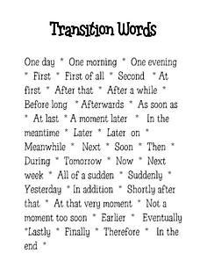
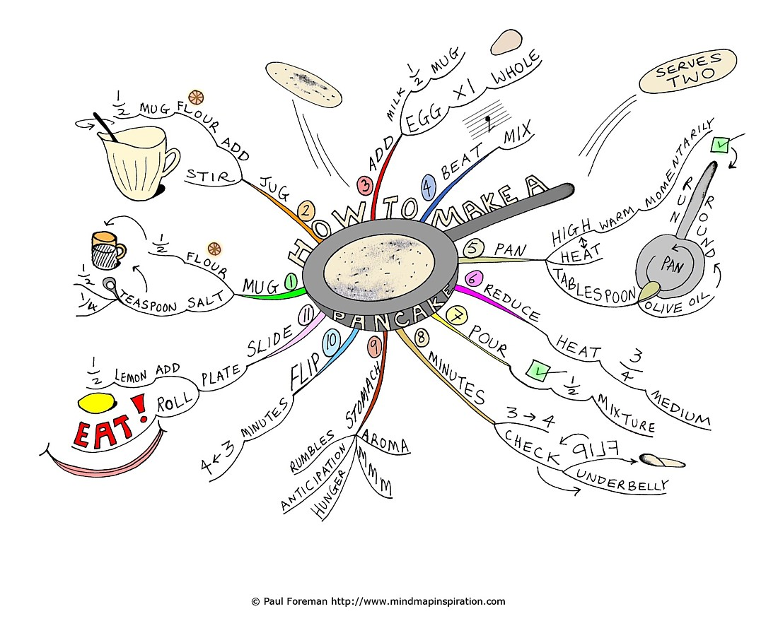

A MODEL READING and WRITING PARAGRAPH ACTIVITY
Read Anna’s letter and draw circle around all of the time order words and phrases you find. Notice that almost every paragraph begins with a time order expression, and some paragraphs have time order expressions within them.

A Traditional American Wedding June 17, 2005

Dear Charo,
Last weekend, I had the most wonderful experience! I attended the wedding of two of my friends from college. The bride* was Jennifer Mason, and the groom* was Scott Dixon. They became engaged last year, but they wanted to wait until they had both graduated from college before getting married. Anyway, I thought you would like to hear about a traditional* American wedding and what happens on the wedding day.
First, the guests arrive at the church. The ushers* meet them at the door and I help them find seats. Friends and family of the bride always sit on the left side of the church, and friends and family of the groom always sit on the right. The parents of the couple always sit in the front.
Next, the groom and his best man* enter the church and stand in front. Then, a musician begins to play the "Wedding March," and the bridesmaids* begin to march slowly down the aisle* from the back toward the front of the church. Finally, the bride appears and walks down the aisle beside her father. The bride usually wears a white wedding dress and veil, and she always carries a bouquet of flowers in her hands.
Now, everyone is at the front of the church, so the marriage ceremony can begin. During the ceremony, the groom always gives the bride a wedding ring, and the bride sometimes gives the groom one, too. At last, the religious official says, “I now pronounce you husband and wife,"* and the couple is now married. The bride and groom kiss and then leave the church arm in arm. The guests throw rice over the couple outside the church as they leave.
The last big event is the wedding reception. This is a big party after the ceremony. Everyone brings or sends a gift, so the young couple often doesn't need to buy a lot of things for their house or apartment. The wedding reception may be a dinner, or it may be an afternoon party with only snacks*. Champagne is usually served, and everyone eats, drinks, and dances for many hours. The bride throws her flowers to the unmarried girls before she and her husband leave the reception. According to tradition, the girl who catches the flowers will be the next one to get married.
I hope you have enjoyed my story about a traditional American wedding. Of course, not everyone in the U.S. has a big wedding like this one. It is very expensive, and not everyone can afford it.
Write soon. I am eager to hear about your vacation.
Love, Anna
bride: woman who is getting married best man: man who helps the groom
groom: man who is getting married bridesmaid: woman who helps the bride
traditional: refers to a custom or practice aisle: path between rows of seats handed down from the past
usher: person who helps guests find their seats at a church or theater
“I now pronounce you husband and wife,": I say officially that you are now married.
Snack: something eaten between meals Specific: certain.
Now write your country’s traditional wedding ceremony

PROCESS ESSAY - PRACTICE:
1. The following sets of sentences are not in correct time order. Number the sentences in the correct order.
2. Write the sentences from the preceding exercise as single paragraphs. Try to make your paragraphs flow smoothly by using these three techniques:

(A) Add time order words or phrases at the beginning of some of the sentences to show chro nological order.
(B) Combine some of the sentences to form simple sentences with compound verbs.
(C) Change nouns to pronouns where possible.

Example:
___ She put the clean dishes away.
___She removed the dirty dishes from the table.
___She turned on the dishwasher.
___She put them in the dishwasher.
___She piled* them in the sink and rinsed* them.
___ It was Sarah's turn to wash the dishes last night.
___ Finally, the dishes were clean.

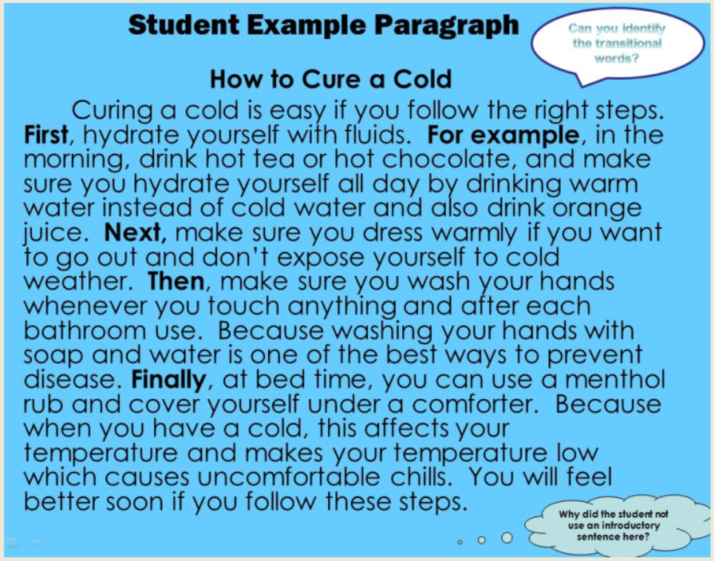

HOW TO PEEL AND CORE AN APPLE
Baking an apple pie or making applesauce? Here’s the easiest way to peel and core an apple without resorting to fancy gadgets.
WHAT YOU NEED
•apples
Y-shaped peeler
chef’s knife
cutting board
1.Choose the right apple variety for your recipe. There are dozens available, but some of our favorites include: Mutsu, for baking in apple pies; Rome and Macintosh for baking or making applesauce; Macoun for slicing raw into salads; Pink Lady, for snacking. See our best apple recipes.
2.Once you’ve selected your apple, use a Y-shaped peeler and swipe across the top and bottom of the apple to remove the peel.
3.Starting from the top of the apple and ending at the bottom, remove the peel in strips, working your way around the apple.
4.After the apple is fully peeled, stand the fruit upright on the cutting board and slice off one side, as close to the core as possible.
5.Set the apple flat-side down on the board and cut off another side, as close to the core as possible. Repeat with the remaining 2 sides.
6.Discard the core and slice or dice the apple as needed.
It was Sarah's turn to wash the dishes last night. First of all, she removed the dirty dishes from the table. Next, Second, she piled them in the sink and rinsed them. After she put them in the dishwasher and turned it on. Finally, the dishes were clean, so she put them away.

piled: put several things on top of each other rinsed: washed in clean

PRACTICE 1
……He filled it out and left.
……He went to the bookshelf, but the book wasn't there.
……Tom went to the library.
……He went to the card catalog.
……The librarian told him to fill out a reserve slip.*
……He told the librarian he wanted to reserve that book.
……He wrote down the title and call number* of the book.
________________________________________________________________________________________________
________________________________________________________________________________________________
________________________________________________________________________________________________
________________________________________________________________________________________________
________________________________________________________________________________________________
________________________________________________________________________________________________
PRACTICE 2
……They chose a dining table and six chairs.
……Mr. and Mrs. Smith went shopping today.
……He gave it to the salesperson.
……They took the escalator* down to the furniture department.
……Mr. Smith took his credit card out of his wallet.
……The salesperson wrote up a bill of sale.
________________________________________________________________________________________________
________________________________________________________________________________________________
________________________________________________________________________________________________
________________________________________________________________________________________________
________________________________________________________________________________________________
reserve slip: piece of paper used to reserve a library book call number: identifying number of a library book escalator: moving stair

DIGESTION
Process

A PROCESS of DIGESTION
Maintain: keep, continue
Esophagus: throat
Intestine: guts, insides
Absorption:
The digestive process is important in maintaining the lives of living organisms and in providing them with needed energy. Groups of organs, such as the mouth, esophagus, stomach, and intestines, work together to perform this complex task. Digestion is the process of breaking down food from large molecules into small ones to make it easier for absorption. The three major steps involved in the digestive process are ingestion, digestion, and absorption.

Ingestion, which occurs in the mouth, is the first step of the digestive process. After food enters the mouth, the teeth chew it. Saliva, which is produced by the salivary glands, plays a major role in breaking down the food into smaller pieces. These small pieces travel to the stomach through the esophagus.

In the stomach, the second step of the digestive process begins. When the chewed food reaches the bottom of the esophagus, a valve lets the food enter the stomach. Contraction of the stomach wall mixes the food. Acidic gastric juices, which are secreted by the gastric glands in the stomach, help in mixing the food and in turning it into a partial liquid so it will have the ability to move into the small intestine. In the small intestine, enzymes are secreted, and digestion is completed.

The last step in the digestive process is absorption. Absorption takes place in the small intestine. The wall of the small intestine is lined with small, finger like projections called villi. Small molecules of food are absorbed by the huge number of vile. Some of these absorbed molecules enter the bloodstream to be distributed throughout the whole body.

In conclusion, the digestive process involves three major steps: ingestion, digestion, and absorption. Ingestion, which occurs in the mouth, helps to increase the surface are of the food particles and prepares them for digestion. In the stomach, digestion begins, and it continues until it reaches the small intestine, where absorption takes place. The digestive process maintains organisms' lives by providing them with energy needed for different functions.

Making potato salad
Process

Making potato salad
USEFUL EXPRESSIONS
- make potato salad
- need to be sure
- peel of the skin
- It is need to be cooked..
- Cut the onion into tiny pieces.
- Set the pieces aside.
- Cut smth into small square pieces
- Taste little a bit salty..

How do you make potato salad? Some people make potato salad by learning from each other or by looking at a recipe in the cookbook. However, when I learned how to make potato salad from my oldest sister, I was really happy because potato salad is my favorite food. So now, whenever I want to eat potato salad, I do not need to tell somebody to make it for me. I have my own recipe that if you follow my steps you can make a wonderful pal….
Making potato salad is easy when you follow these steps.

First, I have to buy all the ingredients: eggs, potatoes, onions, mayonnaise, salt, and black pepper. I need to be sure that I get those eggs that are just new, and the fresh potatoes (with the red skins) because once (When) I cook the potatoes, I peel off the skins and the whole potatoes will not fall apart. It’s the same with the onions-- I need to look for the fresh ones.

Second, I have to put the potatoes and the eggs in separate pots and boil them. The potatoes need to be cooked for 20 minutes or more, and the eggs need to be cooked for only 10 minutes. While the potatoes and the eggs are still cooking, I have to cut the onion into tiny pieces and set it aside.

Third, when the eggs and potatoes are finished cooking, I have to peel them and put them in a different bowl. When all the ingredients are all set on the table, I can start the next step: cutting the potatoes and eggs into small square pieces and mixing them together. In addition, I put in as much mayonnaise as I want and mix them together until it looks like how potato salad should be. I also put in some salt and black pepper on it to taste little a bit salty. Finally, when every thing is complete, it is ready to serve.

In conclusion, by following all my steps you will become a good salad maker. In addition, if a person is willing to spend her/his time with someone who teaches cooking, he/ she will not spend more money to pay for the same thing from a restaurant.
By Dally J Billy- http://www.comfsm.fm

How to make a cup of coffee with nescafe?

Best Answer: A little less than one tea spoon should be enough for an average sized cup. You can add upto one tea spoon or more if you want a stronger coffee.
About 3-4 spoons of milk. More if you want it lighter and creamier.Be careful with the hot water and milk.
Put the coffee in the cup and add 3-4 spoon of hot water and dissolve the coffee well. Then add some more water and the milk. Add milk in spoons till you get the colour you want. Then add sugar ( 1.5 teaspoons or less ).
Pour the water/milk slowly to get a frothy coffee cup.

