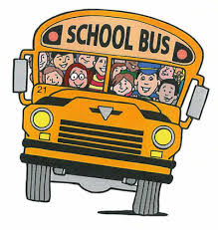

SCHOOLTHINGS 3
Write name of the objects.
 | 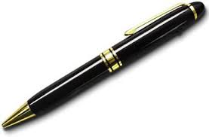 | 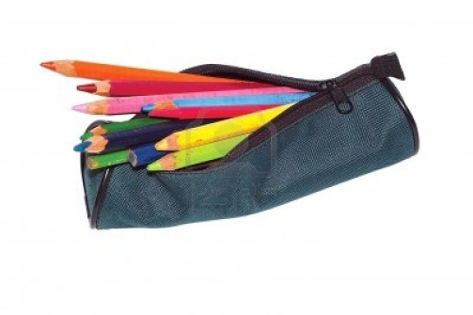 | 
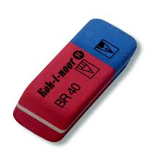 |  | 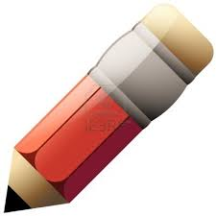 | 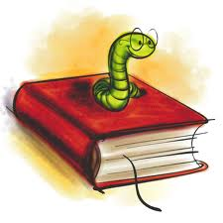

SCHOOL THINGS 4


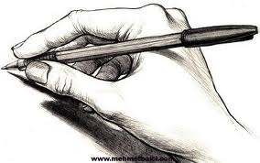


Describe the pictures.
__________________________________________________________________________________________________
__________________________________________________________________________________________________
__________________________________________________________________________________________________
__________________________________________________________________________________________________
__________________________________________________________________________________________________
__________________________________________________________________________________________________
__________________________________________________________________________________________________
__________________________________________________________________________________________________
__________________________________________________________________________________________________
__________________________________________________________________________________________________
__________________________________________________________________________________________________
__________________________________________________________________________________________________
__________________________________________________________________________________________________
__________________________________________________________________________________________________
__________________________________________________________________________________________________
__________________________________________________________________________________________________
__________________________________________________________________________________________________
__________________________________________________________________________________________________
__________________________________________________________________________________________________
__________________________________________________________________________________________________
__________________________________________________________________________________________________
__________________________________________________________________________________________________
__________________________________________________________________________________________________
__________________________________________________________________________________________________

