
FOLLOWING NEW THINGS
Newspaper Editor: ZEYNEP ÇELİK Date: 28.10.2013 No:1
A NEW BOOK
We have a new book.
This week, I will introduce a new book to you. The name of the book is "Kendi Ruhumuzu Ararken ". the writer of this book is M.Fethullah Gulen .
The book tells us; everybody wants to find his or her values, so we should search our values too and we should try to find.
We can learn from this book that;
- How can we find our lost values?
- How can we be successful in this way?

HAVE A GOOD READING :)

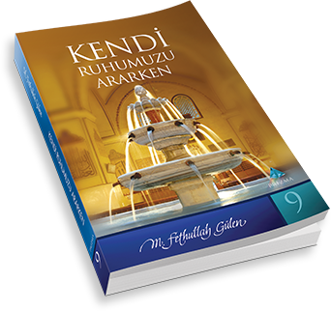

______________________________________________ _____________


A NEW FILM AT THE CINEMA
Gru was a bad man but right now he is a good man and a good father. Now then he has adopted children. Their names are Magro, Edith and Agnes... Gru loves them. Gru and his family are happy right now. Gru sets up a job. But some mystery events start. An organization, its name is Villain League. Villiain League calls Gru for searching a dangerous duty and a good agent will help him...... WILL CONTINUE AT THE CINEMA…

