Brainstorming

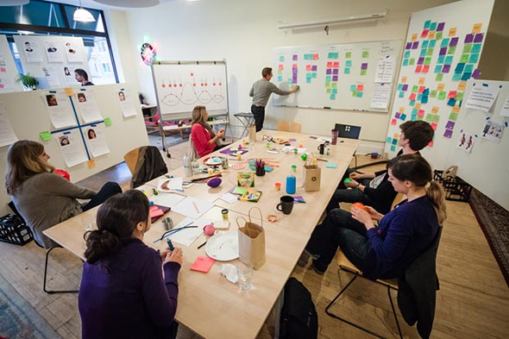
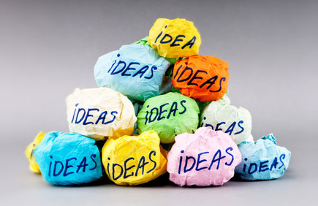

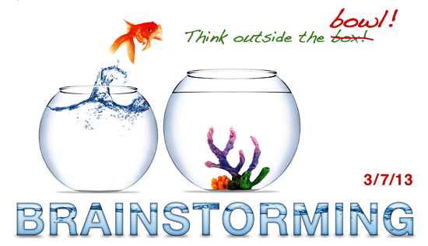
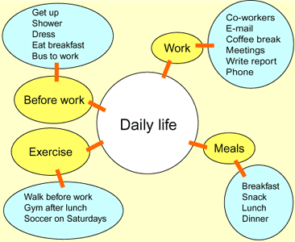
Brainstorming is a way to think of new ideas.
Brainstorming means you write every idea that is in your head (your brain). When you brainstorm, you write all your ideas and all the words you can think of about a topic.
Do not say "This idea is a bad idea." When you are brainstorming, all ideas are good ideas.
You do not write complete sentences when you brainstorm.
You just write words or phrases.
Write all the things that you think of.
Here is an example of what an office worker wrote when he brainstormed about the topic Daily Routine.

How to Brainstorm a Topic:
Step 1 -- Choose the topic you’re interested in writing about and write it at the top of your paper.
Step 2 -- Write down as many words, phrases, or sentences as you can think of underneath the topic. Use Different Kinds of Sentences
Step 3 -- Once you’ve finished writing down as many ideas as you can, examine your ideas to see if any of them have anything in common.
Step 4 -- You are likely to see that some of your ideas are related and do, indeed, have things in common. Identify these relationships, or similarities, and create several categories for your ideas. Write those on the backside of your paper.
Step 5 -- Look at your brainstorming list and group your ideas into the categories you’ve created as you see fit.
More Suggestions:
- Relax. Play some creative music.
- Spelling or style doesn't count
- Don't worry about organization.
- Think quantity.
- Be positive, don't criticise.
- Free-associate ideas. Keep them simple.
- Write or sketch as quickly as you can.
- Develop all ideas.
- Keep working.
- Combine to improve each other's ideas
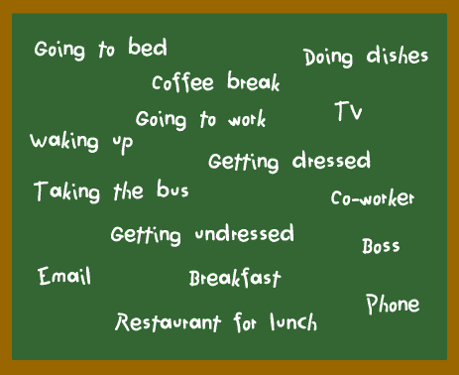

KINDS or BRAINSTORMING

Clustering
Clustering is another way to think of new ideas.
The word "cluster" means a group of similar things.
Clustering means putting words into groups.
Each group, or cluster, has a number of words that are related to each other.
You try to think of many words and phrases. When you make a cluster map, you write the words and phrases in groups.

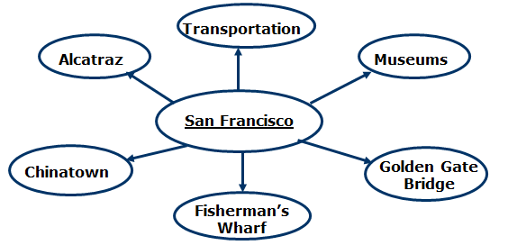

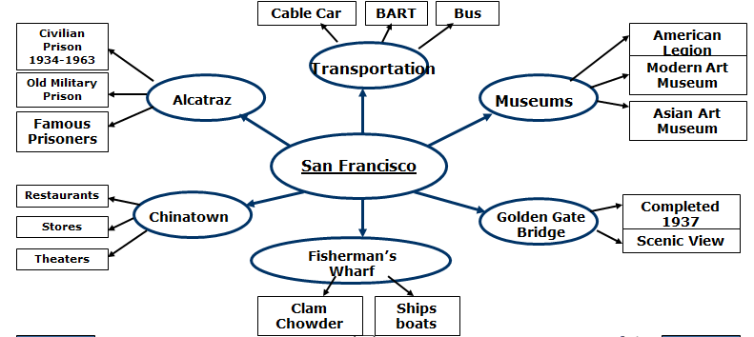

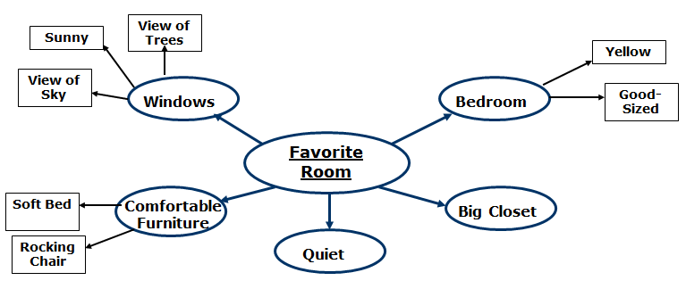

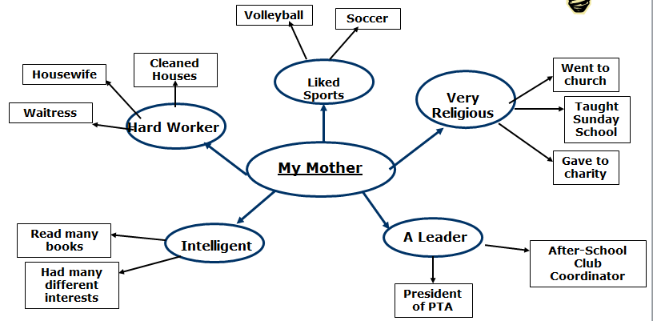

Making Lists


Making lists is a way to think of new ideas.
When you make a list, try to think of ideas in an organized way.
For example, you can make a list of actions, a list of places, a list of people.
Here is an example of three lists about daily routine:
Sample 1

Actions
Wake up
Get up
Shower
Get dressed
Eat breakfast
Brush teeth
Take the bus
Buy coffee

Places
Bedroom
Bathroom
Kitchen
Bus stop
Coffee shop
Office building

People
Bus driver
Waitress
Co-worker
Boss
Customer
Friend

Sample 2
Like science
Like problem solving
Many jobs available in nursing
Good salary
Like working in a hospital
Want to help other people
Opportunities for promotion
Interested in study of diseases
Interested in study of human body
Flexible hours
Will always learn something new

Free Writing

1. Start with the main topic of your subject. Write that word or words at the top of your paper.
2. Freewriting is like talking to yourself on paper. Write as much as you can in connected sentences (not lists) about your topic. Write as quickly as you can without stopping to think about grammar or organization.

Sample:
My favorite book… I don’t know where to start. I read so many books that are interesting that it’s hard to choose just one. I guess I could start by talking about the kinds of books I really like. I like biographies and autobiographies the best. I really enjoy reading about another person’s life. One of my favorite books is called Roots by Alex Haley. How the author was able to trace his family history all the way back to Africa was amazing! Another book I really enjoyed was Carl Sandburg’s biography of Abraham Lincoln. What an incredible president! There are also some very interesting books about leaders like Napoleon, Churchill, and Stalin. Well, I guess that gives me a few ideas about where I can start on my topic.

Venn Diagram

A Venn diagram is used to help visualize the similarities and differences between two subjects.
Venn diagrams are very useful when brainstorming a compare/contrast essay

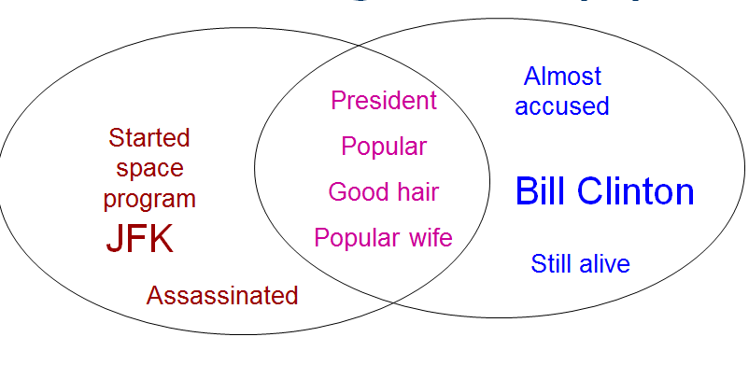

Asking Yourself Questions
Asking yourself questions is another way to think of new ideas.
When you answer the questions, you think of ideas.
Here is an example of some questions about daily routine:

When do I get up?
What do I do in the morning?
When do I go to work?
What do I do at work?
When do I have lunch?
Where do I have lunch?
When do I go home from work?
How do I get home from work?
What do I do after work?
What do I do in the evening?
When do I go to bed?

Brainstorm Before Writing

Before you write a letter or a paragraph, you need to organize all the ideas you thought of in the pre-writing stage. There are many ways to organize your ideas. Here, you will learn about two common ways to organize ideas.
Time Order
Time order means putting your ideas in the order in which they happened. When you are writing about a past event you need to use time order. You begin with the first thing that happened, then tell the second thing that happened, and then the third thing.
You need time order so that your reader can understand when something happened. If you tell a story without time order, you will confuse your reader.
Here is an example of using time order to tell about a short trip to Victoria:

First action:
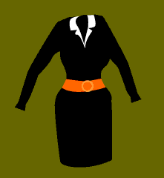
Took a ferry to the island
Second action:
Drove the car from the ferry to the centre of the town on the island
Third action:
Got a room at a hotel in the town
Had dinner at a nice restaurant
Went to a music concert
Walked along the beach after the concert
Went to bed at midnight
Had breakfast in the hotel
Visited a garden
Drove to the ferry
Final action:
Took the ferry home from the island

Revising & Editing

After you have written a first draft, you need to read it again. You will see some errors and some sentences that need to be changed. Revising means changing and editing means correcting. The second draft is where you make changes in your writing and where you correct your mistakes. After you have made the changes and corrections, you will have your final draft.
Look at the example to see how we revised and edited the first draft about a short trip to Victoria.
First draft
I taked a ferry from Vancouver to Victoria. I drove the car from the ferry to the centre of the city Got a bedroom on a hotel. We had dinner in a nice restaurant and we went to a music concert and we walked along the beach after the concert. I went to Bed at midnight then I had breakfast in the hotel. At the end I took the ferry back to Vancouver but I visited a beautiful garden before I drove to the ferry.
Revisions
We took a ferry from Vancouver to Victoria. We drove the car from the ferry to the centre of the city. We rented a room in a hotel. We had dinner in a nice restaurant. We went to a music concert, and after the concert we walked along the beach. We went to bed at midnight and woke up at 8 in the morning. We had breakfast in the hotel. We visited a beautiful garden before we drove to the ferry to go back to Vancouver.
Final draft
We took a ferry from Vancouver to Victoria. We drove the car from the ferry to the centre of the city. We rented a room in a hotel. We had dinner in a nice restaurant. We went to a music concert, and after the concert we walked along the beach. We went to bed at midnight and woke up at 8 in the morning. We had breakfast in the hotel. We visited a beautiful garden before we drove to the ferry to go back to Vancouver.

BRAINSTORMING ORGANIZERS and SAMPLES

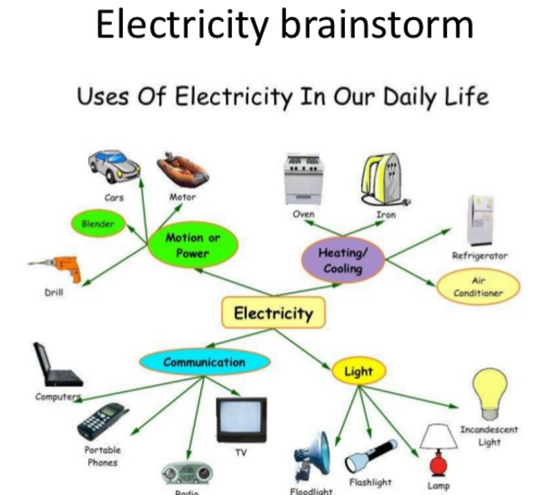
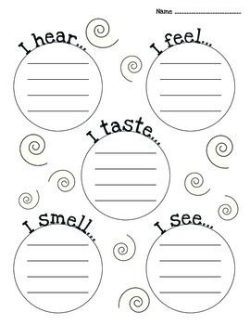

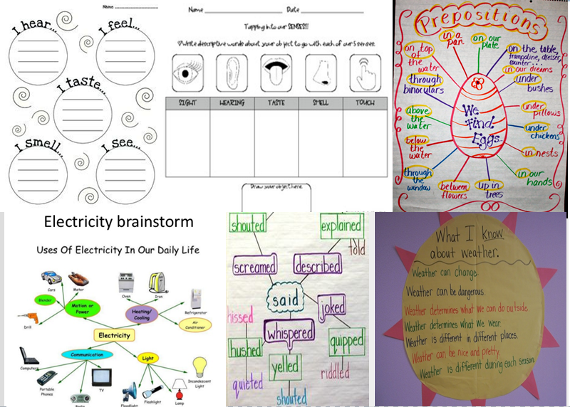

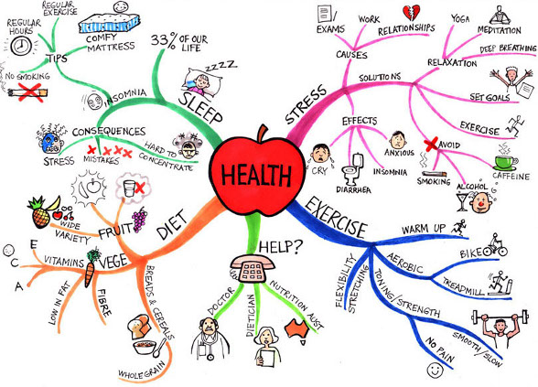

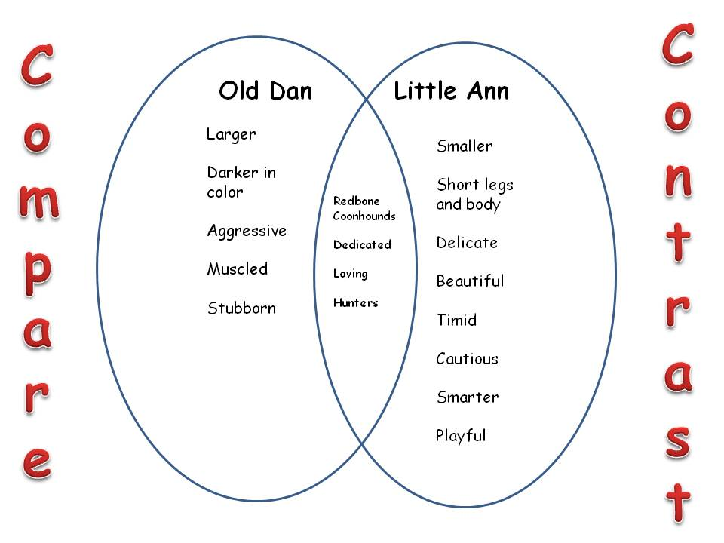
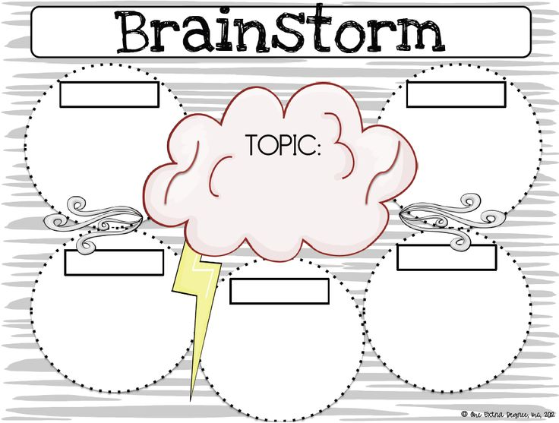

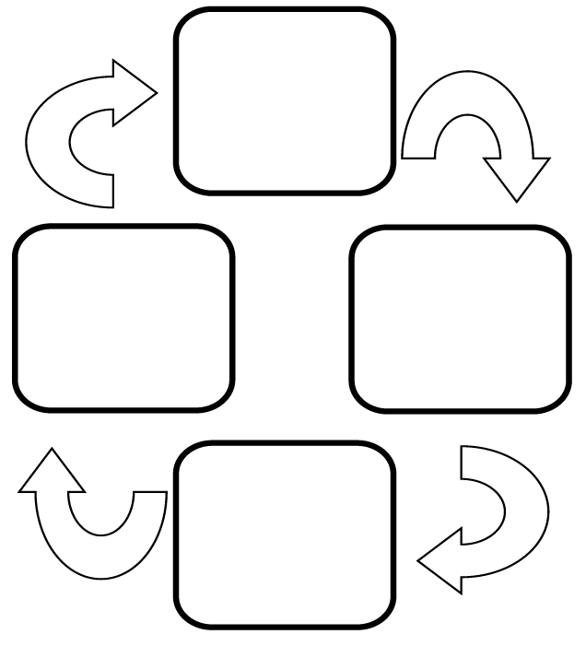
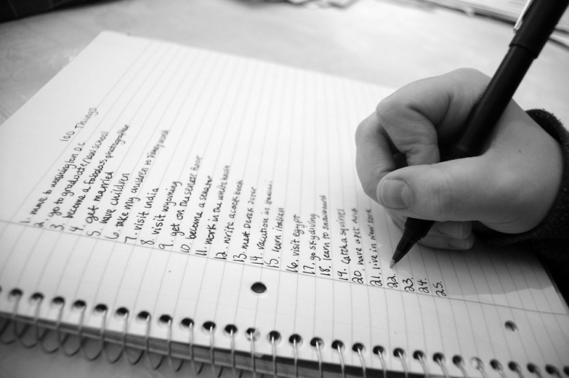
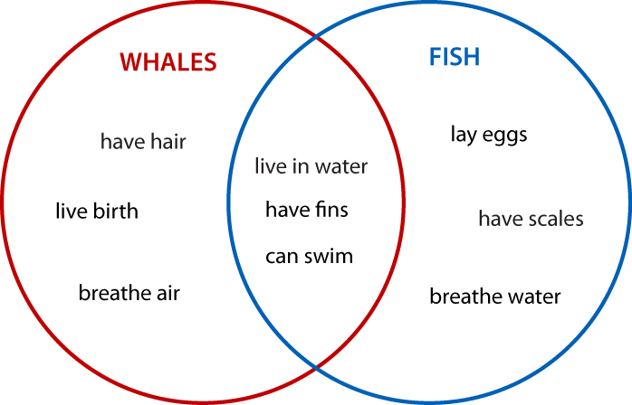

Brainstorming techniques
Example:
Instructions for students

1. Look at the following writing task which is taken from a sample FCE paper.

You have been asked to write a story for a student magazine beginning with these words: "I wanted to give my best friend a surprise...."

Write your story.

2. You have 3 minutes to jot down 5 points or ideas related to this story. Use the following questions if you're stuck for ideas.

About your friend
Who is your best friend?
What is he/she like?
How long had you known him/her?
Why did you want to give them a surprise?
About the surprise
What did you decide the surprise should be?
How long did it take you to make up your mind?
The events leading up to the surprise
What preparations or arrangements did you have to make?
Were there any problems or complications?
Did you feel excited or nervous beforehand?
The surprise
What was your friend's reaction?
Was he/she pleased or angry or disappointed or...?
The consequences
What happened afterwards?
Did your friendship change as a consequence?

3. Find a partner or work in a small group. Tell each other the brief outline of your stories and ask for comments from others about how interesting your stories sound.

Useful links:
Generating Ideas: BRAINSTORMING (now disabled, sorry)
Creative Education Foundation at SUNY - Steps in the Brainstorming Procedure (now disabled, sorry)
Mind Tools [online] How to Brainstorm Individual vs. group brainstorming
Step to Step Guide to Brainstormming
Brainstormming (encyclopedia article)
Process Guide #1: Brainstorming
Project Based Learning - Brainstorming
Brainstorming With Your Computer
Double Brainstorming

