LESSON PLAN
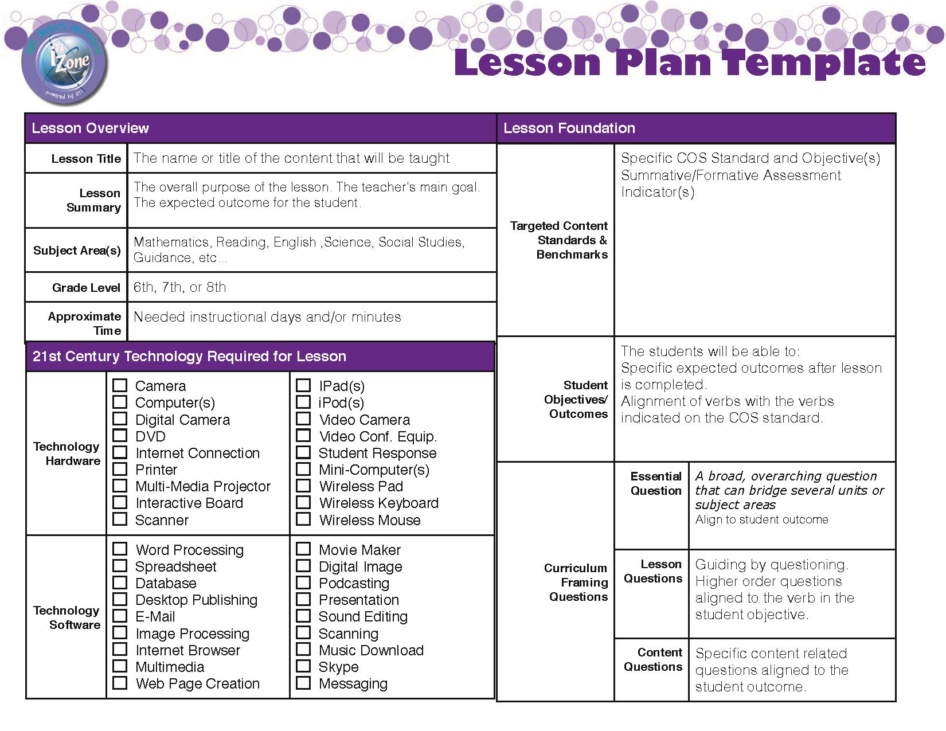
LESSON PLAN 1
Teacher : M. L
Date : June 24, 2013
Grade : 5
Level : Elementary Level
Time : 40 minutes
Class : Grammar
Subject : Would like + Dishes/Drinks/Meals
Materials : Computer, Projector, Board, Handout 1, Handout 2
LESSON OBJECTIVES
1. Students will learn how to use “would” in terms of grammar.
2. Students are expected to develop their speaking ability in some communicative activities.
3. Students are supposed to use the target language creatively.
4. Students will learn some specific vocabularies and structures.
WARM UP ( Motivation )
(After the greeting)
I know you are a bit tired. You look also hungry. Right? I understand you very well.
Maybe, most of you started to think of lunch.
Maybe, some of you curious about the menu at lunchtime.
Or, the others want to taste their favorite meal.
Then, lets talk about the meals food dishes desserts. (Teacher asks the students their favorite meal.)
INTRODUCTION
Let’s have a look at their (English & American) cuisine culture and learn some dish name in English.
Main meal dishes in England
Roast Beef Yorkshire Pudding
Toad in the Hole- Roast Meats
Fish and Chips- Ploughman's Lunch
Cottage Pie- Shepherd's Pie
Gammon Steak with egg- Bubble and Squeak
English Breakfast- Black Pudding
Cumberland Sausage
Main meal dishes in the USA
Beef brisket- Pulled pork sandwich
Chicken and dumplings- Chicken fried steak
Chicken gizzards (fried)- Country Captain
Fried chicken- Hot chicken
Catfish- Fried pork chops
Fried turkey- Jambalaya
Liver- Salmon Croquettes
Souse meat
Soup
Tomato soup Chicken soup
Vegetable soup Pea soup
Starters
Avocado- Grapefruit
Melon
Main Courses
Fish and chips- Sausage and beans
Chicken pie and chips- Cheese salad
Desserts
Apple pie- Chocolate pudding
Ice cream- Fruit salad
PRESENTATION
* Teacher uses PowerPoint slide shows. Students look at the structure and try to learn the usage of “would” After giving the structure in a meaningful context, it will be useful to present the rules.
ACTIVITIES
* Teacher tells the students that they will listen to a scrambled dialogue and unscramble the dialogue after listening two times.
Teacher asks the students to pay attention to the sentences that include “would” form while listening.
- Would you like…
-What would you like to eat?
- I would like to have…
* Teacher says: Now, we will play a game. I need two volunteer students. One of you will look at the board and choose a word (silently). But, don’t say to your friends. The other one will ask questions with ‘would’ and he will try to find within three questions.
HOMEWORK
*When you go to home, prepare a list of your meals dishes etc. from breakfast to dinner for one day and write a dialogue.

LESSON PLAN 2
Date & Time: | 6/27/2013 9:30 -10:00 | Teacher | M
Class: | ESL Kindergarten | Children: | 18
Subject | ESL Grammar (The plural S)
Lesson Name | Animals
Teaching Goals | The goal of the lesson is to introduce the students to the plural S. Have them begin to see the difference between 1 animal and multiple animals.
Teaching Materials | Flashcards, whiteboard, computer, giant cube, compute, chairs
Teaching Important Points | It is important to use animals the students are familiar with. The young learners don’t have a large enough vocabulary to use “harder animal names”. We are focusing on the use of the plural S and not the acquisition of new vocabulary terms.
Teaching Difficult  Points | Some students L1 may not include grammatical features such as plural S. This may prove to be a harder lesson for them.
Teaching Process | - Start the lesson off by reviewing the animals we will be using. Use the flash cards  - Show the animal flashcards one at a time to ensure the students know all of them  - Begin showing the new flashcards/ whiteboard pictures with multiple animals Example (one dog flashcard ,followed by 3 dogs flashcard)  - Expected student response =3 dog. Use corrective feedback to introduce the plural S.- No, 3 dogs.  - Continue working through the remaining cards repeating the above procedure up) take the cards as place them in the cube.  - Use the cube as giant dice and have the students come up one at a time and roll the dice. Ask them to say the Plural S they have landed on (Ex: 4 birds)  - After a 10 minutes of this, and after each student has done at least 2 rolls Finish by reviewing the cards one at a time.
Effect Analysis | The effect of the this lesson is to introduce the Plural S to the students and should begin to give them exposure to this grammatical feature.

LESSON PLAN1
Teacher: |  | Time:
Date: |  | Class:
Grade: |  | Subject:
Level: |  | Materials:

LESSON OBJECTIVES
__________________________________________________________________________________________
__________________________________________________________________________________________
__________________________________________________________________________________________
__________________________________________________________________________________________
__________________________________________________________________________________________
__________________________________________________________________________________________
__________________________________________________________________________________________
WARM UP ( Motivation )
__________________________________________________________________________________________
__________________________________________________________________________________________
__________________________________________________________________________________________
__________________________________________________________________________________________
__________________________________________________________________________________________
__________________________________________________________________________________________
__________________________________________________________________________________________
INTRODUCTION
__________________________________________________________________________________________
__________________________________________________________________________________________
__________________________________________________________________________________________
__________________________________________________________________________________________
__________________________________________________________________________________________
__________________________________________________________________________________________
PRESENTATION
__________________________________________________________________________________________
__________________________________________________________________________________________
__________________________________________________________________________________________
__________________________________________________________________________________________
__________________________________________________________________________________________
__________________________________________________________________________________________
ACTIVITIES
__________________________________________________________________________________________
__________________________________________________________________________________________
__________________________________________________________________________________________
__________________________________________________________________________________________
__________________________________________________________________________________________
__________________________________________________________________________________________
HOMEWORK/ASSIGNMENT
__________________________________________________________________________________________
__________________________________________________________________________________________
__________________________________________________________________________________________
__________________________________________________________________________________________
__________________________________________________________________________________________
__________________________________________________________________________________________

LESSON PLAN 2
Date & Time: |  | Teacher
Class: |  | Children:
Subject
Lesson Name
Teaching Goals
Teaching Materials
Teaching Important Points
Teaching Difficult
Points
Teaching Process
Effect Analysis

