Progressive Magazine

Produced by: - Hassan H. Rasul 27-10-2013

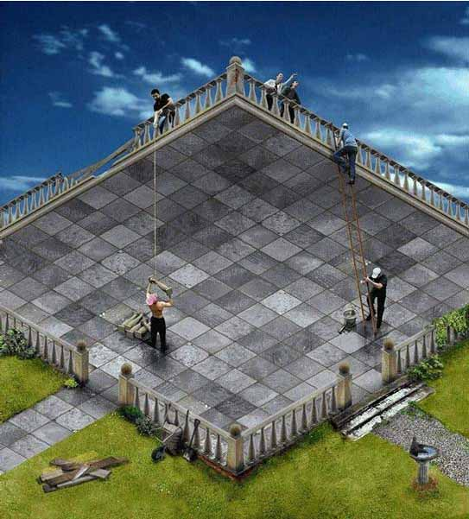
Optical illusion
An optical illusion (also called a visual illusion) is characterized by visually perceived images that differ from objective reality. The information gathered by the eye is processed in the brain to give a perception that does not tally with a physical measurement of the stimulus source.
Modern Building
In the fields of architecture and civil engineering, construction is a process that consists of the building or assembling of infrastructure. Far from being a single activity, large scale construction is a feat of human multitasking. Normally, the job is managed by a project manager, and supervised by aconstruction manager, design engineer, construction engineer or project architect



Google began in 1996 as a project by Larry Page and Sergey Brin. Larry and Sergey were both studying at Stanford University California. In their research project they came up with a plan to make a search engine that ranked websites according to the number of other websites that linked to that site (and ultimately came up with the Google we have today). Before Google, search engines had ranked sites simply by the number of times the search term searched for appeared on the webpage, and the duo set out to make a more “aware” search engine.

