

USING MUSIC in the CLASSROOM
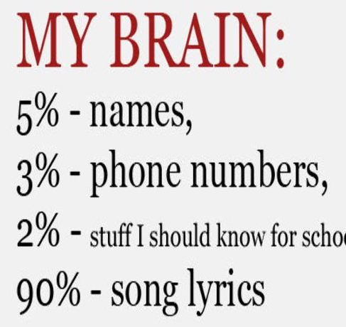

PRE-LISTENING

PRE-LISTENING – phrasal verb learning

Before listening to the song, learn the following phrasal verbs

go on: to continue or move to the next thing:
[+ ing form of verb] We really can't go on living like this - we'll have to find a bigger house.
If you go on (= continue behaving) like this, you won't have any friends left at all.
go through: check; look over; to examine something which contains a collection of things carefully in order to organize them or find something;
Remember to go through the pockets before you put those trousers in the washing machine.
go away: to disappear, to leave a place:
Go away and leave me alone!
settle down: to become quiet and calm, or to make someone become quiet and calm:
Come on children, stop chatting and settle down please!
look at : to turn your eyes towards something, so that you can see it
Did you get the doctor to look at your knee?
(Song: Father and Son – Cat Stevens)

PRE-LISTENING – vocabulary learning

Before listening to the song, learn the following vocabulary.
Lead: ____ make someone follow you - Some people say she is too old to lead the country.
Core: ____the center of something; the part that is the most inside of something (i.e., an apple core is the part of the apple you don’t eat) -The core of the book focuses on the period between 1660 and 1857.
Numb: ____you can’t feel anything; -The dentist makes your mouth numb before fixing your tooth
Soul-: spirit; the part of you that isn’t your body - My brother thinks that anyone who doesn't like poetry has no soul.
Bid: ____ask (old English)
Among: ____like between, but for more than 2 things - I saw a few familiar faces among the crowd.
Frozen: ____ (of water) turned into ice, or (of food) preserved by freezing -. Ice is frozen water - We don't have any fresh vegetables, only frozen peas.
(Song: Bring me to life - Evanescence)

PRE-LISTENING - matching words

Match the words with the definitions
- grieve ___1. a place in the ground where a dead person is buried
- breathe ___2. not moving, quiet, calm
- grave ___3. great sadness esp. at the death of a loved person
- wake ___4. to take air into the lungs and send it out again
- still ___5. to cause someone to stop sleeping
(Song: My lady d'arbanville – Cat Stevens)

PRE-LISTENING - srambled sentences

Separate the words and write them correctly.
Iamnotaperfectperson
There'smanythingsIwishIdidn'tdo
ButIcontinuelearning
I never meant to do those things to you
AndsoIhavetosaybeforeIgo
ThatIjustwantyoutoknow
(Song: The Reason- Hoobastank)

PRE-LISTENING - scrambled sentences

Before listening to the song put the words in order..

- gone - my tea's - cold, wondering - I'm - why I - at all - got out of bed
________________________________________________________________________
- up my window - rain clouds - the morning - and I - see at all - can't
________________________________________________________________________
- if I could - and even - it'd all - be grey - but - on my wall - your picture
________________________________________________________________________
- that it's not - so bad - it reminds me - it's not so bad
________________________________________________________________________
(Song: Thank You – Dido)

PRE-LISTENING - scrambled words

Fill in the blanks with the words on the right. Unscramble them
What I got to do to make you love me?
What I got to do to make you c __________1_? (ACER)
What do I do when lightning s __________2_me? (SESKIRT)
And I w __________3_ to find that you’re not there? (WKEA)
(Song: Sorry seems to be the hardest word- BLUE)

PRE-LISTENING - matching definition

Before listening to the song, write the words from the boxes that match the definitions in parentheses. Then listen to check your answers

heavy – stop – distance- highway – smell
On a dark desert ____________ 1 (main road), cool wind in my hair
Warm ____________ 2 (aroma, perfume) of colitas, rising up through the air
Up ahead in the ____________3 (space between two points), I saw a shimmering light
My head grew ____________4 (difficult to lift, very large) and my sight grew dim
I had to ____________5 (pause during a journey) for the night
(Song: Hotel California – Eagles)

PRE-LISTENING - fill in the blanks

Fill in the blanks with the words given.
lightening – strike – situation – absurd - care
- The only thing he ___________is money.
- The shi ___________a rock and started to sink.
- It’s ___________ not to wear a coat on such a cold winter day.
- On the news we heard that ___________struck an old tower.
- With no rain for the last three years, the country in a desperate ___________.
(Song: Sorry seems to be the hardest word- BLUE)

PRE-LISTENING – complete the lines

BEFORE LISTENING, complete the lines with the given words.

beautiful and blue- a picture of you-the story’s too thin-you're not here to see me- it's already morning-some coffee
What's the time, seems _1__________________
I see the sky, it's so _2_____________________
The TV’s on but the only thing showing is _3______________________
Oh I get up and make myself _4________________
I try to read a bit, but _5______________________
I thank the Lord above _6______________________
In this shape I'm in
(Song: Spending my time – Roxette)

PRE-LISTENING- questions

Pre listening. Please answer the following questions.
- How did you feel when you lost someone you loved?
______________________________________________________________________________
- Who do you think Lady d’Arbanville is? What is the singer’s relationship with her?
(Song: My lady d'arbanville – Cat Stevens)

WHILE LISTENING

WHILE LISTENING – fill in the blanks (given words)

While listening, fill in the blanks with the given words.
believe –find - teach - tell – do – attack – call – take
No matter what they _1 __________us
No matter what they _2__________
No matter what they _3 __________us
What we _4__________is true
No matter what they _5__________us
However they _6__________
No matter where they _7__________us
We'll _8__________our own way back
(Song: No Matter- Boyzone)
- WHILE LISTENING – fill in the blanks

while Listening, fill in the blanks. (Difficult)
My tea's gone_1______________, I'm _2______________why I got out of _3______________at all
the morning rain _4______________my window and I can't _5______________at all
And even if I _6______________it'd all be grey, but your _7______________on my _8____________
it _9______________me that it's not so _10______________
it's not so bad
I _11______________too much last night, got _12______________to pay
(Song: Thank You – Dido)

WHILE LISTENING – put the lines in order

While listening put the lines in order. (Difficult)

- _____ I'm just a simple girl
- _____ Kate Moss can't find a job
- _____ In a world of post modern fad
- _____ I really try to understand
- _____ All the powers that rule this land
- _____ In a high tech digital world
- _____ They say Miss J's big butt is boss
- _____ What was good now is bad
(Song: Intuition – Jewel)

WHILE LISTENING – matching
Listen to the song and match the phrases. Then write down the complete lines and listen to the song again.

I'm crying | night before
And there inside | everyone's tears
I died the | supposed to do
And all of these remnants | our private war
What am I | of joy and disaster

1. ___________________________________________________________
2. ___________________________________________________________
3. ___________________________________________________________
4. ___________________________________________________________
5. ___________________________________________________________
(Song: King of Sorrow - Sade

POST- LISTENING

POST-LISTENING – Vocabulary

Write 5 adjectives from the song to describe the singer’s feelings

1. ________________
2. ________________
3. ________________
4. ________________
5. ________________

(Song: My lady d'arbanville – Cat Stevens)

POST-LISTENING – Comprehension Question

Answer the questions according to the song.
- What is the weather like? _____________________________________________________________
- Why does her head hurt? _____________________________________________________________
- Did she arrive at work on time? ________________________________________________________
- What do her colleagues think of her? ____________________________________________________
- What makes her day bearable? ________________________________________________________
(Song: Thank You – Dido)

POST-LISTENING – focusing words / comprehension
- Write some adjectives to describe her feelings.
- How do you think she feels while she’s singing this song? Why do you think this?
(Song: Bring me to life - Evanescence)

POST-LISTENING – Multiple Choice

After listening to the song, answer the following questions.
1) The father wants:
- His son to start a new life far away
- To get married
- To make good decisions
2) The son wants
- to stop crying
- to leave his father and go away
- his father to listen to him
(Song: Father and Son – Cat Stevens)

POST-LISTENING - Classifying

Once you have completed the song, classify the words you have filled in into the following categories:

ADJECTIVES VERBS NOUNS ADVERBS
___________________ ___________________ ____________________ __________________
___________________ ___________________ ____________________ __________________
(Song: Father and Son – Cat Stevens)

POST-LISTENING – focusing grammar / comprehension

1) List the sentence with present perfect from the song. Why did he use present perfect here?
2) This is a song written by a man to a woman. What happened between them?
___________________________________________________________________________________________________________3) How does the man feel now? Use adjectives to describe the man’s feelings.
___________________________________________________________________________

POST-LISTENING: Grammar

PAST SIMPLE | PRESENT PERFECT | WILL FUTURE

(Song: Have you ever seen the rain - Creedence Clearwater Revival)
- POST-LISTENING - project

If you were a director, what kind of a video clip would you shoot for this song?

WHY MUSIC?
Benefits of Using Music in Class

- improve pronunciation
- improve fluency
- improve concentration
- improve memory
- bring a sense of community to a group
- motivate learning
- relax bothTs & Ss who are overwhelmed or stressed
- make learning fun
- help students absorb language material

Affective reasons
Krashen (1982 )

- present a topic, a language point, vocabulary, etc.
- practice a language point, vocabulary, etc.
- focus on learner errors in a more direct way
- encourage extensive and intensive listening
- stimulate discussion of attitudes and feelings
- encourage creativity and use of imagination
- provide a relaxed classroom atmosphere
- bring variety and fun to learning

Disadvantages
- The material may be too culturally biased (influenced)
- The vocabulary might not be relevant to the ss’ needs
- There may be too many structures
- Special preparation is necessary
- The material can become outdated easily

When to use a song?

- As warm-up activities
- Towards the end of the lesson
- to break tiredness and restlessness
- As a background music for quieter activities
- During the whole lesson
- For self-study and practice

How ?
- Gap-filling
- Paraphrasing
- Finishing sentences
- Associations
- Matching pairs
- Inventing new lyrics
- Drawing/painting

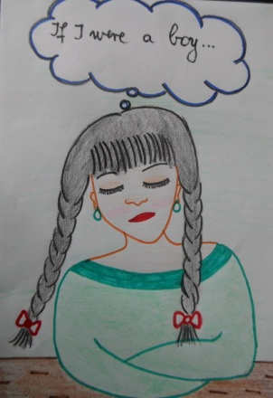
More: Activities

Spot the mistakes - An easier activity:
- Write out the lyrics of the song, but make about 20 mistakes e.g. change the tense, write an opposite or synonym instead of the correct word. The students listen.
- The first time ask them to underline the words that are different and the second (or third) time actually write what they hear above the word or phrase that is wrong.
- After each hearing they can check with each other – in a mixed ability classroom this ensures no-one is left behind and gets demotivated.
- After they have checked that they got the right words, ask them to go through and see if the mistakes were words or phrases that were the same, similar or opposite in meaning: a good focus on vocabulary and/or grammar.

After you listen
Things to think about

- Is there an answer to the questions in this song?
- What do you think the title “___________” means?
- What do you think the meaning of this song is? What does the writer want to say?

