NICE CITIES NEWSPAPER
Newspaper Editor: SEMİH ÇERKEZ Date 21.10.2013 No .1
MALATYA
Malatya is a nice city in Turkey. It is in the east of Turkey. Malatya’s population is 750000. Summers are very hot and winters are very cold in Malatya. Malatya’s people are very friendly.
.______________________________________________________________________________________________________________________________________________________________________________________________________________________________________________________________________________________________________________________________________________________
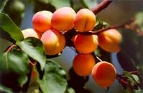

KEMAL SUNAL
DELICIOUS FRUIT APRICOT
Kemal Sunal was born on 11october in 1944. __________ He was a very famous actor in Turkey.

Malatya’s apricots are very famous in the world. It is special for Malatya because it doesn’t grow everywhere. It is very delicious fruit. Apricots are very useful for our body. They clean our stomach and digestion. You can dry apricot in summer and eat in winter.
__________________________________ ______________________________________________
______________________________________________ ______________________________________________
______________________________________________ ______________________________________________
______________________________________________ ______________________________________________
______________________________________________ ______________________________________________
______________________________________________ ______________________________________________
______________________________________________ ______________________________________________
______________________________________________ ______________________________________________
______________________________________________ ______________________________________________
______________________________________________ ______________________________________________
______________________________________________ ______________________________________________
______________________________________________ ______________________________________________
______________________________________________ ______________________________________________
______________________________________________ ______________________________________________
______________________________________________
He went to Vefa High School. After that he
went to Marmara University. His films are
very fun. When we watch his films, we
laugh a lot. He got married Gül in 1974.
He had two kids. When he died in 2000,
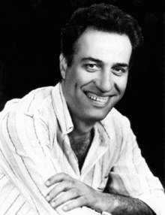
we were very sad.

YOU SHOULD DO THESE
If you will go to Malatya, you should eat Analı – Kızlı meatball and apricot revolving. After you should go to Kernek and Battalgazi.



