
Newspaper Editor SACİDE DENİZ Date 27/10/13 No: 1
EDITOR:SACİDE DENİZ DATE:27/10/2013 NO:1
Sea NEWSPAPER

Dr. Muammer Yildiz is from Hatay. He is thirty-four years old.
He was a rheumatism patient when he was 12 years old. His illness was escalating more and more. He went to lots of doctors but he was not recovered from it. There was a doctor who was one of the world’s top three doctors. He said him “Don’t insist! You can never recover.
He was a successful student. His aim was to go to university. He fell in love. He said to his girlfriend “ You must get married and you must be happy .I’m very sick and I can’t walk. “ He was losing everything -his girl friend, his patience, his believe- . He wanted to do something but he couldn’t do anything.
One day a Scholar gave him a book. Its name was ‘Semsul Maarif’ . He said “You must analyze this book. “ And then Mr. Yildiz began to examine this book. It was a book about herbs. Then he decided to investigate medicinal herbs. He searched about herbs for 2 years. He tried those herbs and he began to feel power in his legs. After two months he began to walk.
He went to university. He graduated from Halep University. Now He is a doctor. He has almost 150 kinds of medicine. They are naturel. He has 25 offices in Turkey.

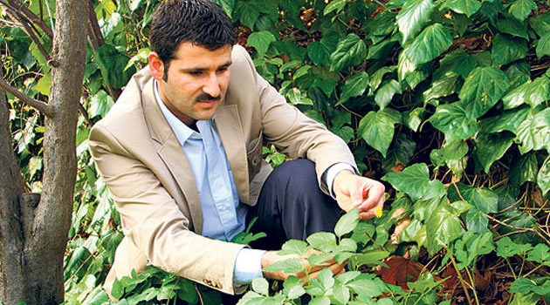

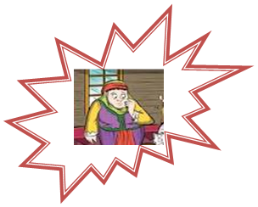

One day , Nasreddin Hodja bought two kilos of meat and he came home .He said his wife “I want to eat meat this for dinner“ His wife invited her friends to her home. She cooked meat for them and they ate it. In the evening, Nasreddin Hodja came home but there wasn’t any meat. He asked his wife “Where is the meat ?” She said “The cat stole the meat and ate it. I ran after the cat but I couldn’t catch it. Nasreddin Hodja grabbed the cat and weighed it. It weighed 2 kilos. Nasreddin Hodja turned to his wife and he said “ IF THIS IS THE CAT , WHERE IS THE MEAT . BUT IF THIS IS THE MEAT , WHERE IS THE CAT??? “

