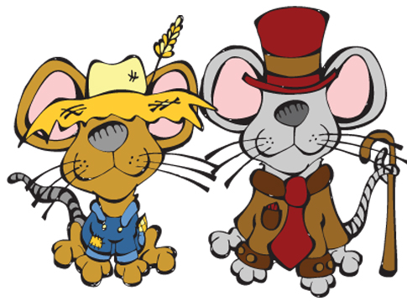
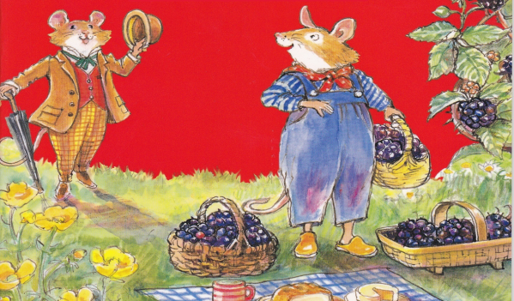
THE TOWN mouse AND
the COUNTRY MOUSE
Main Characters

Active verbs Adjectives
Character 1 (Describe)

_________________________________________________________________

_________________________________________________________________

_________________________________________________________________

_________________________________________________________________

_________________________________________________________________

_________________________________________________________________
Character 2 (Describe)

_________________________________________________________________

_________________________________________________________________

_________________________________________________________________

_________________________________________________________________

in the book: in the book:

_______________________ _______________________
_______________________ _______________________
_______________________ _______________________
_______________________ _______________________
_______________________ _______________________
_______________________ _______________________
_______________________ _______________________

Name: ____________________ Class: ____________
Date: _____________________

