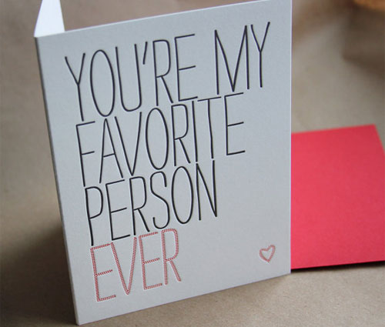
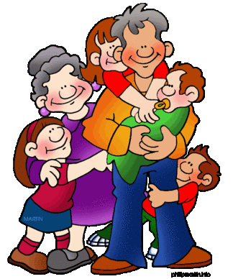
My favorite person
in my life

I have a good family and I love everybody in my family. They are always very kind. I think dads are usually like their sons. Well my dad and I are very similar. My favorite person is my father.
Who is my favorite person

Reason 1

Reason 2

Reason 3

Result- my opinion

My dad is a teacher. He is very good at math, English, especially writing. Math isn’t my best subject. Don’t get me wrong, I love it but sometimes I need help. My father is always there to help me.
He always helps me when I need him. For example he helps with my homework. He also loves singing with me. We always watch cartoon or movie together.
We both love to sing and we both share a love of music. Our dream is to play the guitar by a seaside.
Cooking is a loved thing in my family. Everyone loves to eat. He’s the breakfast king. Anything you want he can make it!
From cooking, to singing, to helping me with my homework, my favorite person is definitely my dad! I love him and couldn’t imagine my life without him.

