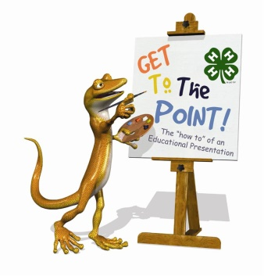

Making a Presentation and Speech
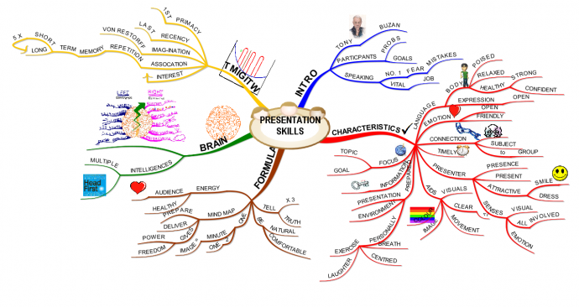

Preparation
How many times a day do you make a “speech” or persuasive argument? To a parent? To a teacher? To a peer? What are some ways in which you can apply the essential elements of great speeches to your everyday communication?

- Choose a good topic that would attractiveness to your audience.
- Begin to write your speech. Divide your speech into a definite
introduction,
body,
end/conclusion.
- Add interesting
facts,
stories,
examples
to make your speech more vivid and interesting to your classmates.
- Prepare, prepare, prepare. As the cliched saying goes, "Preparation is the key to success."
- Practice in front of the mirror.
- Dress well. This will prevent you from getting distracted and in turn help your overall body image. Now you can concentrate on your speech rather than your attire. If you do not have any, then borrow some of your friends' clothes.
- Find out how much space you will have. Practice using the space you have. Walk around and use your hands economically.
- Imagine yourself making a good speech. Watch yourself and play it in your head.

Organization
- Have a very clear introduction, to motivate what you do and to present the problem you want to solve.
- Don't put all the details in the talk. Present only the important ones.
- Give your full attention to your topic. “30 Years from now, your job won’t exist.”
- Having "talk outline" slide is very useful, usually after the introduction.
- Plan your speech closing as carefully as your opening.
- Don’t forget to thank your audience.
- Use only one idea per slide.
- Have a good conclusions slide: put there the main ideas, the ones you really want people to remember. Use only one "conclusions" slide.
- The conclusion slide should be the last one. Do not put other slides after conclusions, as this will weaken their impact.
- Try to cut out as much as possible; less is better.
- Help the audience understand where you are going. Often it's best to give them a high-level overview first, and then jump into the details; then, while listening to the details they can relate to the high-level picture and understand where you are.

Mechanics
- Humor is very useful; prepare a couple of puns and jokes beforehand (but not epic jokes, which require complicated setup). However, if you're not good with jokes, better avoid them altogether. Improvising/making up humor is very dangerous.
- The more you rehearse the talk, the better it will be. A rehearsal is most useful when carried out loud. 5 rehearsals is a minimum for an important talk.
- The more people criticize your talk (during practice), the better it will be; pay attention to criticism, not necessarily to all suggestions, but try to see what and why people misunderstood your ideas.
- Not everything has to be written down; speech can and should complement the information on the slides.
- Be enthusiastic.
- Act your talk: explain, ask rhetorical questions, act surprised, etc. (rhetorical: symbolic, debating e.g. If Winter comes, can Spring be far behind?”)
- Give people time to think about the important facts by slowing down, or even stopping for a moment.
- Do not go overtime under any circumstance.
- Listen to the questions very carefully; many speakers answer different questions than the ones asked.
- Do not treat your audience as mentally-impaired: do not explain the completely obvious things.
(impaired: unable to see or hear as well as most people, damaged)

Text/ Power Point
- Slides should have short titles. A long title shows something is wrong.
- All the text on one slide should have the same structure (e.g. complete phrases, idea only, etc.).
- Put very little text on a slide; avoid text completely if you can.
- Put no more than one idea per slide (i.e. all bullets should refer to the same thing). If you have lots of text, people will read it faster than you talk, and will not pay attention to what you say.
- Don't use small fonts.
- Use very few formulas (one per presentation). The same goes for program code (at most one code fragment per presentation).
- Do not put useless graphics on each slide: logos, attachments, etc.
- Make sure your spelling errors.
- Emphasize the important words.
- Avoid detailed reports. If you need to include a report in your presentation, hand it out.
- Don’t distribute a handout before you begin speaking. If you do so, people will start reading ahead instead of listening to you. It’s just one more distraction to keep them from focusing on your message.

Illustrations
- Use suggestive/ remindful graphical illustrations as much as possible. Prefer an image to text. Try to have 70 or 80% of the slides with images.
- Do not "waste" information by using unnecessary colors. Each different color should signify something different, and something important.
- A few real photos related to your subject look very cool. Real photos are much more effective during the core of the talk than during the intro.
- Sometimes a not shiny pastel background looks much better than a white one.
- Use strong colors for important stuff, pastel colors for the unimportant.
- Use appropriate fonts. I recommend a MS Reference Sans Serif font for titles (e.g., Arial, Verdana, He etc.) and body text (e.g., Times New Roman, Garamond, Goudy, etc.).
- Don’t force people to try to read a ledger printout on a slide. If you must show a report, use it as a picture and then use a “call out” to emphasize the part of the report you want people to focus on.

Results
- Don't put useless information in result graphs.
- Explain the un-obvious ones. Use large fonts for labels; the default fonts in Excel are too small.

Golden Rules
- RESPECT THE TIME LIMITS. Human attention is very limited. Don't cram too much information, either in each slide, or in the whole talk. Avoid details: they won't be remembered anyway. Plan your time, and don't let it happen
- DON'T EVER BEGIN WITH AN APOLOGY. Everyone has seen speakers beginning a presentation by apologizing for how unworthy they are, how little of their work is really conclusive, how they hope people will forgive them and so

Golden Tips
- Record yourself and watch your speech to see if you're doing anything that you don't like or think that you'll get marked down for.
- Check to make sure all the grammar and punctuation is correct.
- Add humour to show confidence, but there's a fine line between being funny,and making a fool out of yourself.
- Look at everyone in the audience, not just one person.
- Make sure you don't offend, or embarrass your audience.
- Make sure that your speech isn't too long or too short, especially if there's a time limit or minimum.
- Focus on people's foreheads. It will appear as if you're making eye contact. This way, you will not have to stare into critical eyes, if there are any.
- Never hold a piece of plain paper in your hand while speaking. It will flutter with every tiny movement and exaggerate all your shakes. If you need notes, write them on index cards.
- Practice, practice, and practice your speech until it feels natural
- Keep in mind that you will stand out more if you stutter and use "um"s in every sentence than if you were to give a speech perfectly and without speech fright. Don't be afraid that people will think your speech is horrible, and realize that probably a lot of other people in your class, or school, etc, have nervousness when giving a speech.
- If you're presenting in a class with other students, then try to go first. You should get a better grade, because your speech is the base for all other speeches and if you build the confidence to go first you should be confident on stage.
- If you are really nervous take a small paperclip up on stage (or in class) bending it will help!
- Get a good night’s sleep.

Before the Presentation
Please arrive early. Check the microphone, over projects, lighting, etc., before everyone arrives. Protect yourself from all the problems that can ruin your talk

- References
- Mihai Budiuk: https://www.cs.cmu.edu/~mihaib/presentation-rules.html
- Micheal Hyatt: http://michaelhyatt.com/5-rules-for-more-effective-presentations.html
- Geoff Pullum: http://people.ucsc.edu/~pullum/goldenrules.html
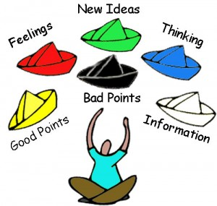
- Scott Schwertly: http://blog.slideshare.net/2014/04/07/presentation-design-dos-and-donts/

PRESENTATION TOPICS

 | Topics | Konular | Presenter - Konuşmacı
 | Active Learning / Teaching | Aktif öğrenme / Öğretme
 | Administration of Education | Eğitim Yönetimi
 | Affective Learning | Etkili öğrenme
 | Behaviorist Learning | Davranışsal Öğrenme
 | Classroom Design | Sınıf Düzeni
 | Classroom Management | Sınıf Yönetimi
 | Classroom Teacher Education | Sınıf Öğretmen Eğitimi
 | Collaborative Learning | Birlikte Öğrenme
 | Constructivist Learning | Yapısal Öğrenme
 | Course and Program Evaluation | Ders ve Program Değerlendirme
 | Creative Teaching | Üretici Öğretim
 | Critical Thinking and Problem Solving | Eleştirel Düşünme ve Problem Çözme
 | Working with Difficult Students | Problemli Öğrencilerle Çalışmak
 | Educational Administration | Eğitim Yönetimi
 | Educational Technology | Eğitim Teknolojisi
 | Effect of Music in Teaching | Eğitimde Müziğin Etkisi
 | Guiding and Counseling | Rehberlik ve Danışma
 | High School Teacher Education | Lise Öğretmen Eğitim
 | Knowledge Management in Education | Eğitimde Bilgi Yönetimi
 | Language Learning and Teaching | Dil Öğrenimi ve Öğretimi
 | Language Teacher Education | Dil Öğretmen Eğitimi
 | Learner Centered Strategies | Öğrenci Merkezli Stratejiler
 | Learners Diversity and Inequality | Öğrenci Çeşitliliği ve Denksizliği
 | Learning and Teaching Research Methods | Öğrenmce ve Öğretme Araştırma Metodları
 | Learning Disabilities | Öğrenme Güçlükleri
 | Learning Skills | Öğrenme Teknikleri
 | Learning Theories | Öğrenme Teorileri
 | Measurement and Evaluation in Education | Eğitimde Ölçme ve Değerlendirme
 | New Learning Environments | Yeni Öğrenme Alanları
 | New Learning Web Technologies | Yeni Öğrenmede Web Teknolojisi
 | Pair/Group Work | Grup Çalışmaları
 | Performance Assessment | Performans Değerlendirme
 | Portfolio Assessment | Portfolio Değerlendirme
 | School Administration | Okul Yönetimi
 | Student Diversity | Öğrenci  Farklılıkları
 | Student Motivation | Öğrenci Motivasyonu
 | Supporting Students Experience | Öğrenci Deneyimleri Destekleme
 | Teacher Experiences | Öğretmen Deneyimleri
 | Teacher Professional Development | Öğretmen Kişisel Gelişimi
 | Teaching Pronunciation | Telafuz Öğretimi
 | Teaching in Crowded Classrooms | Kalabalık Sınıflarda Eğitim
 | Teaching Vocabulary | Kelime Öğretimi
 | Teaching with Games | Oyunlarla Öğretim
 | Use of Authentic Materials in Classroom | Otantik Malzemelerin Sınıfta Kullanımı
 | Use of stories/dramas in classroom, puzzles, cartoons | Sınıfta hikaye/drama kullanımı
 | Vocational Education | Tatil Eğitimi
 | Emotional Barriers to Learning | Öğrenmede Duygusal Engeller
 | Helping Kids How to Learn | Çocuklara Nasıl Öğreneceğini Öğretmek
 | How Kids Learn | Çocuklar Nasıl Öğrenir
 | How to Teach Students to Think | Öğrencilere Nasıl Düşünüleceğini Öğretmek
 | Student Centered Teaching | Öğrenci Merkezli Öğretme
Learning Styles – Öğrenme Sitilleri
 | Learning Styles in the Pre-school Classroom | Okul Öncesi Eğitimde Öğrenme Sitilleri
 | Learning Styles in the Primary School Classroom | İlköğretimde Öğrenme Sitilleri
 | Learning Styles in the Secondary School Classroom | Ortaöğretimde Öğrenme Sitilleri
 | Learning Styles in the High School Classroom | Lisede Öğrenme Sitilleri
In Field Teaching - Branşlar
 | Pre-School Teacher Education
 | Elementary School Teacher Education | İlköğretim Öğretmen Eğitim
 | Secondary School Teacher Education | Ortaokul Öğretmen Eğitim
 | High School Teacher Education | Lise Öğretmen Eğitim
 | Education in High School | Lisede Eğitimi
 | Mathematics Learning and Teaching | Matematik Öğrenimi ve Öğretimi
 | Primary School Maths Teaching | İlköğretim Matematik Öğretimi
 | Using technology in Math Class | Matematik Dersinde Teknoloji Kullanımı
 | Biology Learning and Teaching | Biyoloji Öğrenimi ve Öğretimi
 | Chemistry Learning and Teaching | Kimya Öğrenimi ve Öğretimi
 | Physics Learning and Teaching | Fizik Öğrenimi ve Öğretimi
 | Turkish Learning and Teaching | Türkçe Öğrenimi ve Öğretimi
 | English Learning and Teaching | İngilizce Öğrenimi ve Öğretimi
 | Arabic Learning and Teaching | Arapça Öğrenimi ve Öğretimi
 | Social Sciences Teaching | Sosyal Bilgiler Öğretimi
 | Using Technology in Maths/Biology/Chemistry/Turkish/Physics
Lessons - Dersler
 | Teaching Grammar | Gramer Öğretimi
 | Teaching Listening | Dinleme Öğretimi
 | Teaching Reading | Okuma Öğretimi
 | Teaching Writing | Yazma Öğretimi
 | Teaching Course Book | Kurs Kitabı Öğretimi
 | Teaching Speaking | Konuşma Öğretimi
Games - Oyunlar
 | Grammar Games | Grammar Oyunları
 | Reading Games | Okuma Oyunları
 | Writing Games | Yazma Oyunları
 | Speaking Games | Konuşma Oyunları
Multiple Intelligences - Çoklu Zeka
 | Bodily Kinesthetic | Dokunsal Zeka
 | Intrapersonal | Sosyal Zeka
 | Linguistic | Dilsel Zeka
 | Logical Mathematical | Matematik Zeka
 | Musical | Müziksel Zeka
 | Naturalist | Doğal Zeka
 | Visual Spatial | Görsel Zeka
Techniques and Principles in Language Teaching- Dil Öğretiminde Teknikler
The Grammar-Translation Method
The Direct Method
The Audio-Lingual Method
The Silent Way
Desuggestopedia
Community Language Learning
Communicative Language Teaching
Total Physical Response
Content-based, Task-Based, and Participatory Approaches
Learning Strategy Training, Cooperative Learning and Multiple Intelligences
My Topic – Benim Konum
 | Teaching Techniques / Methods and Material Design | Öğretim Teknikleri – Yöntemleri ve Mataryel Tasarım
 | Learning English | İngilizce Öğrenme
 | Teaching Method in Class | Sınıfta Öğretim Metodu
 | Child Education | Çocuk Eğitimi
 | Material Usage | Materyal Kullanımı
 | School and Classroom Design | Sınıf ve Okul Dizaynnı
 | Using Materials in Maths Class | Matematik Dersinde Mataryel Kullanımı

