
uu

USEFUL NEWSPAPER

Newspaper Editor: Fatma ADAY
Date:27.10.2013
HEADLINE: TOBACCO
Tobacco is the small feathery, sticky, straight
stem of a plant. Tobacco’s leaves have starch,
resin, nicotine and glue. The government
inspects the quality of tobacco fields.
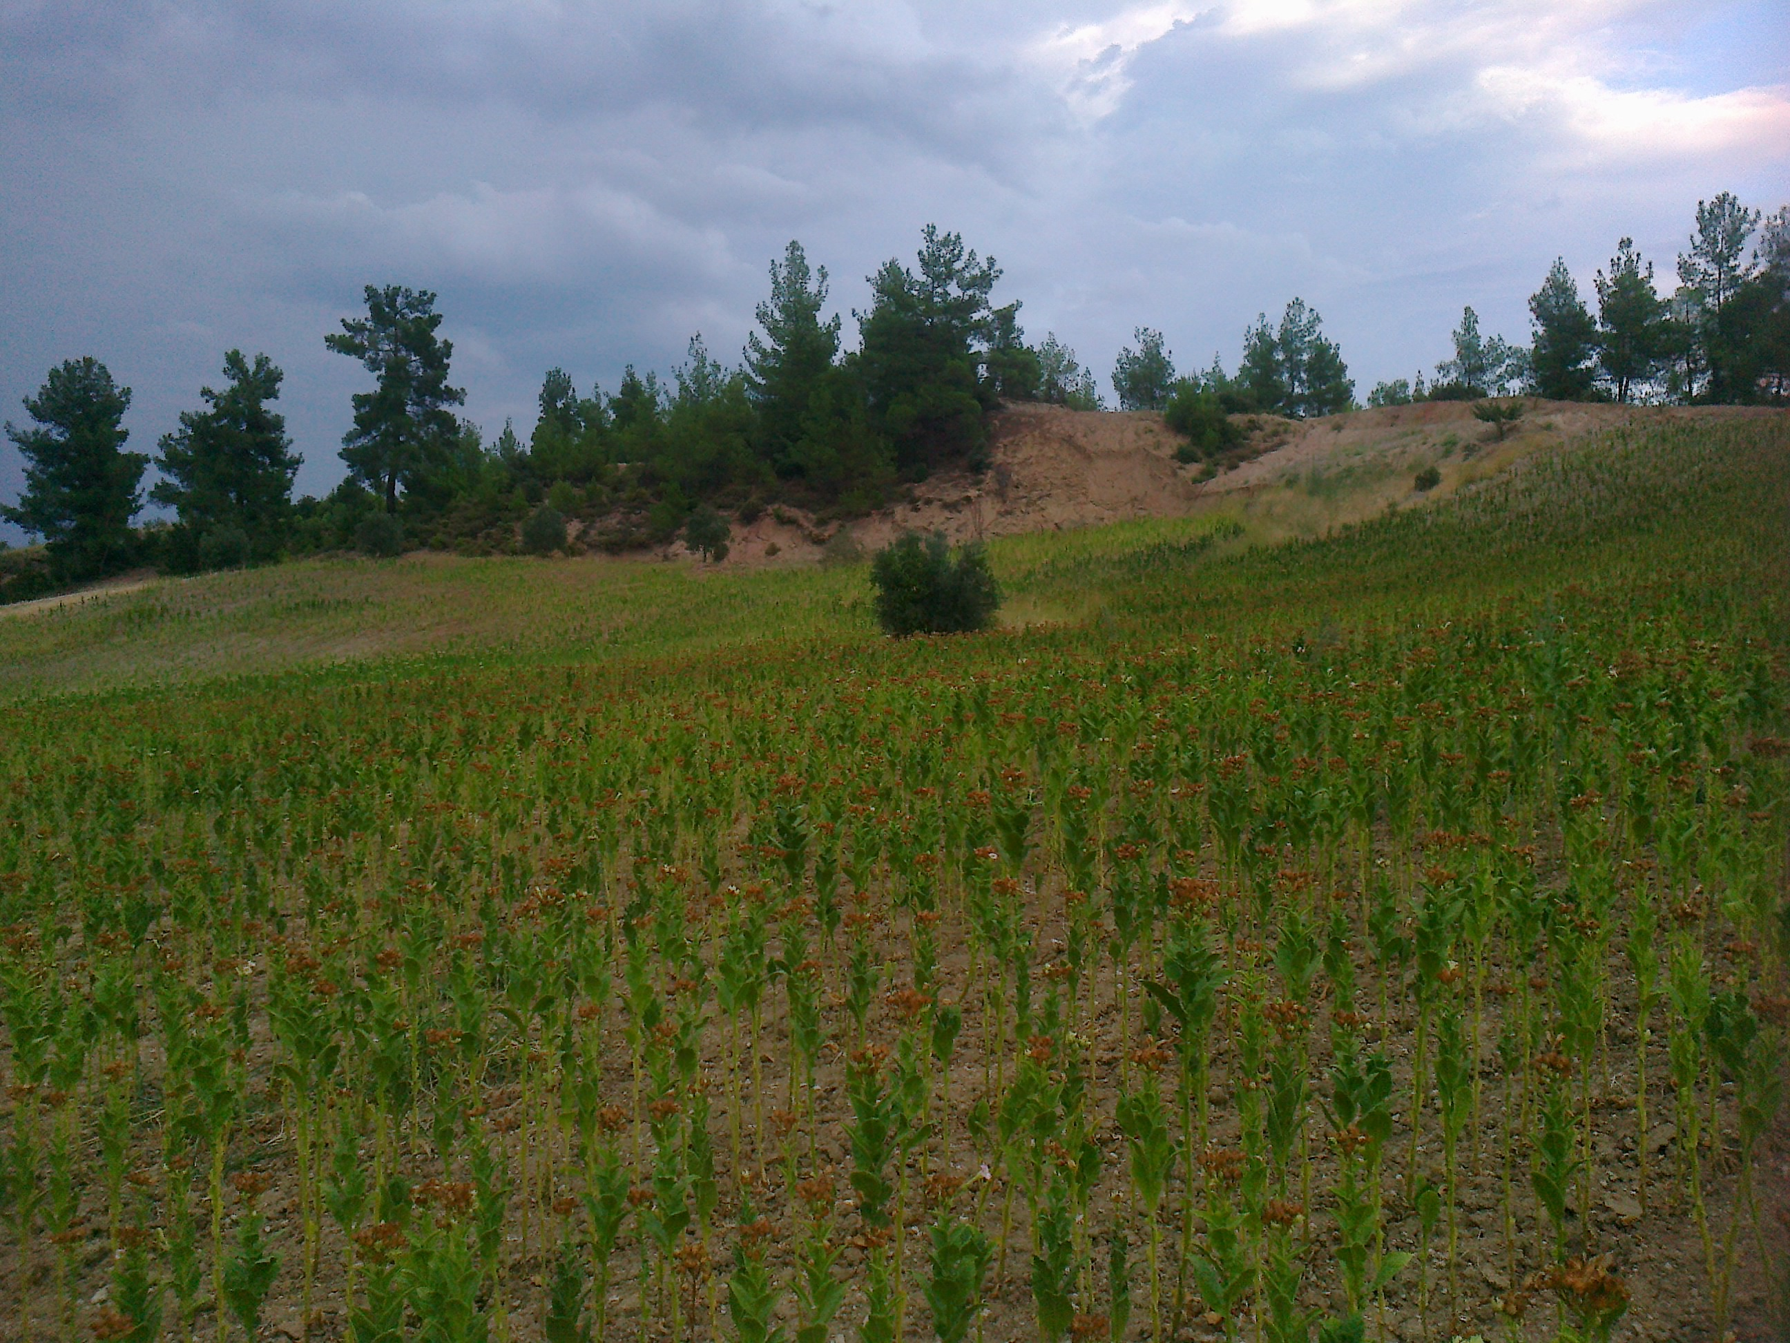
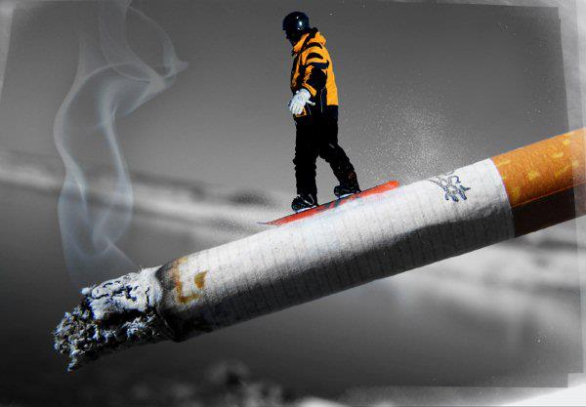

Tobacco is used for killing insects and removing of insects.
Some agriculture medicines are made of tobacco’s leaves.
Smoking is harmful for people’s health. If the tobacco’s leaves in cigarette burn, it will be more dangerous for health. Some harmful results of smoking is lung cancer, heart and vein cancer, high blood pressure, memory lost. Bronchitis, asthma and stomach illness.

WWW.USEFULNEWSPAPER.COM

