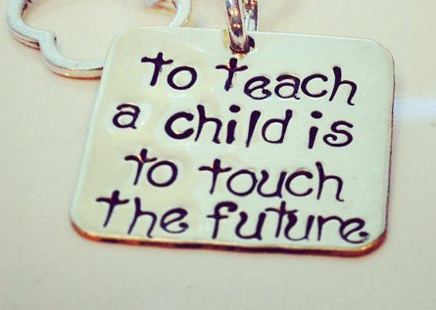

ISHIK UNIVERSITY
Teacher Education Department
SHOOL VISITING WEEK (1)
Name ___________________________________________
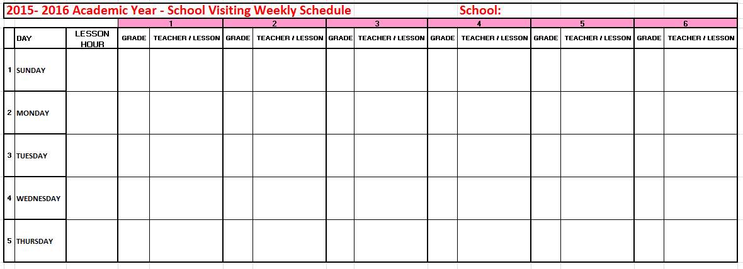
What Will You Look For? (1)
These observation assignments are designed to help you have a more productive learning or teaching experience when you do your 25-30 hours of observations. You will have several observation assignments to complete during your field work.
You should pay attention the selected topics below:
- Map of the room
- Beginning of the Lesson
- Use of Questions
- Interpersonal Interactions
- Discipline
- External factors
- Use of Textbook
- Use of Learning Aids (materials, ppt..)
- Use of chalkboard/Smartboard/LCD projector
- Assignments
- Grading
- Students
- Using Language (Fluency, …)
- Body Language
- Message…

1. Map of the Room:
- Draw a map of the classroom.
- What kind of a learning environment is it?
- What "signs" do you see in the room that science/chemistry/maths.. is taught & learned here? comfortable learning environment? seating arrangements?
- Beginning of the Lesson:
- lesson begins with some sort of introduction, the aim of which frequently is to motivate, or to "grab" the students' interest.
- Use of Questions:
- What types of questions were asked? By whom? Who responds? How often?
- What happens to the responses of the students? Responses of the teacher?
- Interpersonal Interactions:
- What is the "flow" of classroom communication? Primarily from teacher to students?
- What is the role of the teacher in this lesson? (i.e., source of all the information? facilitator? or what?) What evidence is there to indicate the degree to which students are actively involved in learning?
- Discipline
- What things does the teacher say or do to establish the "tone" of the classroom?
- What factors contribute to making the classroom an effective learning environment?
If an "event" occurs -- how did it develop? What did the student(s) do? What did the teacher do? Not do?
- External Factors:
- How many interruptions during the class period? For what? By whom?
- How does the teacher deal with these unasked for interruptions?

- Use of Textbook:
- Does it "dominate" what happens in class?
- How is it used? For what purposes? How often? How helpful is it?
- Do students appear to like it?
- Does the teacher share strategies for success with students?
- Use of Learning Aids
- Does the teacher use audio-visual materials?
demonstration materials?
models?
charts/maps?
- How effective do the materials seem to be?
- Does the teacher do something interesting to grap students’ attention?
- Use of board/Smartboard/LCD projector:
- understandable?
- visible?
- make sense?
- What might have been done differently?
- Assignments/handsouts, test:
- When given? What? Why? What happens to it afterward? Clear purpose?
- How does it relate to enhancing learning?
- Student reactions?
- Handouts, Test… How helpful are they? How do they contribute to learning? Legible/clear? Understandable?
- Grading:
- How is it handled/controlled/carried out? Student reactions?
- How do the students feel about teacher’s grading procedures?

What will you do? (2)

- Begin class on time in an orderly.
- Appear well-prepared for class (knows of course material well).
- Clearly state the goal or objective for the period.
- Present or explain topics with a logical order and clarity.
- Explain new/difficult terms and concepts clearly and in multiple ways.
- Speak audibly and clearly and talks to the students, not the board or windows.
- Use a variety of appropriate “teaching” techniques to maintain student interest and attentiveness (e.g., keeping of eye contact, etc.)
- Present nonverbal gestures.
- Use humor appropriately to strengthen holding & interest.
- Listen to student questions & comments and provides practice time.
- Encourage students to answer difficult questions.
- Treat class members equitably and respectfully.
- Provide opportunities for dialogue about the activity (e.g.WBT) with peers and/or the instructor.
- Present helpful audio- visual materials to support lesson organization & major points
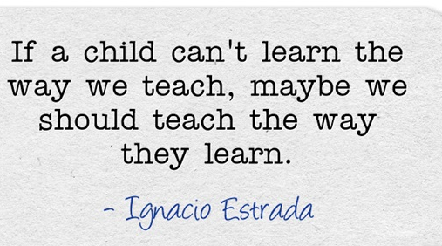
- Demonstrate teaching materials clearly visible to all students
- Use of board/overhead/smartboard effectively
- Summarize major points of lesson.
- Respond to problems raised during lesson.
- Pace lesson the allowed time.
- Provide relevant written assignments or projects.

Teacher 1
Date: ___________ Lesson: ___________________ Subject: ____________________
Minute Implementation

What I learned from observing this lesson: _______________________________________________________

________________________________________________________________________________________________

________________________________________________________________________________________________
Teacher 2
Date: ___________ Lesson: ___________________ Subject: ____________________
Minute Implementation

What I learned from observing this lesson: _______________________________________________________

________________________________________________________________________________________________

________________________________________________________________________________________________
Teacher 3
Date: ___________ Lesson: ___________________ Subject: ____________________
Minute Implementation

What I learned from observing this lesson: _______________________________________________________

________________________________________________________________________________________________

________________________________________________________________________________________________
Teacher 4
Date: ___________ Lesson: ___________________ Subject: ____________________
Minute Implementation

What I learned from observing this lesson: _______________________________________________________

________________________________________________________________________________________________

________________________________________________________________________________________________

Teacher 5
Date: ___________ Lesson: ___________________ Subject: ____________________
Minute Implementation

What I learned from observing this lesson: _______________________________________________________

________________________________________________________________________________________________

________________________________________________________________________________________________
Teacher 6
Date: ___________ Lesson: ___________________ Subject: ____________________
Minute Implementation

What I learned from observing this lesson: _______________________________________________________

________________________________________________________________________________________________

________________________________________________________________________________________________

Teacher 7
Date: ___________ Lesson: ___________________ Subject: ____________________
Minute Implementation

What I learned from observing this lesson: _______________________________________________________

________________________________________________________________________________________________

________________________________________________________________________________________________
Teacher 8
Date: ___________ Lesson: ___________________ Subject: ____________________
Minute Implementation

What I learned from observing this lesson: _______________________________________________________

________________________________________________________________________________________________

________________________________________________________________________________________________

Teacher 9
Date: ___________ Lesson: ___________________ Subject: ____________________
Minute Implementation

What I learned from observing this lesson: _______________________________________________________

________________________________________________________________________________________________

________________________________________________________________________________________________
Teacher 10
Date: ___________ Lesson: ___________________ Subject: ____________________
Minute Implementation

What I learned from observing this lesson: _______________________________________________________

________________________________________________________________________________________________

________________________________________________________________________________________________

Teacher 11
Date: ___________ Lesson: ___________________ Subject: ____________________
Minute Implementation

What I learned from observing this lesson: _______________________________________________________

________________________________________________________________________________________________

________________________________________________________________________________________________
Teacher 12
Date: ___________ Lesson: ___________________ Subject: ____________________
Minute Implementation

What I learned from observing this lesson: _______________________________________________________

________________________________________________________________________________________________

________________________________________________________________________________________________

Teacher 13
Date: ___________ Lesson: ___________________ Subject: ____________________
Minute Implementation

What I learned from observing this lesson: _______________________________________________________

________________________________________________________________________________________________

________________________________________________________________________________________________
Teacher 14
Date: ___________ Lesson: ___________________ Subject: ____________________
Minute Implementation

What I learned from observing this lesson: _______________________________________________________

________________________________________________________________________________________________

________________________________________________________________________________________________

Teacher 15
Date: ___________ Lesson: ___________________ Subject: ____________________
Minute Implementation

What I learned from observing this lesson: _______________________________________________________

________________________________________________________________________________________________

________________________________________________________________________________________________

Teacher 16
Date: ___________ Lesson: ___________________ Subject: ____________________
Minute Implementation

What I learned from observing this lesson: _______________________________________________________

________________________________________________________________________________________________

________________________________________________________________________________________________
Teacher 17
Date: ___________ Lesson: ___________________ Subject: ____________________
Minute Implementation

What I learned from observing this lesson: _______________________________________________________

________________________________________________________________________________________________

________________________________________________________________________________________________
Teacher 18
Date: ___________ Lesson: ___________________ Subject: ____________________
Minute Implementation

What I learned from observing this lesson: _______________________________________________________

________________________________________________________________________________________________

________________________________________________________________________________________________

Teacher 19
Date: ___________ Lesson: ___________________ Subject: ____________________
Minute Implementation

What I learned from observing this lesson: _______________________________________________________

________________________________________________________________________________________________

________________________________________________________________________________________________

Teacher 20
Date: ___________ Lesson: ___________________ Subject: ____________________
Minute Implementation

What I learned from observing this lesson: _______________________________________________________

________________________________________________________________________________________________

________________________________________________________________________________________________
Classroom Observation Reports
Summarizing

- What were the benefits of classroom/school/teacher observation?
_____________________________________________________________________________
_____________________________________________________________________________
_____________________________________________________________________________
_____________________________________________________________________________
_____________________________________________________________________________
_____________________________________________________________________________
- How did the teachers make their lesson interesting and useful? Give examples.
- __________________________________________________________________________
- __________________________________________________________________________
- __________________________________________________________________________
- __________________________________________________________________________

- What do you think about students?
- __________________________________________________________________________
- __________________________________________________________________________
- __________________________________________________________________________
- __________________________________________________________________________

- How did the teachers encourage students to help each other and to learn from each other?
- __________________________________________________________________________
- __________________________________________________________________________
- __________________________________________________________________________
- __________________________________________________________________________
- What suggestions do you have for improving upon this observation?
_____________________________________________________________________________
_____________________________________________________________________________
- Any other comments about the observation.

_____________________________________________________________________________
_____________________________________________________________________________
_____________________________________________________________________________
_____________________________________________________________________________
_____________________________________________________________________________
_____________________________________________________________________________

ESSAY TOPIC
Schools are important areas that need good teachers. Choose one of the teachers (that you observed) and describe the most important qualities of that teacher. Explain why these qualities are important, using specific examples and details.

