
Why do laugh?


U2-L2
BY MAGPAK
WORD ORDER: Put the words in the correct order to make a grammatical meaningful sentence.
- every day - Do – laugh- people?
__Do people laugh every day?__________________________________________
- people - most - do.
_______________________________________________________________________________________________________
- - a day scientists say that - about 17 times - people laugh -
_______________________________________________________________________________________________________
- - laughter - a lot of - that is
_______________________________________________________________________________________________________
- hundreds of - laughter clubs- in india, - there are -
_______________________________________________________________________________________________________
- get together - in these clubs - every morning - the people
_______________________________________________________________________________________________________
- above their heads- - they -stretch their hands -first -
_______________________________________________________________________________________________________
- pretend - they- then, to - laugh.
_______________________________________________________________________________________________________
- everyone is - naturally- soon - laughing
_______________________________________________________________________________________________________
- after laughing- feel good - together - people say- they -
_______________________________________________________________________________________________________
- good for you - scientists - believe that - laughter is -
_______________________________________________________________________________________________________
- for one thing, - good exercise- laughter – is-
_______________________________________________________________________________________________________
- you exercise - in your body-when - many muscles -you laugh,-
_______________________________________________________________________________________________________
- when you laugh,- you also - breathe deeply -
_______________________________________________________________________________________________________
- helps - this- you - relax
_______________________________________________________________________________________________________
- too-that’s - for you,- good -
_______________________________________________________________________________________________________
- why - do –we- laugh?
_______________________________________________________________________________________________________
- to answer -a hard question- that is
_______________________________________________________________________________________________________
- - in a group- we know that people laugh - more often -
_______________________________________________________________________________________________________
- when they are alone - they -don’t laugh- very often-
_______________________________________________________________________________________________________
- laughter helps -us feel - part of a group
_______________________________________________________________________________________________________
- laughter is - the best medicine - in english,- people say that -
_______________________________________________________________________________________________________
- helps sick people - get well - - some think that laughter -
_______________________________________________________________________________________________________

TEXT BASED QUESTIONS (Student A asks, Student B tells the text)

- Do people laugh every day?
________________________________________________________________________________
- How many times do people laugh a day?
________________________________________________________________________________
- How many laughter clubs are there in India?
________________________________________________________________________________
- When do people get together in laughter clubs?
________________________________________________________________________________
- At a laughter club, what do people do first?
________________________________________________________________________________
- What do people feel after laughing together?
________________________________________________________________________________
- What do scientists think about laughing?
________________________________________________________________________________
- How do you breathe while laughing?
________________________________________________________________________________
- What makes you when you breathe deeply?
________________________________________________________________________________
- Do you people laugh in a group or alone.
________________________________________________________________________________
- What do English people say about laughing?
________________________________________________________________________________
- What do you think about laughing?
________________________________________________________________________________
- What is your opinion about laughing?
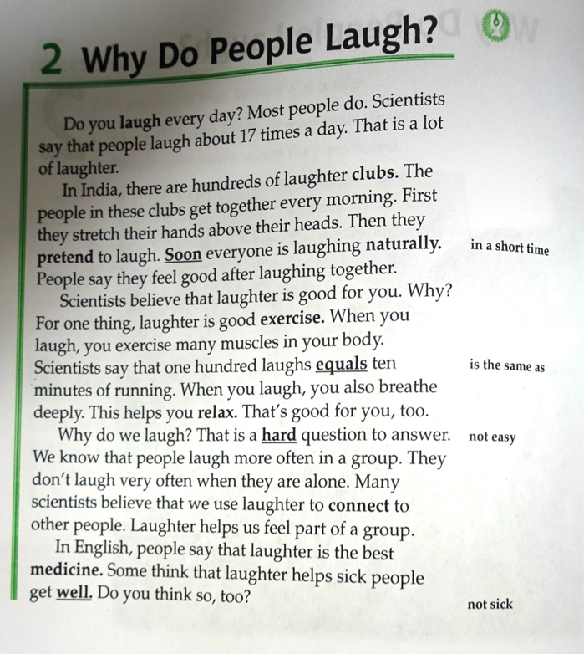
________________________________________________________________________________

QUESTION BASED LEARNING
GENERAL QUESTIONS
- At a laughter club, what do people do first?
______________________________________________________________________________
- Do people laugh every day?
______________________________________________________________________________
- Do you laugh a lot?
______________________________________________________________________________
- How do you breathe while laughing?
______________________________________________________________________________
- How does laughter happen?
______________________________________________________________________________
- How important is laughter?
______________________________________________________________________________
- How many laughter clubs are there in India?
______________________________________________________________________________
- How many times do people laugh a day?
______________________________________________________________________________
- Is laughter ‘the best medicine’?
______________________________________________________________________________
- Is laughter contagious?
______________________________________________________________________________
- What definition would you give for laughter?
______________________________________________________________________________
- What do English people say about laughing?
______________________________________________________________________________
- What do people feel after laughing together?
______________________________________________________________________________
- What do scientists think about laughing?
______________________________________________________________________________
- What do you think about laughing?
______________________________________________________________________________
- When do people get together at the laughter clubs?
______________________________________________________________________________
- Why do you think some people laugh more than others?
______________________________________________________________________________
- How many times do you laugh in a day?
______________________________________________________________________________
- Do you usually laugh quietly or do you laugh out loud?
______________________________________________________________________________
- What kind of things make you laugh? Cartoons? Funny movies?
______________________________________________________________________________
- There's a saying in English that "laughter is the best medicine". Do you agree or disagree?
______________________________________________________________________________

