TRIANGLES

- Label your triangles and write the degrees of angles what you want by considering types of triangles.

Acute Triangle Right Triangle Obtuse Triangle

- Look at origami examples below.

ORIGAMI FROG | PAPER PLANE
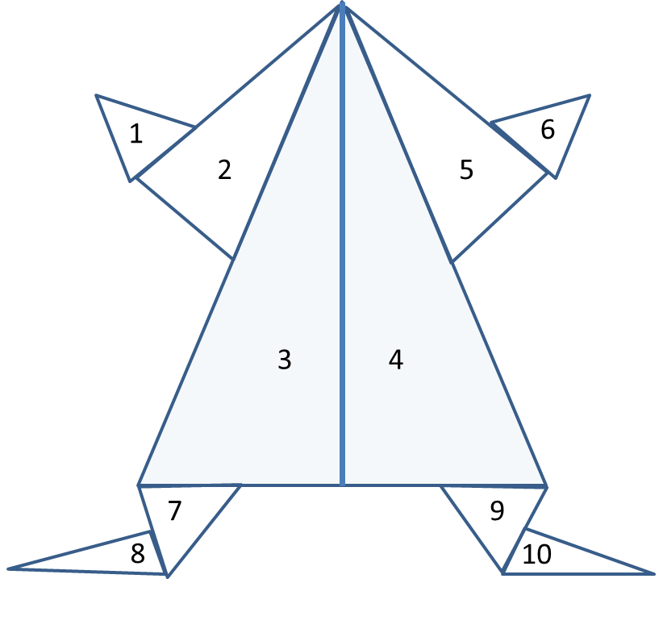 | 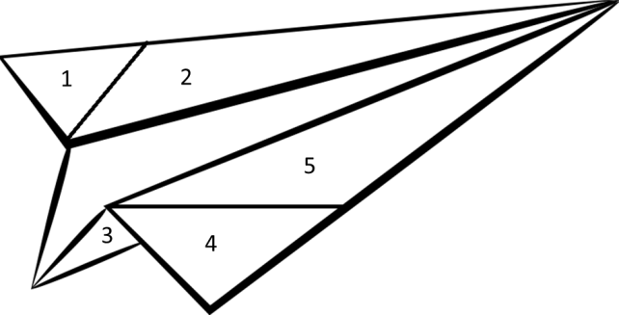
- Which triangles are acute triangle?  ……………………………………………………. | - Which triangles are acute triangle?  …………………………………………………….
- Which triangles are obtuse triangle?  ……………………………………………………. | - Which triangles are obtuse triangle?  …………………………………………………….
- Which triangles are right triangle?  ……………………………………………………. | - Which triangles are right triangle?  …………………………………………………….
- Where is the 11th triangle? Can you show it? | - Can you find the missing two triangles in the plane figure?

