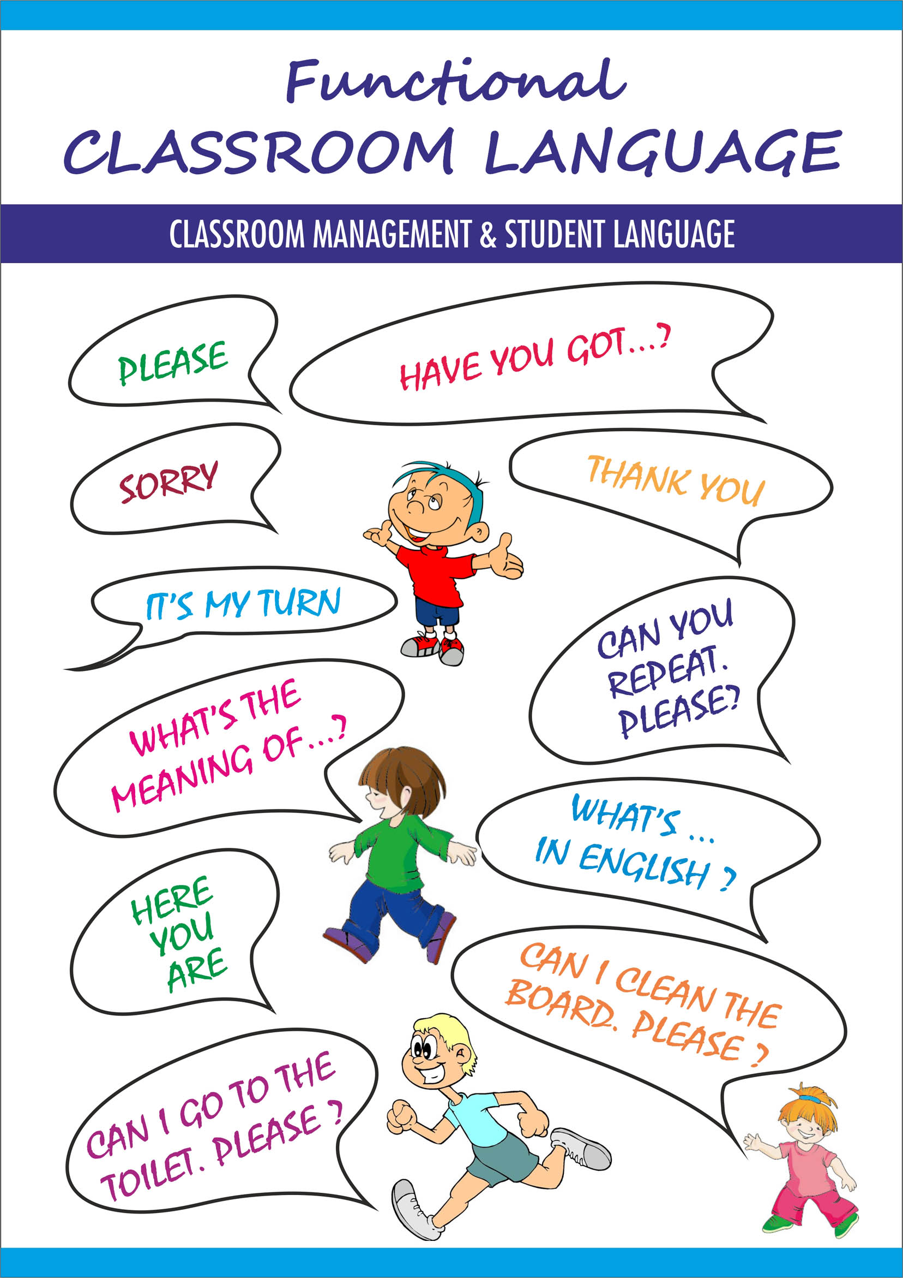
By mağpak

What is classroom language?

Classroom language is the routine language that is used on a regular basis in classroom like giving instructions of praise, for example “Take out your books” or “Please sit down”. This is language that teachers are used to using and students are used to hearing, but when teaching a language it takes a while to learn this part of the language. Knowing these language basics reduces the amount that students are forced to use their mother tongue and increases the amount of the target language they are using; it makes the language classroom environment more authentic.

Why can teaching classroom language pose a challenge?
Teachers often experience difficulties when trying to integrate classroom language into a lesson. The difficulty often lies in that many second language teachers learned the language themselves after childhood, so are not exposed to authentic classroom language. Those teachers must make a particular effort to seek out what the correct language is in order to create the most authentic experience for the students. Students often encounter difficulties when the form in the target language does not make sense in their mother tongue; students must learn to accept that different languages work in different ways.

How can classroom language be taught?

When teaching classroom language, there are several strategies a teacher can employ to facilitate the learning:
Teach the students the classroom language in a scaffolded way. Start with short commands, maybe just one word such as “Sit”. Then the teacher can progress to a longer command, such as “Sit down please” and eventually students can learn alternate phrases that mean the same think, for example “Take a seat”.
Make sure the students know what this language is for. Don’t leave them out of the learning process; they should know that the more they use the language, the more they will develop and that these forms are meant to help use the language in the most natural way possible.
Once you introduce the concepts, use them! Employ them as much as possible so the students become accustomed to them and eventually are able to use them as well.

Sources:
www.educ.ualberta.ca/staff/olenka.Bilash/best%20of%20bilash/classroom%20language.html
www.edge.ascd.org
www.curriki.org
www.cambridge.org/us/ESL/letstalk/support/language.htm

Entering the Classroom

Let's go in.

Let's go inside.

Let's go into the classroom.

Come in and sit down.

You can come in and sit down.

Go in and sit down.

I'll open the door and let you in.

I'll unlock the door and let you in.

Come in and take a seat.

Come on, Mary.

Come along, Mary.

You can come in now, Mary.

Come this way, please.

Close the door properly behind you.

Please don't bang the door.

Please don't slam the door.

You can leave the door open.

Every Day Greetings

Good morning, everybody.
Good morning/ Good afternoon class.
Good morning boys and girls.

Good afternoon, everyone.

Good evening to you.

Hello, everybody.

HOW ARE YOU TODAY?

How are you all today?
How are things with you, Mary?

How are things?

How are we all doing this morning?

How's everyone feeling today?

How's it going?
How's life?
I hope you all had a good holiday.
I hope you all had a nice weekend.
I hope you all had an enjoyable weekend.
I hope you all had a relaxing break.
I hope you had a good day so far.
I hope you're all feeling well.
I hope you've had a nice day so far.
It is a beautiful day today.
It is a pleasant morning.
The weather is great today, isn’t it?
What a fine day!

Did you do anything interesting on the weekend?
Did you do anything interesting during the break?
Did you enjoy your holiday?
Did you enjoy your weekend?
How was your weekend?
How was your holiday?
Did you have a nice weekend?
Did anybody watch the game on the weekend?

REPLIES
That's good.
That's good to hear.
That's nice to hear.
I'm glad to hear that.
I'm sorry to hear that.
I'm happy to hear that.

Meeting a New Class- Introductions

Perhaps you’re wondering who I am.
Let me introduce myself.
My name is Mr/Mrs/Ms Silver.
I'm your new English teacher.
I'm your new Math teacher.
I'll be teaching you Math this year.
I'll be teaching you English this year.
Let me tell you something about myself.

Our lessons are on Monday mornings and Wednesday afternoons.
I’ll be teaching you on Tuesdays and Fridays.
I have five classes with you each week.
I have three classes a week with you.
We’ll meet three times a week.

It’s nice to meet you all.
I’m very pleased to meet you all again.
I’m very pleased to see you all again.
I’m looking forward to working with you.
It’ll be fun getting to know you all.

What is your name?
How do you pronounce your first name?
How do you spell that?
Introductions

My name is Mr/Mrs/Ms Kim. I'm your new English teacher/ I'm your English teacher this year/ this term/ today. (Can you ask me some questions, e.g. where I'm from and my free time?
I'll just introduce myself first.
I've got five lessons with you each week.
I'm covering for your usual teacher (today/ this week). He/ she has a cold.
I'm new to this school, so please be nice to me.
Your last teacher told me you are the best class, so I hope that is true!
Can you all introduce yourselves to me?
Can you tell me and the rest of the class two or three things about the person sitting next to you?
Let's introduce ourselves, shall we?
This is my name at the top of the board, it's pronounced...

Calling out to Students / General
Attention, everybody!
Attention, please!
Boys and girls!
Cheer up!
Dear students!
Eyes on the board!
Face the board!
Focus on!
Focus! Let’s focus!
Hey folks!
You can also address the class as class, ladies and gentlemen, and, depending on the age of your students, as boys and girls or children. Informally, and with older learners, you can also use people, folks, guys and you guys.)

I would like everybody to turn towards the board.
I’d like everybody to turn towards the board.
Ladies and gentlemen!
May I have your attention for a minute?
Okay everybody, listen now!
Put down your pencils and listen carefully.
Repeat after me!
Say it after me!
Speak up, please!
Stop working and look at the board.

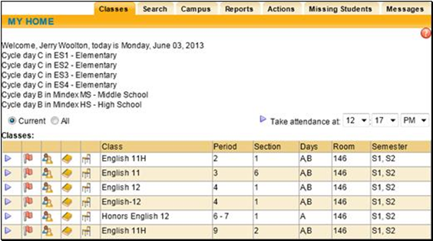
Taking Attendance

First, let me take attendance.
Raise your hand and say here.
Raise your hand and say present.
Raise your hand and say yes.
Let’s see if everyone’s here.
I’ll just check who’s here.
I have to take/check attendance.
Is the whole class here?
Anyone absent?
Who is absent?
Nice to see you all here.
Nobody’s away today.
Is there anybody missing today?
Is there anybody absent today?
Is there anybody away today?

Where’s Mary this morning?
What’s the matter with Mary?
What’s the matter with Mary?
Has anybody seen Mary today?
Does anybody know where Mary is?

Mary's away. Does anybody know why?
Is she absent or just late?
When will Mary be back?

Who was absent last time?
Who missed last Wednesday’s lesson?
Was anybody away last lesson?
Was anybody missing last lesson?
Was anybody absent last lesson?

You missed three lessons.
I hope you can catch up.
Stay after the lesson.
See me after the lesson.

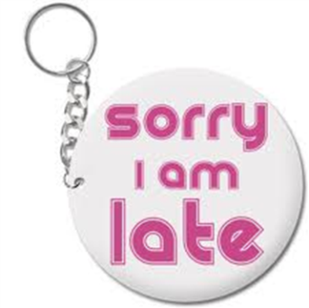
Late
Where have you been?
We started ten minutes ago. What have you been doing?
Did you miss your bus?
Did you oversleep?
Don't let it happen again.
Please be seated.
Please sit down.
I'm still waiting for everybody to be silent before we take our seats.
Once everyone is quiet, we can begin the lesson.
Please stand behind your chairs and wait to be seated.
I hope you’re all ready for your Math lesson.
Put your school bags under your desk.
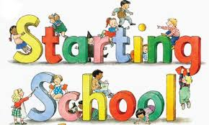

Starting the Lesson
It’s good to see everyone ready to learn.
Excellent! Everyone is here and ready with their books out.
Okay, let's get started.
What I want to do today is _____.
The first thing we will do is_____.
Today's topic is _____.
Today we will look at _ _ _ _.
Today we will find out about _______.
In this lesson, you will learn about_____.
I want to introduce you to_____.
The topic we will be looking at today is ______.
What we are going to cover today is _______.
Today, I am going to talk about ______.
First of all, I would like to talk about_____.
Today we're going to talk about_______.
Today we're going to discuss _______.

Please take out your books.

It's time to start.
I'm waiting to start.
Put your things away, please.
Open your books to page ________.
Open your exercise books.
We will read _______ on page ________.
Could you please turn to page________.

The next thing we will do is_______.
Let’s move on to________.
If there is no problem, we’ll move on to something new.
Okay. I think we can start now.
Let's get down to business!

Comprehension Language:

Are you OK?
Are you ready?
Are you with me?
Do you follow?
Did you get it?
Do you understand?
Does everyone understand?
I don't get it.
I don't understand.
Is this OK?
Like this?
OK so far?
One more time, please.
Say it again, please.
What did you say?

Ending a Lesson/Saying Goodbye

All right.
Before you leave, I have one more thing to say.
Enjoy your vacation.
Goodbye, everyone.
Have a good break.
Have you finished?
I'm afraid it's time to finish now.
I'm really pleased with you.
It's almost time to stop.
Let’s stop here and continue next lesson.
Let’s wrap it up.
OK, everybody.
Right. That's enough.
See you again next Wednesday.
See you in room 7 after the break.
See you tomorrow afternoon.
Stop now.
That’s all for this lesson. See you tomorrow.
That’s all for today. Are there any questions?
That's all for today. You can go now.
There's the bell. It's time to stop.
Time is running short. We have to stop here.
Two more minutes.
We will go through all that tomorrow.
We’ll discuss this further in the next lesson.
We'll continue this chapter next Monday.
We'll do the rest of this chapter next time.
We'll finish this exercise next lesson.
We'll have to stop here.
We'll take a break.
We've run out of time, so we'll continue next lesson.
What a great piece of work from everybody!
You've all tried really hard today.



Thanking

I really am very grateful for your help.
I'd be grateful if you could help me.
I'd be thankful if you could help me.
It was very good of you to help.
It was very nice of you to help.
Many thanks.
Thank you very much.
Thank you so much.
Thank you. I appreciate your help.
Thanks a lot/a million.
Thanks for helping.
Thanks for that.
Thanks for the idea.
Thanks for your help.
That's great. Thank you.
That's lovely. Thank you.
There you are. Take this.
This is all thanks to you.
Thank you + for (doing) something:
Thank you for cleaning the blackboard/board.
Thank you for helping me move the desks.
Thank you for lending me your book.
Thanks for lending me your book.

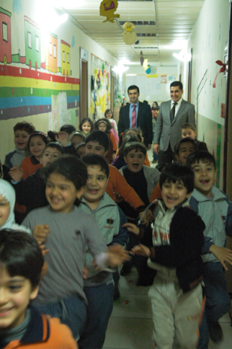
Leaving the Room
All of you go outside now!
Be quiet as you leave. Other classes are still working.
Everybody outside!
Form a line and wait for the bell.
It’s time to tidy up.
Line up!
Try not to make any noise as you leave.

Reviewing a Lesson/Talk/Presentation
Last time, we talked about ______, today we will continue with ______.
Let’s do some warming up questions before we start our new topic.
Let's review what we did yesterday.
What did we do during our last lesson?
Where did we leave off?
Who can remember what we covered in the last lesson?
Who can remember yesterday’s lesson?
Yesterday we looked at ______, today we will be continuing our work on _______.

Encouraging
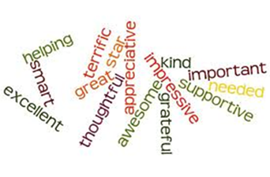

A good guess!
Are you happy with your answer?
Do you want to try it again?
Do your best.
Don’t worry about the spelling.
Good try!
Have another look!
Have another try.
I knew you could do it!
It doesn't hurt to try.
Nice try!
Not bad!
Not quite right.
Not so fast!
Take it a little more slowly.
Take it easy!

Take your time!
That's (a bit) more like it.
That's (so) much better.
That's a big improvement.
That's a lot better.
That's almost it.
That's better!
There's no hurry!
There's no need to rush/hurry.
Think about it again.
Try again.
We have plenty of time.
What should the answer be?
You just got about it.
You were almost right that time.
You're almost/nearly there.
You're so close.

More General Encouragement and Feedback

You read quite well.

You read very well.
You speak/read very fluently.
I'm really impressed with your progress.
You have all made a lot of progress.
You have very good pronunciation.
You need some more practice with these words.
You still have some trouble with your irregular verbs.
You still have some trouble with spelling words.
You'll have to spend more time practicing this.
Your pronunciation is excellent.
Your pronunciation is fantastic.
Your pronunciation is outstanding.

Your pronunciation is very good.
You're getting better all the time.
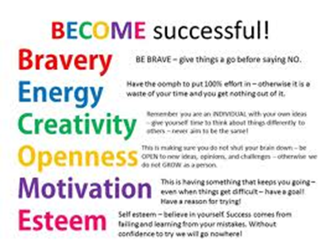
You've been working hard and it shows.
You've improved a lot.
Remember, though, to add an encouraging comment:
Nothing to worry, it'll get better.
Nothing to worry, it'll get easier.
Don't worry about it.
It'll get better in time.
Don't give up!
Don’t lose hope.

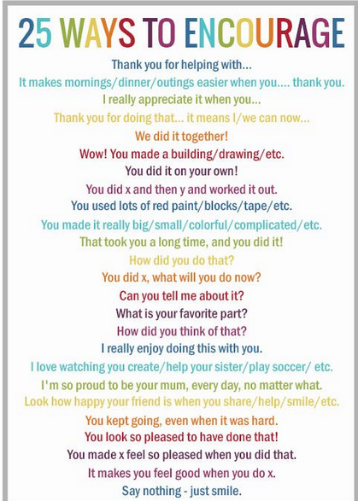
Encouraging Students to Speak - Eliciting an explanation

Can you say more on that?
Could you say a little more about that?
Do you agree?
Don't worry about it. It is very easy to learn.
Give me some examples.
How do you feel about this issue?
I can’t hear you. Say it again, but this time louder.
I would prefer to hear your answer, not your neighbor’s.
Not so quickly. I can’t understand.
Repeat once again, please.
Say it a bit louder, please.
Speak more clearly, please.
What comparisons can you make between Mary and David?
What do you think?
What is the point made by the author?
Why /why not?
You are communicating well.
You have good pronunciation.
You have made a lot of progress.
You need more practice with these words.
You speak very fluently.
You still have some trouble with pronunciation.
You were almost right.
You won’t be punished for a wrong answer.
You'll have to spend some time practicing this.
Your pronunciation is very good.
You're getting better at it.
You're halfway there.
You're on the right path.
You've almost got it.
You've improved a lot.

Encouraging Students to Speak /Participate
Do you have any comments?
Does anybody want to add to that?
Does everyone agree with the answer given by Mary?
Does everyone disagree with the answer given by Mary?
Good answer! Is there anybody that would like to contribute to that?
How would you summarize this part/piece?
Mary, what do you think about this?
Please explain your reasoning.

Encouraging Students to Speak

Can anyone tell us the answer?
Does anyone know the answer?
Raise your hand, if you know the answer.
Can anyone help her?
Can anyone help him?
What can we do next?
What can we do in this case?
What’s the answer?
Who would like to volunteer to read ______?
Who would like to volunteer to answer the question?

I need two volunteers to solve this problem.
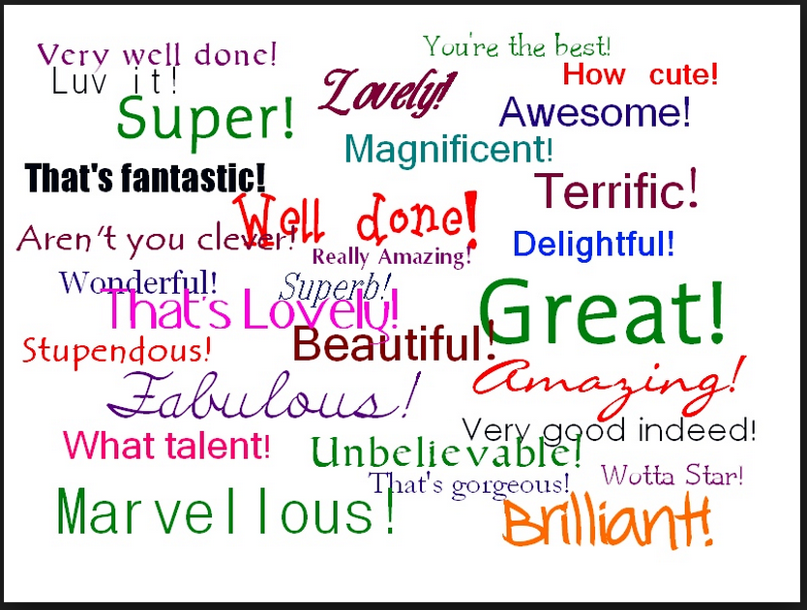
Who would like to say something?
Who would like to comment on the following?
Who wants to answer this question?
Think about_____.
Who can tell me the answer to _____?
Read your notes and tell me the correct answer.

Who would like to answer the question _____?
Who would like to solve the question?
David! Can you please tell us the answer?
Who knows what _____ means?
Who can tell me the meaning of _ _ _ _?
Comment on it.
Who can explain why this happened?

Is there an easier way to solve this problem?
Can there be more than one answer?
What more information do you need to solve this question?
What more information do you need to prove this question?
Mary has got a point.
Mary has got something to say.
Mary has got something to say, so can everyone please listen?
What you are saying relates to_____.
That reminds me of_____.

What does this mean/show?
How did you do this?
Why did it happen?
Any comments?
Do you have any ideas about_____?
Why did you do it this way?
What will you do next?
Let me give you some hints/help.

You are communicating well.
You have good pronunciation.
You have made a lot of progress.
You need more practice with these words.
You speak very fluently.
You'll have to spend some time practicing this.
Your pronunciation is very good.
Could you give me an example?
It is used for________ .
It is the same as_______.
It is the opposite of________.
Why did you disagree with the answer that ________ gave?
Can you explain?
You still have some trouble with pronunciation.

Many Different Ways to Say Very Good

Amazing!
Aren’t you proud of yourself?
You should be proud of yourself!
Awesome!
Congratulations!
Congratulations. You got it right!
Cool!
I couldn’t have done it better myself.
It couldn't be better!
Exactly right.
Exactly!
Excellent answer, ________.
Excellent!
Fabulous!
Fantastic!
Fine!
Good!
Good for you!
Good going!
Good job!
Good memory!
Good thinking!
Good work!
Great stuff!
Great!
I am delighted to have you in my class.
I am speechless!/amazed/ surprised.
I can't see anything wrong with that. Perfect!
I couldn't have given a better answer myself.
I knew you could do it.
I like that!
I’m happy to see you working.
I’m proud of the way you worked today.
I’m very proud of you.
I’ve never seen anyone do it better.
Impressive!
Keep it up!
Keep on trying.
Keep up the good work!
Keep working on it.
Lovely!
Magnificent!
Marvelous!
Much better!
Nice going!
Nice work!
Not bad!
Now that’s what I call a fine job.
Now you have it!
Now you have the hang of it.
Now you’ve figured it out.
One more time and you’ll have it.
Outstanding!
Perfect!
Quite right.
Right on!
Right!
Sensational!
Splendid!
Super!
Superb!
Terrific.
That sounds good to me.
That’s better than ever!
That’s coming along nicely.
That’s good!
That’s great.
That’s how to handle that.
That’s it!
That’s much, much better!
That’s not half bad!
That’s quite an improvement.
That’s right!
That’s the best ever.
That’s the best you’ve ever done.
That’s the right way to do it.
That’s the way to do it.
That’s the way!
That’s very good!
That's correct!
That's it!
That's nice!
That's perfectly correct!
That's quite right!
That's right!
That's very good!
There's nothing wrong with your answer.
Tremendous!
Very fine!
Very good!
Way to go!
Well done!
Well look at you go!
What you said was perfectly all right.
Wonderful!
Wow!
Yes, you've got it!
You are learning fast!
You are really learning a lot.
You are very good at that!
You are very good at this!
You certainly did well today.
You did a great job!
You did a lot of work today!
You did it that time!
You did that very well!
You didn’t make any mistakes.
You didn't make a single mistake.
You haven’t missed a thing!
You must have been practicing.
You outdid yourself today!
You're absolutely right.
You really make my job fun.
You’re doing a good job.
You’re doing fine!
You’re doing that much better today.
You’re getting better every day.
You’re going to ace the test.
You’re improving.
You’re on the right track now!
You’re really going to town.
You’re really improving.
You’re really working hard today.
You’ve done a great job.
You’ve got that down pat.
You’ve just about got it.
You’ve just about mastered it.
You've got the idea.

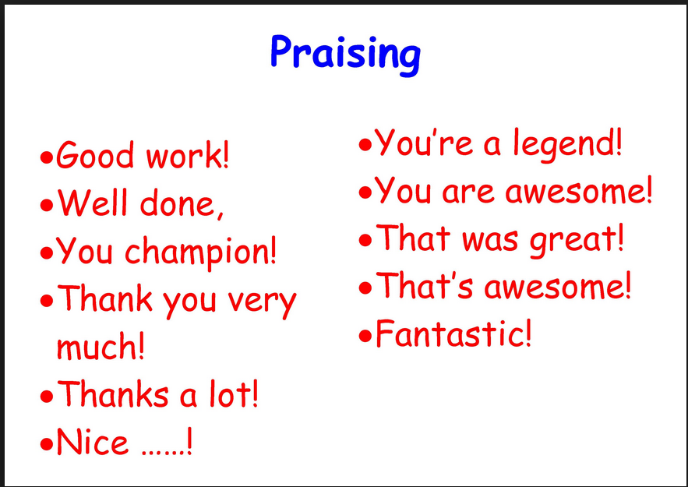

Complaining

A bit more effort, please!
Better than that!
Can't you do any better than that?
Come on!
I know you're capable of better work.
I'm sure that's not the best you can do.
Is that the best you can do?
Try harder!
You can do better than this.
You can do this!

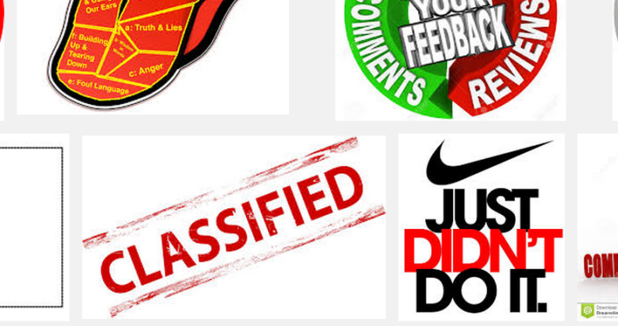
Expectations
In future, I want you to bring your textbook.
When you try this again I would like you to prepare some questions.
The next time we do this I expect you to read the passage at home.
Next time I prefer you to learn the vocabulary.
From now on I expect you to do your homework on time.

Giving Instructions for Pair/ Group Work
Boys on the right and girls on the left.
We're going to do pair work, so you need to sit closer to each other.
All the students in this row are in group one.
Can you please get yourselves into groups of four?
Each student within the group will be assigned a specific task.
Find a partner.
Find somebody to work with, on this task.
Half of the class is team one, the other half is team two.
I don't want only one person to do all the work.
I need five groups.
I want you to make groups of five.
I will divide the class into groups.
I will divide you in four groups.
I'd like you to form pairs.
In group activities do not put same level students in one group, otherwise they will not be able to help each other.
Make a straight line!
Mary, Sarah and Susan will be in one group.
One by one please or one at a time please.
Partner up please!
This side of the class is team one, the other side is team two.
We are now going to do some group work.

Work in groups of four…
Work in groups of three/four…
Work in groups of two …
Work in pairs.
Work in threes….
Work in twos….
Work together with your friend.
Work with the person next to you.

You are to find yourself a partner.
You are to form groups of 3/4/5…

Instructions for Homework /Assignments
Always get your homework checked by your parents.
Always get your homework signed by your parents.
Are there any questions you couldn’t answer in the homework? Let’s do it then.
Complete the exercise at home.
Did you do all your homework by yourself?
Did you turn in your HW?
Do exercise 10 on page 23 for homework.
Do questions _____ for homework.
Do activities _____ for homework.
Do you have any excuse for not doing your homework?
Don’t forget to bring your homework.
For your homework answer the questions on _____
Have you done your homework?
How can I assist you in doing your homework?
I see you’ve finished early. Now see if you can solve this question/riddle/puzzle.
If you do not complete your homework, stay in at lunchtime.
If you have a problem with the work, you need to come and see me after class.
If you need an extension, see me prior to the due date.
Learn this by heart.
No extensions will be given.
Please turn in your homework.
Please write your homework in your planner.
Prepare the next chapter for Monday.
Put your homework in the homework box.
Read it for comprehension!
Remember your homework.
Research the given topics.
See me during breaks for more information regarding your project.
Take a worksheet as you leave.
The deadline is over, folks.
The following questions are very important, so please answer them.
There is no homework today.
This is the homework for tonight.
This is your homework for tonight.
You have 20 minutes to get this done.
You were reminded yesterday to complete _____ for homework.
Your project is due on _______.
I’m giving back your HW. Please look at question #...
I’m handing back your HW. Please look at question #...
Have you checked all your answers to make sure they’re correct?
Since you’ve finished early, I’d like you to read this short article. I’d like you to tell your classmates about it at the end of class.
Okay everyone turn in/submit your homework.

Error correction/Improving Mistakes

Don’t be afraid to make mistakes.
Don’t worry about being wrong.
Don't worry about your pronunciation.
Don't worry about your spelling.
Don't worry, it'll improve.
Give it a try.
Go on. Have a try!
Good try, but not quite right.
Have a go.
Have another try.
I am afraid that’s not quite right.
If it is wrong, we will talk about it.
It is not quite right. Could anybody help?
It’s O.K. to make mistakes.
Maybe this will help you.
Not quite right. Try again.
Not really.
Take a guess.
Tell me your answer. If it is correct, good.
That's a lot better.
That's almost it.
That's exactly the point.
That's just what I was looking for.
That's more like it.
That's much better.
There's no hurry.
There's no need to rush.
There's nothing wrong with your answer.
We all learn from mistakes.
We have plenty of time.
We’d really like to hear what you think.
What you said was perfectly all right.

Transitions/Checking understanding
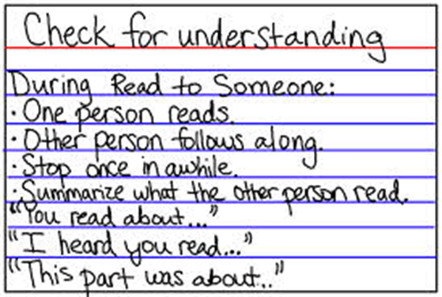
Are we clear?
Are you all on the same page?
Are you keeping up?
Are you with me?
Did you understand this entirely?
Do you follow me?
In order to be successful we all should be on the same page.
Is everything clear?
Is there anything you don’t understand?
Is there anything you would like to ask me about?
Another important point is _________.
It might be better to say________.
Another example is _______.
Let me give you an example.
Let's finish talking about ______, before we move on to ________.
In other words, ________.
Let’s go over the topics we have covered so far.
Now let's approach the problem in a different way.
Now let's look at the problem in a different way.
Raise your hand if you have any question.
There is an alternative way to solve this problem.
There is another way to solve this problem.

Transitions/Summarizing, Concluding
As a result
Does anybody have any questions in their minds about the last topic?
Finally
In conclusion
In summary
Let's put together everything we have talked about so far.
Before I conclude let me make a point about ________.
Okay, we have discussed______ .
All of you should know _______.
Since we are about to finish, let’s have a quick review of the topic.
So how can we conclude?
So what have we understood from this topic?
That is the way it goes.
That is the way it works.
To conclude,
To sum up,
To summarize,
What message is the piece of writing trying to give?
What message is this story trying to give?
What was the best part of this lesson?
What was the easiest topic we’ve covered so far?
What was the most difficult topic we’ve covered so far?
So far I have been trying to show you______ .
The conclusion we can draw from this is______ .
The important point I want to make is ______ .
The important points to remember are ______ .
The main points are ______ ._.
This was a very productive session. So please read ______ .
What we have been talking about is ______ .

Instructions for Tests and Examinations
All pens down.
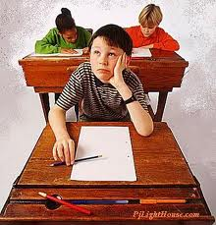
Don’t turn over the question paper yet.
I am going to give a quiz on the spot.
I hope you will nail all the questions.
No more writing.
Stop writing!
Now put your things away.
Pass the paper to the back.
Pass the quiz to the back.
Pass the test to the back.
Pass your paper to the front.
Take one and pass it on.
Put all your books away.
Put down your pens, please.
Read the instructions carefully.
Ready, set, and go!
Remember to write your name and class number.
Skip question number 6.
Time is up.
Today’s test is a piece of cake.
When you hand out the results of the exam, don't let anyone see the others` results.
You may start now.
You still have 10 minutes.

Taking Part

Can you all hear?
I'll speak a bit louder.
Can you see all right?
Is that better?
Has everybody got a pencil?

Taking turns:
Your turn.
Who's going to start?
Who's next?
Who hasn't had a turn?
Not you again.
Let's give someone else a chance.

Working in groups:
Work in groups.
Find yourself a partner.
Could you join this group?
Work on your own.
One of you..., the other (one)...

Student choices:
Any volunteers to try the next one?
Anybody willing to clean the board for me?
Are there any volunteers?
Which group do you want to join?
Which team do you want to be in?
Which topic would you like to take?
Who wants to act as the secretary?
Who wants to be Mrs. Brown?
Who wants to start?
Who wants to write that for me?
Who wants to write that on the board?
Who would like to do this?
Who would like to go first?
Who would like to read the part of John?
Who would like to write that on the board?
You can choose.
You can decide.
You can pick.

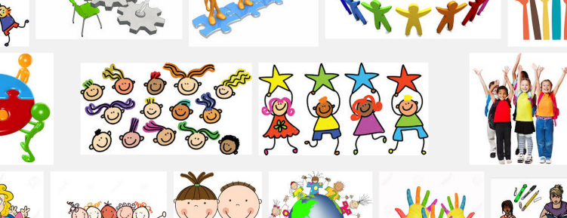

Role Play Activities
Choosing a group or team and choosing a topic:

Do you want to be in David's team?
Do you want to be John or Mark?
Is there a particular topic you are interested in?
Is there anybody you would like to work with?
Which English name do you want?
Which name do you like best?
Which name do you prefer?
Which part do you want to play?
Which subject do you want to work on?
Which team do you want to be in?

Working in Groups

Work in groups.
Get into groups.
Three students in each group.
For this activity, I'd like you to work in fours.
I'd like you to arrange yourselves into two teams.
I'd like you to divide yourselves into threes.
I'll divide the class up into five groups.
I'll split the class up into five groups.
Find yourself a partner.
Work together with a friend/ the person next to you.
Work together with your neighbor the person next to you.
Work together with the person next to you.
You two together, and you two, and so on.
Go and sit with David and make a pair.
Team up with two other people to make a group of three.
Has everybody got a partner?
Haven't you got anyone to work with?
Could you join this group?
You'll have to join Julia's group.
Lena and Marco, you can form group.
Could you work with Michael today?
Move over to this group, Melanie.
Can you team up with Sara?
We need one more person in this group.

Checking answers
How did you answer number 1?
I agree.
I don’t agree.
What do you think?
I think that’s right.
I think that’s wrong.
Let’s ask the teacher about this.

Playing Games

Let's play a game.
Get into two teams.
Listen carefully to the rules.
Are you ready?
It's your turn.
One point for this team.
Last question.

Songs, rhymes and chants:
It's time for a song.
Do you know this song?
Repeat the words after me.
Sing along with the recording.

Acting out:
Let's act out this dialogue.
Who wants to be the detective?
You have five minutes to practice.
Give yourselves a clap.

Preparing and organizing displays:
You are going to prepare a poster.
First decide what information to include.
Now try out different designs.
Let's make the display.

Using objects:
I have something to show you.
I'll give you a clue first.
Look at it carefully.
How would you describe this?

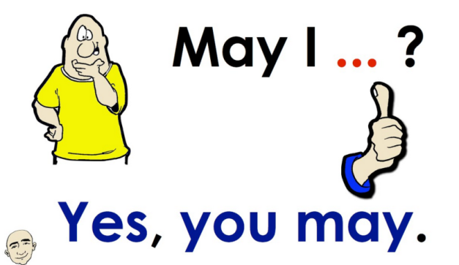

Dates, Birthdays and Holidays

What's the date today?
What day is it today?
What date is it today?
What's today's date?
What's special about today?
What makes today a special day?

Birthday:

Happy birthday!
Mary has a birthday today.
Mary has her birthday today.
Anna is twelve today. Let's sing 'Happy Birthday'.
Congratulations on your 8th birthday, Jeanne.

Have a good holiday.

I'd like to wish you all a very happy holiday.
Have a good holiday!
Enjoy your winter break.
Have a great vacation!
Make the most of your winter holiday.
Enjoy your holiday!

Expressions for Conversations
Responding to someone in a conversation:

Yeah, I guess so.
No, I guess not.
Oh, that’s great.
Oh, that’s terrible.
Really? That’s interesting.
You’re kidding!

Asking for clarification and asking for more details

And what about . . . ?
What do you think?
I didn’t hear what you said.
What do you mean?
Really? Why?
I didn’t hear what you said.
So, then what happened?

Using conversation fillers
Do you know what I mean?
Well, _______.
I mean, _______.
Actually, _______.
You see, _______.
You know, _______.

General expressions for the classroom

I’m sorry. What are we supposed to do?
Can you say it again, please?
How do you say _____ in English?
How do you spell _____ ?
How do you pronounce _____ ?
What does _____ mean?

Expressions for pair work and group work
Role-playing activities and sharing information
Who's going to begin?
You start.
Let’s start.
Which role are you going to take?
I’ll be . . . You’ll be . . .
It’s my turn.
It’s your turn.
Whose turn is it?
I think we’re finished.
What should we do now?

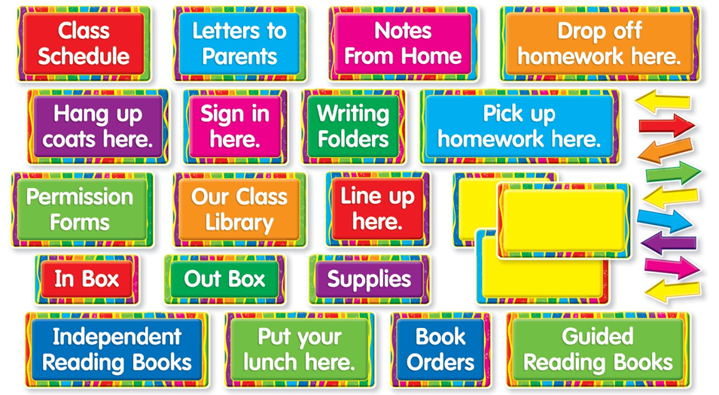
CLASSROOM
MANAGEMENT

Simple Classroom Rules
We have rules to make our school a better place. Here are our school rules:

Always try to be helpful.
Be on time for school.
Be polite to each other.
Be polite.
Be respectful to your teachers and the elders.
Do your homework and bring your materials.
Don’t run or shout in classroom and lunchroom.
Enter class quietly.
Knock before you enter a room.
Let others work.
Look after our school.
Make visitors feel welcome.
Remember to smile.
Respect others' rights to speak.
Respect the rights of others.
Speak with permission.
Take care of your belongings.
Think others before yourself.
Work quietly.

Managing the Classroom
Keeping the classroom comfortable
Can you see the board?
Don't you think it's quite chilly today?
Don't you think it's somewhat chilly today?
How about drawing the curtains?

I don't think we'll be able to do anything about this now.
Is the sun shining on the board? Is the sunlight reflecting on the board?
Isn't it really freezing?
It seems to be too cold in here.
It seems to be too hot in here.
It's very stuffy in this classroom, isn't it?
It's very warm in this classroom, isn't it?
Let’s open the curtains please.
Let's open the curtains.
Oh, this classroom is too bright. Let's switch off/on the lights.
Oh, this classroom is too dark. Let's switch on the lights.
Open a window, please.
Phew! It's warm in here today. Open the window, please.
Please close the window. Could you open the door? Let's have/keep the door open.
Please turn on the lights.
That feels a lot/much better.

That’s better.
That's an improvement.
That's more like it.
That's the best we can do for now.
Well, we'll just have to manage with things as they are.

Making space
We need to make some space.
Does everyone have enough room to move?

Moving Furniture
We have to rearrange the tables around for this lesson/afternoon session.
Please push your desks to the side.

Moving Around in the Classroom

Bring out what you have done.
Bring out your work, please.
Bring your work to me to check/look at.
Change places with David.
Come and sit at the front.
Come and stand by the board.
Come and stand here.
Come closer to the television.
Come nearer to the board.
Come nearer to the screen.
Come over here.
Come to the back of the class.
Come to the front.
Come up here.
Find yourself a seat.
Follow me.
Go and sit down again.
Go and stand there.
Go back to your place without disturbing anyone.
Go back to your seat.
Let's see what you have been working on.
Please return to your seat quickly and quietly.
Please stand by the door.
Return to your own place, please.
Sit down, please.
Sit in your original/normal seat, please.
Sit in your seats.
Sit properly.
Stand facing (the rest of) the class.
Stand up.
Take your seat(s).
You are welcome to sit.
You may sit down now.

Group/Pair Work

Can you join the other group?
Find a partner.
Form groups of three.
Here are some tasks for you to work on in groups of four.
I asked for four people in a group.
I want you to form groups.
Make a circle with your desks.
Make a horseshoe shape with your desks.
Make a line of desks facing each other.
Make groups of four desks facing each other.
Make groups of four.
Move your desks into groups of four people.
Only three people in each group.
Sit back to back.
There are too many people in this group.
Turn your desks around.
Work in groups of two/three/four.
Work in pairs/threes/fours/fives.
Work together with your friend.

Work Individually

Ask everyone in the class.
Ask other people in the group.
Ask others in the class.
Ask your neighbor for help.
Do the next activity.
Everybody work individually.
Have you finished?
Interview someone else.
Move on to the next activity.
Stand up and find another partner.
Work by yourselves.
Work independently.
Work on the task together.

Explain
What's the Spanish for doll?
Explain it in your own words.
It's spelt with a capital J.
Can anybody correct this sentence?
Fill in the missing words.
Mark/choose the right alternative/best answer.

Classroom Management Interactions with Class

Be quiet!
Be seated!
Cut it out.
Everyone sit up please!
Have a seat.
I am sick and tired of _____.
I cannot believe this!
I need silence here!
I want you to be ready before I come to class.
Keep quiet please!
Keep quiet!
Keep quiet, please.
Keep your silence!
Keep your voices down.
Listen up please!
Lower your voices!
Please be quiet.
Please be silent.
Quiet now, please!
Quiet, please!
Please remain silent while I introduce your new topic.
Settle down!
Sit down!
Stop it!
You are making too much noise.
Stop talking!
Take your seats.
That’s enough!
We are doing this because we want our class to run smoothly.

We are in class; your break time is over. Have a seat, please.
You should not walk in the classroom with food or drinks.
There is to be no eating or drinking in the computer lab.
Please do not interrupt me.
Be respectful to your classmates.

Will you listen to me?
You’re disrupting me and your friends.
Sit up please!
Keep your comments to yourself please.
Pull up your chair!
Straighten your chair!
Do not push me! / You are pushing it!
Do not make me say it again!
Do not rush me!
Give it a rest, will you?
If I see anybody talking when they shouldn’t, they will be punished.
I want everybody to be silent for the next 5 minutes.
I don’t want anybody complaining.
Can only the person whose name has been called out answer my question?

Keep your desk clean.
You are interfering with other students’ listening.
You are preventing other students in this class from learning.
I am not going to warn you again!
Stop raising your voice!
Stop going word for word with me.
Do not talk back to me!
You and I are going to have a talk in the hallway.
Cut it out please!
Do not disrupt the class please!
Do we have to go through all that again?
Don't tell me what to do!
I am not finished with you!
Knock it off!
Stop acting that way!
Watch your mouth!
Watch your tongue!
We have been through this before.
You cannot tell me what to do!

Gaining Attention / Interactions with Class

Be still, please!
Calm down!
Can I have a word with you?
Can I see you in my office?
Can you please be quiet and listen, so we can continue with ______.
Could I have a bit of silence, please?
Could you please come outside for a minute?
Do not lean on your chairs.
Do not speak to me in that tone!
Don’t talk to each other.
Don't move.
Excuse me John, do you have a question?
Face the front and listen carefully.
Get up from your desk/table.
Go have a seat!
His constant talking interrupts my teaching.
Hold your thought = Hold your point.
I am going to change your seat.
I can't hear myself think!
I can't hear with this noise.
I can't hear with this racket.
I think Michael wants to add something to our discussion.
I want your undivided attention.
I will appreciate if you could move over here.
I'd like you all to be quiet for a moment.
If I were you, I would change my tone!
If I were you, I would stop talking right now. (to audience)
If you've got something to say, say it to me.
I'm sorry you're too noisy now.
I'm waiting for absolute silence.
Is there a reason for this amount of noise?
It's getting too noisy in here.
Just let me explain.
Let's have some quiet now.
Leva, can you please be patient and wait for your turn?
Look at your teacher!
Look at/towards the board.
Look over here.
Look this way now.
Move on with your life.
No chatting now.
No talking now!
No way!
Nobody move!
Once everybody is quiet we may continue.
Please be quiet while listening to others.
Please get to the point.
Please stay on the subject/issue.
Please take your stuff and go sit next to Tim.
Pull up a chair.
Put your hand up if you don't have your book here today.
Raise your hand if you don't have your book with you.
Respect others who are speaking.
Seeing that you are talking you can answer this question.
Silence, please!
Sit properly.
Stand up, and go over there.
Stand, please.
Stay in your seat/place.
Stay where you are.
Step aside!
Step outside!
Stop fighting!
Stop shouting!
Stop talking for a minute now.
Thank you. Be quiet!
That sort of behavior will not be tolerated.
Turn round to face me, please.
Wait outside.
You are not supposed to do that.
You are not supposed to_____.
You are supposed to___ .
You need to look and listen, please.
You should be listening.
You shouldn't be eating and drinking in the classroom.
There’s too much noise.
Keep your voices down.
What a lot of noise!
What a noise!
This level of noise is too much.
Keep your voices down.
You may want to change your tone!
I’m afraid you’re a little bit too noisy now.
I’m sorry you’re a little bit too noisy now.
If you’ve got something to say, say it to me.
Quiet please!
Did everyone catch that?

GENERAL
REMINDERS
for the TEACHERS

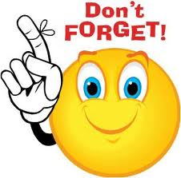

General Reminders for Teachers
The first day is too important.

RULES

State the class rules.
Rules should be both written and taught to students at the beginning of the year.
Involve the class in making the rules.
Keep the rules short and easy to understand.
Phrase the rules in a positive way.
Make different rules for different kinds of activities.
If a rule isn't working, change it.

GRADING
You have to give at least four grades for each student in a week.
Justify your grade.
You should have a notebook for student grades.
Make sure that the students are on task.

Don't give busy work to students.

Don’t yell.
Don't constantly warn the students; give them time to correct their behavior.
Learn their names and call them with their names.

Post the procedures of homework, test, etc. on the wall of classroom.
The students like to have a certain reputation.
Don't publicly yell at a student.
When you warn a mischievous student, try to not interrupt the lesson.
You should say “Excuse me!” when you are passing among or in front of people.
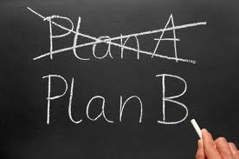
You should always have a plan-B
You should have an activity folder.
Always act positively.

If you don't have definite information about his/her family, don't ask any questions about his/her parent.
When you start to speak slowly and calmly, they'll stop talking and pay attention.
You may prepare a table which shows the success ratio of the class after the exams.
Don't constantly stand at the front.

Be careful when you pronounce the last word of your sentence (intonation).
You may send your syllabus to the parents with students to be signed that gives information about you and your
course at the beginning of school.
Don't forget the special days for your students, call them and give them small presents.

You should also notify the parents about the positive development of their child.
Think out of the box. Not in the box.
You should walk around in the class while you are teaching.
The students will test you.
You must not tolerate bad behavior.
If someone is angry, don't laugh or smile at her or him especially to the parents.
Spell out everything in your syllabus.
Your syllabus must be posted on the wall.
Observe which students participate during the lesson.
Make everyone participate in the lesson.
Be well prepared!
Keep your word!

Never argue with the students.
If a student has a discipline problem, talk to him/her privately.
When you are talking with a student in your office keep the door open.
Be a polite host.

DON’T SAY or SAY

Never say! “I need your help.” Instead say: “I need this.”
Never say “loser” to a student.
Instead of “Not or It is not correct”; say: “It is an idea or Try it again.”
Don't say “hurry up”.
Do not say to the students “my way” or “the highway”.
Use “correct” in the classroom instead of “true” .
Write them in your notebook, not on your notebook.

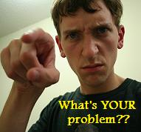

Communication with Students and Parents


Wrong (W) Right ®
To students:
a) What’s your problem? (W)
What’s the problem? ®
To parents:
b) Your child is causing problems in the class. (W)
Your child is not doing what I tell her to do. ®
She is challenging my authority in the classroom. ®

c) Your child does not listen. (W)
She is having some trouble listening to and following directions. What can we do to help her? ®

d) You should help your child with his/her homework. (W)
Does she have anyone who can help her with her homework? ®
Is it possible for her to get some help with her homework? ®

e) Your child always lies. (W)
Sometimes she has some trouble being honest. ®

Misbehaviors of Teachers
Early firing.
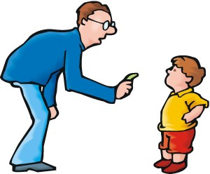
Keeping students overtime.
Lack of emotion or feeling; impassiveness.
Lack of response to students' questions.
Lateness.
Negative personalities.
Sarcasm (irony) or put-downs.
Show unfairness.
Showing lack of interest
Unfair grading.
Unreasonable and arbitrary rules.
Verbal Abuse.

Other Common Phrases

Glad to Meet You

Nice meeting you.
Nice seeing you.
Nice to have you back.
Nice to meet you.

Starting a Conversation or Discussion, and for Asking Someone's Opinion:

I'd like to know...
I'm interested in...
Could I ask...?
Could you tell me...?
Perhaps you could tell...
What do you think of...?

Asking for Information
Excuse me, could you tell me where ... is?
Excuse me. Can you tell me...?
Do you know...?
Do you happen to know...?
I'd like to know..., please.
And there's another thing I'd like to know... would be interested to know...
Please could you tell me...

Expressing Uncertainty
I'm not really sure but I think...
I can't say for certain but...
It's difficult to say exactly but perhaps...
I couldn't say, really... I'm not sure.
I don't know for sure but...

Giving Yourself Time to Think

How shall I put it?...
I think it's difficult to answer that question...
I'll have to / Let me think about that for a moment...
I'm afraid, I can't help you.
I'm sorry, I don't know.
Let me get this right...
Let me think...
Now, how can I say this...?
Um, well, that's a difficult question / that's an interesting question.
Well, let me see...

Being Polite Showing Interest

Right!
Really?
That's interesting!
And? What then?
Oh? What happened next?

Showing that You're Listening
Now, you mentioned...
So, that's how...?
Yes, I was going to ask you about that...
Could you give me / us an example of...?
Could you explain in more detail...?

Please accept my apologies.
That's all right/OK.
Nothing to worry.
That's quite all right.
That's perfectly all right.
All right.
No reason/need to apologize.
Don't worry about it.

Checking if someone has Understood
Are you with me?
Did you follow that?
Have you got that?
Is everything clear so far?
Does that seem to make sense?

Sequencing Actions
First of all, ...
Next, ...
Then, ...
After that, ...
Finally, ...

Making suggestions
Shall I / we... (do)?
Let's... (do).
Why don't I / we... (do)?
How about... (doing)?
What about... (doing)?
I think we should... (do).
I suggest that we... (do).
It might be a good idea if we / you... (do).
I think the best way of dealing with this situation would be to... (do).
If you ask me, I think we / you should... (do).

Agreeing to a Suggestion
Yes, I think that's a good idea.
That's probably the best option.
Sure, why not?
Yes, definitely.
Good idea!

Rejecting a suggestion
Yes, but wouldn't it be better to... (do)?
That's a good idea, but... (do).

Making Invitations
What are you doing on... (day)?
Have you got any plans for... (day/time of day)?
Would you like to... (do)?
What about... (doing)?

Accepting an Invitation

Yes, I'd love to.
Yes, that would be great.
Refusing an invitation I'm afraid I'm busy on... (day).
How about ... (day)?
I'm sorry I can't.
I'm... (doing something else).
I'm afraid I can't make it.
I'm... (doing something else).
I'd love to, but...
That's very kind of you, but...

Expressing a preference
I'd rather... (do) than... (do something else).
I prefer... to... I'd prefer to... (do).
I think... is much more interesting than...
I don't find... half as interesting as...
I like... better than...
Making recommendations
You mustn't miss the...
You must go to the...
You've got to... (do)
You'll love the...
I wouldn't recommend the...

Offering Something

Would you like...?
What can I get you?
Help yourself to...
Please have some...
Would you care for some...?
Can I offer you...?
Can I get you a... / anything?

Accepting Something That's Offered

Yes, please.
Thank you very much.
That would be very nice.
I'd like some... , please.
Declining something that's offered
I'm all right/I'm fine, thank you.
No, thanks.
Not this time, thanks.
I'm not sure I could, thank you.
Asking for advice
What do you think I should do?
What would you do (if you were in my situation)?
What would you advise me to do?

Giving Advice
I think you should... (do).
You could... (do).
Why don't you... (do)?
If I were you, I'd... (do).
Have you tried... (doing)?

Asking for Permission
Can I.../May I..., please?
Do you mind if I...?
Mind if I...?
Any chance I could...?
I wonder/I was wondering if I could...
Would it be possible for me to... ?
Do you have any objection if I...?
Would it bother you if I...?

Giving Permission
Certainly. Yes, that's OK/fine.
You're welcome to...
Please feel free to...
Please don't hesitate to...
Sure. OK.
Go ahead.
Why not?

Refusing Permission
I'm sorry it's not possible...
I'm afraid you can't.
I'm afraid that's out of the question.

Communicating Ideas
I'd probably agree on that.
I think that's probably right.
That's absolutely right.
Sure! That's exactly what I think.
I couldn't agree with you more.
That's what I think.

Disagreeing
Yes, but... True, but...
I see what you mean, but...
I suppose so, but...
Yes, but on the other hand...
I'm afraid I disagree / don't agree / can't agree...
You have a point there, but...
Actually, I'm not sure if I agree with that.

Asking What Someone Thinks

What do you think?
What do you reckon?
What's your opinion about/of... ?
What's your position on...?
What's your reaction to...?
What's your take on... ?
Do you have any thoughts on... ?

Stating Consequences
As a result, ...
Consequently, ...
Because of this, ...
Due to (cause),...

Expressing Two Points of View
On the one hand..., on the other hand...
Although I'd...,
I certainly wouldn't...
While I might...,
I don't think I'd...
Of course I'd..., but I'm not sure if I'd...
There's no doubt that it would..., but there's also a chance it might...

Giving Examples

For example, ...
For instance, ...
One example of this is...
To give you an idea, ...
Look at the case of...
Take, for example, ...
Let's say, ...

Explaining your Opinion:

First of all,...
The main reason is..
The main thing is...
The most important thing is...
Secondly,...
The other reason is...
Another reason is...
Besides that, ...
And on top of that,...
And finally,...

Justifying your opinions
Personally, I (don't) think... because...
Let's (not)... because...
In my opinion, I (don't) feel... because...
I would definitely (not)... because...
It would be better to... as...
I (don't) feel that it's important to... as...

Linking what you're saying
Anyway, ...
True, but ...
As a matter of fact, ... ... sort of...
Hmm... ... you know... ... believe me...

Ordering / Sequencing

First of all, ...
To start with, ...
Secondly, ...
Another thing is that...
Alternatively, ... Last but not least, ...
Persuading: But don't you agree that...
Don't you think that...

Presenting An Opinion
Personally, I think that...
It seems to me that...
From my point of view, ...
In my opinion, ...
Prioritizing ... would be much more important than...
I don't think... would be nearly as important / urgent as... ... will definitely be the most / least ...
Speculating
It's difficult to say exactly, but I suppose it could be...
I'm not sure but it might be...
It can't be... because...
It must be... because...
I would guess...

Summarizing

Basically, ...
In short, ...
Let me just recap what's been said so far.
Overall, it would seem that...
The point I'm trying to make is...
To sum up, ...
What it comes down to is...

Giving Directions
Go straight on.
Take the first/second on the left / right.
Turn left / right.
Go along... as far as...
Take the number 7 bus / tram.
Get off (the bus / tram) at... (place).
Carry on until you see...
Look out for...

Mottos on the Classroom Walls.
Believe in yourself!
Everyone has problems and obstacles to overcome.
Hand in Hand, Together We Can.
I hear and forget, I see and I remember, I do and I understand.
If you aren't willing to work for your goals, don't expect others to.
If you can dream it, you can do it.
Is directly related to what you do or fail to do.
Keep trying!
Knowing there are guarantees, and give it all they've got.
Never give up!
Never stop learning.
Never think it's too late or too early to begin.
Practice makes perfect!
Time plays no favorites.
What you achieve, or fail to achieve in your lifetime…
Whatever you are, be a good one.
Winners meet life challenges head on.
You can choose your own direction.
You cannot open a book without learning something.

DAILY CONVERSATION TOPICS

Giving advice and opinions
- He won’t pay attention to anybody. You’re just wasting your breath.
- I suggest that you tear up the letter and start over again.
- I’m old enough to make up my own mind.
- I’ve always tried not to interfere in your affairs.
- If you don’t like it ,I wish you would say so.
- If you don’t take my advice, you’ll be sorry.
- If you want my advice, I don’t think you should go.
- In general, my reaction is favorable.
- In my opinion, the house isn’t worth the price they’re asking.
- It’s none of my business, but I think you ought to work harder.
- It’s only a suggestion, and you can do what you please.
- Let me give you a little fatherly advice.
- My feeling is that you ought to stay home tonight.
- Please don’t take offense. I only wanted to tell you what I think.
- Thanks for the advice, but this is something I have to figure out myself.

Getting other people’s opinions and ideas
- Certainly, you’re absolutely right about that.
- Do you really want to know what I think?
- Do you think it’s going to rain tomorrow?
- He’s tired because he worked hard all day today.
- I don’t know whether it will rain or not.
- I like hot weather best.
- I think you have very attractive children.
- I think you’re mistaken about that.
- In my opinion, that’s an excellent idea.
- Of course I want to know what your opinion is.
- Personally, I prefer winter weather.
- Please give me your frank opinion.
- What do you think of my children?
- What do you think? Is that right?
- Why is David so tired? Do you have any idea?

Asking favors of other people
- Could you lend me ten dollars? I left my wallet at home.
- Don’t forget to cable to let us know you arrived safely.
- For one thing, I’ve got to drop by the bank to get some money.
- He’ll always be indebted to you for what you’ve done.
- I almost forgot to have the phone disconnected.
- I certainly didn’t intend to cause you so much inconvenience.
- I didn’t realize the time had passed so quickly.
- I never would have thought of it if you hadn’t mentioned it.
- I wish I could repay you somehow for your kindness.
- I’d appreciate it if you would turn out the lights. I’m sleepy.
- I’d be happy to help you in any way I can.
- I’ll see you off at the airport.
- I’m afraid it was a bother for you to do this.
- I’m sure I’ve forgotten something, but it’s too late now.
- I’ve got a lot of things to do before I can leave.
- If there’s anything else I can do, please let me know.
- It wasn’t any bother. I was glad to do it.
- It’s a good thing you reminded me to take my heavy coat.
- Making preparations to travel
- OH, I just remembered something! I have to apply for a passport.
- There’s just one last favor I need to ask of you.
- They’re calling your flight now. You barely have time to make it.
- This is the last time I’ll ever ask you to do anything for me.
- Would you be so kind as to open this window for me? It’s stuck.
- Would you mind giving me a push? My car has stalled.
- Would you please hold the door open for me?
- You don’t have to pay any duty on personal belongings.
- You’d better run or you’re going to be left behind.
- You’re very kind to take the trouble to help me.

Asking people to do things
- Hang up my coat in the closet, will you please?
- If you have time, will you call me tomorrow?
- Please ask John to turn on the lights.
- Please bring me those magazines
- Please count the chairs in that room.
- Please don’t bother me now. I’m very busy.
- Please pick up those pencils and notebooks.
- Put your books down on the table.
- Take these books home with you tonight.
- Will you do me a favor?
- Would you help me lift this heavy box?
- Would you mind mailing this letter for me?

Classroom expressions

- Close your book, please.
- Come in, please.
- Do you understand?
- Don’t open your book.
- It’s time to begin.
- Let’s begin now.
- Listen and repeat.
- No, I don’t understand.
- Now read, please.
- Open your book, please.
- Sit down.
- Stand up, please.
- That’s fine.

- Yes, I understand.

Countries and nationalities
- According to the latest census, our population has increased.
- Do you know what the population of Japan is?
- How old do you have to be to vote in the national elections?
- I was born in Spain, but I’m a citizen of France.
- I’m an American by birth.
- My home is in the capital. It’s a cosmopolitan city.
- Politically, the country is divided into fifty states.
- The country is rich in natural resources. It has mineral deposits.
- The industrial area is centered largely in the north.
- This nation is noted for its economic stability.
- Today we celebrate our day of independence. It’s a national holiday.
- What part of the world do you come from?
- What’s the area of the Congo in square miles?
- What’s your nationality? Are you American?
- Who is the governor of this state?

Describing objects
- How long is 60 meter street?
- I like the shape of that table.
- It’s not too heavy, but I don’t know the exact weight.
- My book has a dark blue cover.
- One of my suitcases is small, and the other one is medium size.
- That street is only two miles long.
- The walls are three inches thick.
- This material feels soft.
- This pencil is longer than that one.
- This round table weighs about forty-five pounds.
- This window is just as wide as that one.
- What color is your book?
- What size suitcase do you own?
- Will you please measure this window to see how wide it is?

Discussing different points of view

- Everyone is permitted to his own opinion.
- He seems to have a lot of strange ideas.
- I don’t see any point in discussing the question any further.
- I must know your opinion. Do you agree with me?
- I won’t argue with you, but I think you’re being unfair.
- Our views are not so far apart, after all.
- Please forgive me. I didn’t mean to start an argument.
- That’s a liberal point of view.
- There are always two sides to everything.
- We have opposite views on this.
- We should be able to resolve our differences.
- What alternatives do I have?
- What point are you trying to make?
- You approach it in a different way than I do.
- You have your point of view, and I have mine.

Eating in a restaurant

- Are you ready for your dessert now?
- I want my meat well-done.
- I’d like a bowl of tomato soup, please.
- I’ll have mashed potatoes and green beans.
- May I have the check, please?
- The waiter seems to be in a hurry to take our order.
- They serve good food in this restaurant.
- This knife is dirty. Would you bring me a clean one, please?
- We have vanilla, chocolate, and strawberry.
- We invited two guests to dinner, but they didn’t come.
- What kinds of vegetables do you have?
- What would you like to eat?
- Which would you rather have--steak or fish?
- Would you please pass the salt?
- You have your choice of three flavors of ice cream.

Making appointments
- Are you looking for a permanent position?
- He wants to change his appointment from Monday to Wednesday.
- I can come any day except Thursday.
- I couldn’t keep the appointment because I was sick.
- I’d like to make an appointment to see Mr. Cooper.
- I’m a new employee. I was hired yesterday.
- I’m going to call a plumber to come this afternoon.
- I’m going to call the employment agency for a job.
- Let’s make a date to go shopping next Thursday.
- Please call before you come, otherwise we might not be home.
- Please fill in this application form.
- She failed to call the office to cancel her appointment.
- Will you please lock the door when you leave?
- Would you like to arrange for a personal interview?
- Your appointment will be next Thursday at 10 o’clock.

Making decisions
What have you decided?
- According to Mr. Green, this is a complicated problem.
- He didn’t want to say anything to influence my decision.
- He knows it’s inconvenient, but he wants to go anyway.
- I assume you’ve decided against buying a new car.
- I want to persuade you to change your mind.
- I’m anxious to know what your decision is.
- I’m confident you’ve made the right choice.
- I’ve definitely decided to go to California.
- It took him a long time to make up his mind.
- She insists that it doesn’t make any difference to her.
- She refuses to make up her mind.
- We’re willing to accept your plan.
- Will you accept my advice?
- You can go whenever you wish.

Making plans

- After you think it over, please let me know what you decide.
- He can’t decide what to do.
- I doubt that I’ll do anything tomorrow.
- I imagine I’ll do some work instead of going to the movies.
- I’m hoping to spend a few days in the mountains.
- If there’s a chance you’ll go, I’d like to go with you.
- It’s difficult to make a decision without knowing all the facts.
- Please excuse me for a little while. I want to do something.
- That’s a good idea.
- There’s nothing to do because tomorrow is a holiday.
- We’re trying to plan our future.
- What do you plan to do tomorrow?
- What’s your brother planning to do tomorrow?
- Will it be convenient for you to explain your plans to him?
- Would you consider going north this summer?

Meeting a friend

- Did you see Mr. Jones yesterday?
- Finally, I asked him how old he was.
- He answered almost all of my questions.
- He said he knew a lot of people there.
- He said he spoke a little English.
- He said he would rather not tell his age.
- I asked him a lot of questions.
- I asked him if he spoke English.
- I didn’t see Mr. Jones, but I saw John Smith.
- I went to see a friend of mine.
- Then I asked him if he knew anybody in New York .
- We talked about a lot of things.
- What did you ask him?
- What did you talk about?
- Where did you go yesterday?

Making telephone calls
- I dialed the right number, but nobody answered.
- I have to hang up now.
- I tried to call Mr. Cooper, but the line was busy.
- I want to make a long distance call.
- Is this Empire 5-4093?
- Pick up the receiver and deposit a coin in the slot.
- Put the receiver closer to your mouth. I can’t hear you.
- The telephone is ringing, would you answer it, please?
- What number should I dial to get the operator?
- Who is this? I don’t recognize your voice.
- Would you like to leave a message?
- Would you mind calling back sometime tomorrow?
- Would you please tell Mr. Cooper I called?
- You must have dialed the wrong number.
- You’re wanted on the telephone.

Schools and education

- During your first year of college, did you make straight A’s?
- He went to grade school in New York and high school in Chicago.
- I’m a graduate of Yale University. I have a Bachelor of Arts degree.
- If you expect to enter the university, you should apply now.
- In college I majored in science. What was your major?
- In elementary school, the child learns to read and write.
- In secondary school, children get more advanced knowledge.
- In universities, students train to become teachers and engineers.
- John has extracurricular activities. He’s on the football team.
- My brother is a member of the faculty. He teaches economics.
- My sister graduated from high school. Graduation was last night.
- My uncle is a high school principal.
- This is my first year of college. I’m a freshman.
- What kind of grades did you make in college?

Activities

- By the way, who are you waiting for?
- He’s studying his lesson.
- I’m going home.
- I’m not doing anything right now.
- I’m not sure what time I’m coming back.
- I’m not waiting for anybody.
- I’m reading a book.
- I’m thinking about my lesson.
- I’m writing to a friend of mine in South American.
- What are you doing?
- What are you thinking about?
- What time are you coming back?
- What’s your friend doing?
- Where are you going?
- Who are you writing to?

Daily activities

- After I get dressed, I have breakfast.
- Before I eat dinner, I read the newspaper for a while.
- I eat dinner at about 7 o’clock.
- I finish working at 5:45 p.m.
- I get to work at nine o’clock every morning.
- I get up at 6 o’clock every day.
- I go out for lunch at about 12:30.
- I have juice, cereal, toast and coffee for breakfast.
- I leave the house at eight a.m. each day.
- I usually go to bed at about midnight.
- I usually wake up early.
- I work hard all morning.
- My brother gets up later than I do.
- Usually, I have a big breakfast.
- What time do you get up every day?

Daily habits
- After brushing my teeth, I put on my clothes.
- After eating breakfast, I go back upstairs again.
- After getting up, I go into the bathroom and take a shower.
- After that, I go downstairs to the kitchen to have breakfast.
- At bedtime, I take off my clothes and put on my pajamas.
- He always forgets to wash behind his ears.
- He can’t dress himself yet because he’s too young.
- He tries to button his own shirt, but he can’t do it.
- I get into bed at about 11:30 and go right off to sleep.
- I get out of bed about 7 o’clock every morning.
- I wash his face and hands, and then I dress him.
- I’m always tired when I come home from work.
- My little brother takes a bath before he goes to bed at night.
- Then, I shave, brush my teeth and comb my hair.
- Then, it’s usually time to wake up my little brother.

Dates
- I don’t know anything about that.
- I don’t know the exact date.
- I don’t remember where I was then.
- I was born in a little town not far from here.
- I was born on November first, nineteen thirty-five.
- Let’s talk about something else.。
- My sister was born in nineteen thirty-eight.
- Today is my birthday.。
- Today is November first, nineteen sixty-three.
- What do you know about the tenth century?
- What’s the date today?
- When were you born?
- Where were you during the month of April last year?
- Where will you be nest year at this time?

Past possibilities
- What would you have done last night if you hadn’t had to study?
- I would have gone on the picnic if it hadn’t rained.
- If you had gotten up earlier, you would have had time for breakfast.
- If I had had time, I would have called you.
- Would he have seen you if you hadn’t waved to him?
- If he had only had enough money, he would have bought that house.
- I wish you had called me back the next day, as I had asked you to.
- If you hadn’t slipped and fallen, you wouldn’t have broken your leg.

Future activities.
- What time are you going to get up tomorrow morning?
- What will you do then?
- After I get dressed, I’ll have breakfast.
- What will you have for breakfast tomorrow morning?
- I’ll probably have eggs and toast for breakfast.
- After breakfast, I’ll get ready to go to work.
- Are you going to have dinner at home tomorrow night?
- Do you think you’ll go to the movies tomorrow night?
- I’ll probably stay home and watch television.
- When I get sleepy, I’ll probably get ready for bed.
- Do you think you’ll be able to go to sleep right away?
- I’ll finish working at 5:30 and get home by 6 o’clock.
- I’ll probably wake up early and get up at 6:30.
- I’ll leave the house at 8:00 and get to the office at 8:30.
- I’ll probably go out for lunch at about 12:30.

Sickness and health
- How are you feeling today?
- I don’t feel very well this morning.
- I was sick yesterday, but I’m better today.
- My fever is gone, but I still have a cough.
- My brother has a bad headache.
- Which of your arms is sore?
- My right arm hurts. It hurts right here.
- What’s matter with you?
- I’ve got a pain in my back.
- Which foot hurts? Is it the left one?
- How did you break your leg?
- I slipped on the stairs and fell down. I broke my leg.
- Your right hand is swollen. Does it hurt?
- It’s bleeding. You’d better go see a doctor about that cut.
- I hope you’ll be well soon.

Things to wear
- What do you going to wear today?
- I’m going to wear my blue suit. Is that all right?
- I have two suits to send to the cleaners.
- I have some shirts to send to the laundry.
- You ought to have that coat cleaned and pressed.
- I’ve got to get this shirt washed and ironed.
- All my suits are dirty. I don’t have anything to wear.
- You’d better wear a light jacket. It’s chilly today.
- This dress doesn’t fit me anymore.
- I guess I’ve outgrown this pair of trousers.
- These shoes are worn-out. They’ve lasted a long time.
- I can’t fasten this collar button.
- Why don’t you get dressed now? Put on your work clothes.
- My brother came in, changed his clothes, and went out again.
- I didn’t notice you were wearing your new hat.

Telling time
- Excuse me. Can you tell me the correct time?
- I don’t know what time it is.
- I don’t think it’s four o’clock yet.
- It must be about three thirty.
- I get up before six o’clock every day.
- The restaurant doesn’t open until seven forty-five.
- Will you be here at ten o’clock tomorrow?

Possible future activities
- If it doesn’t rain tomorrow, I think I’ll go shopping.
- There’s a possibility we’ll go, but it all depends on the weather.
- If I have time tomorrow, I think I’ll get a haircut.
- I hope I remember to ask the barber not to cut my hair too short.
- My son wants to be a policeman when he grows up.
- If I get my work finished in time, I’ll leave for New York Monday.
- Suppose you couldn’t go on the trip. How would you feel?
- What would you say if I told you I couldn’t go with you?
- If I buy that car, I’ll have to borrow some money.
- If I went with you, I’d have to be back by six o’clock.
- One of these days, I’d like to take a vacation.
- As soon as I can, I’m going to change jobs.
- There’s a chance he won’t be able to be home for Christmas.
- We may be able to help you in some way.
- If you were to attend the banquet, what would you wear?

COMMON EXPRESSIONS

- Absolutely.
- And what's more, . . .
- Are you kidding?
- As far as I remember. . . .
- As is often the case with him. . . .
- Believe it or not, . . .
- Between ourselves. . . .
- But anyway, . . .
- By the way, . . .
- Can't you do something?
- Cheers!
- Could I have your attention, please?
- Do you really mean that?
- Do you think it's better to. . . ?
- Do you want anything else?
- Don't be silly!
- Don't worry about it.
- Don't you think so? / Don't you agree?
- Enough of that!
- Everybody knows that. . . .
- Exactly.
- For me, this is number one.
- Go ahead.
- Have you decided between the two?
- Have you heard of her recently?
- He doesn't know what he is talking about.
- How dare you (say [do] such a thing)?
- How have you [things] been?
- I can't get your meaning.
- I can't help it.
- I deny having done any such thing.
- I didn't quite catch what you said.
- I didn't say that.
- I don't know much about it.
- I feel ashamed of myself.
- I have no idea what to do.
- I have exactly the same view.
- I have quite the opposite view.
- I have to repeat myself.
- I know what you mean.
- I read in the newspaper the other day that. . . .
- I really can't allow you to say things like that.
- I see what you mean.
- I think he has a good point.
- I think she's doing very well.
- I want to talk with you about it.
- I was just wondering about that.
- I wonder what it really means.
- I wondered when you were going to ask me that.
- I would agree with you there.
- I wouldn't say that.
- I'd like to hear what you have to say on this subject matter.
- If you don't mind my saying so, . . .
- I'll be delighted to help you.
- I'll go along with you (on this question).
- I'll talk to you later.
- I'm always ready to help you.
- I'm curious (about) if you like it.
- I'm having trouble with. . . .
- I'm not quite with you there.
- I'm not surprised.
- I'm sick and tired of it.
- I'm sorry. I didn't know it was bothering you.
- I'm totally against it.
- In any case, you're not wrong in your judgment.
- In my opinion that is pointless.
- In some ways, perhaps.
- Incidentally, . . .
- Is that your real opinion?
- It can't be helped.
- It was a great surprise to me.
- It's common sense to (carry an umbrella in this weather).
- It's my fault.
- It's one of the most important things .
- It's the same with. . . .
- It's threatening to rain, by the look of it.
- It's very kind of you to say so.
- I've heard much of you.
- Let me talk with you about it.
- Let me think for a moment.
- Look, there she is!
- Marvelous!
- My second choice would be. . . .
- No matter what I say, you always object.
- No, that's a joke.
- No, that's not the problem.
- No, you're mistaken there.
- No, you're wrong there.
- Nobody will ever persuade me into doing [to do] such a thing.
- Not exactly, but. . . .
- Not likely!
- Not really!
- Not so easily as you think.
- Oh, but it's so terrible.
- Oh, no! I couldn't stand that!
- Oh, you mean. . . ?
- Pardon? What did you say?
- Please keep to the point.
- Please let me know when you're coming.
- Please yourself!
- Really? How remarkable!
- Give my kind regards to your parents, please.
- Serve you right!
- So what?
- Someone told me that. . . .
- Splendid!
- Such as?
- Super!
- Sure!
- Sure! No problem!
- Talking of weather, how is it in Turkey this time of year?
- Terrific!
- Thank you, that's enough.
- That depends on circumstances.
- That depends.
- That makes sense.
- That may be so [true], but. . . .
- That means nothing.
- That means. . . .
- That settles it!
- That sounds interesting.
- That way of thinking is old-fashioned.
- That will do.
- That's a good idea!
- That's because. . . .
- That's correct.
- That's going a bit too far.
- That's just the point.
- That's just your way (of treating me).
- That's none of your business.
- That's perfectly right.
- That's perfectly true.
- That's saying too much.
- That's the worst of all.
- That's true, I dare say.
- That's very kind of you.
- That's why I can't agree with you.
- The same is true of. . . .
- The trouble is (that). . . .
- There's much in common between us.
- There's something in what you say.
- Think of B, for example, compared with A.
- This is terribly funny, isn't it?
- This may come as a surprise to you, but. . . .
- To the best of my memory.
- Try it again.
- Well now, let me see. . . .
- Well, it's OK, but. . . .
- Well, yes, I suppose you're right.
- Well, you know [see], . . .
- We're in the same boat.
- What an extraordinary idea!
- What do you have to do with that?
- What do you like about it?
- What do you mean by that?
- What do you think about [of] it?
- What does that mean?
- What I mean is this: . . .
- What I want to say is this: . . .
- What I want to say is, I mean, that you should. . . .
- What makes you say so?
- What would you like then?
- What you say is very interesting.
- What's the advantage of. . . ?
- What's the use of doing so?
- What's wrong with it?
- What's wrong with you?
- What's your opinion?
- Which do you like better, A or B?
- Which do you prefer, A or B?
- Why do you ask that?
- Why don't you sit down?
- Why should I?
- Will you come to the point?
- Would you like another helping?
- Would you mind repeating that, please?
- Would you mind speaking a little more slowly, please?
- Yes, I think so.
- Yes, I've heard of it somewhere.
- Yes, that's very important.
- You are wanted on the phone.
- You do like to find fault with other people.
- You must be proud of it.
- You seem to have something on your mind.
- You're kidding!
- You're not looking quite yourself.
- You're probably right there.
- You're right.
- You're very difficult to persuade.

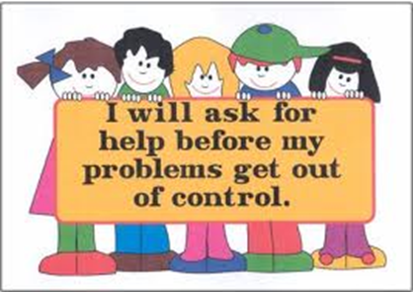
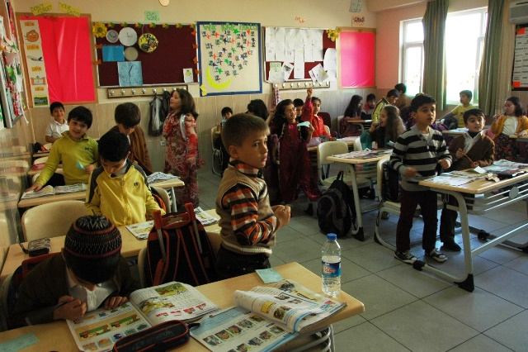
Students’ Language

Asking for something
Can I have a pen, please?
Do you have a pen for me?
May I have a pen, please?

Asking about words
What's (fantastic) in English?
What does (fantastic) mean?
How do you say (harika) in English?
How do you spell (fantastic)?
How do you pronounce (fantastic)?

Asking for Help

Can you help me, please?
Could you repeat that, please?
Excuse me, please.
I don't understand.
I'm sorry.
Is this right / wrong?
May I ask a question?
Please say that again?
Please speak a little louder.
Please speak more slowly.
Sorry about that.
Sorry I'm late.

Checking that you’ve understood
Do you want us to...?
Am I / Are we supposed to...?
Should I...?
Does this mean that...?

Interrupting Politely

Could I just say something?
Sorry to interrupt, but ____.
Oh, while I remember / before I forget...
Excuse me, may I interrupt?
Excuse me.
Sorry, but ___.
Excuse me for interrupting, but...
May I interrupt for a moment?
Just a second please.
Can I add something?
Can I say something here?
I'd like to say something, if I may.
Can I ask a question?
May I ask a question?

Thanking and Responding

Any time.
Don't mention it.
I'm glad to have been of some help.
It's a pleasure.
Many thanks.
My pleasure.
Thank you very much. - Not at all.
Thanks a lot.
That's OK / all right.
That's very kind of you.
You're welcome.

A SAMPLE LECTURE
INTRODUCTION
Ok. Well, welcome everyone to Psychology 210.
Please take a seat. This is PSYCHOLOGY 210 introduction to Social Psychology.
I hope everyone is in the right room. Are you? OK, good. Let me get started.
For today this afternoon, since this is the first day, I want to talk to you about this course.
I am going to give you some information about what we will study and how we will study.
So I want to talk briefly about the field of Social Psychology and then I will give you more information about the course requirements. Everybody OK with this? OK.
First of all, in this course we are going to look at people in social situations. So, what does that mean? That means how people interact with other people. That’s the simplest way to explain this course.
And we are going to discuss some of the theory and research that explains a lot of this.
OK, but before we go any further, let me make one point very clear.
The main objective of this course is to help you to become more interested in the field of social psychology and to prepare you for more studies in this field. That is my hope. OK?
So, I think by now, everyone has had a chance to have a look at the syllabus. You saw it on my website, right?
So, I think that you get the picture of that I am going to expect a lot from you in the Social Psychology class. So, I will go over the syllabus now.
First, let’s talk about the readings.
I will assign new readings each class period and the reading assignments are going to come from the t extbook.
You should complete the assigned readings by the date I give you. That’s simple. You get the assignments and then you do the reading.
Now, the lectures. I am going to give a lecture in each of my class and during my lectures I am going to expand on the ideas that you read about on your textbooks.
So, for example I might explain something that you read about in the assignment or I might give you another example that wasn’t in the reading.
I want to point out—and this is pretty important—that my lectures will also include information that you won’t see in the readings. That’s right.
My lectures will sometimes have new information.
And guess what? You have to come to class. Aha! Alright, the discussions, class discussions, our discussions, are an important aspect of this course.
During our discussions I’ll welcome your questions and comments any time you want to say something, anytime.
You should feel free to contribute your own ideas and your own opinions. But, for this to work, you have to be willing to let the other students do the same, meaning that we all listen to each other, all of us, that’s the deal in here.
Oh, and by the way I just wanna say you don’t have to agree with me, but whenever you do express your opinion, you do have to show me that you understand the ideas we are talking about in the class.
So, what I am saying is, these discussions should show how you think about the ideas in the readings and the ideas you hear in the lectures and discussions. And also, what you think about them. You got the picture?
Now what about your grade, I know you want to know about this information. All right.
Your grade consists mostly of quizzes and exams.
For quizzes, you’ll be able to use you lecture notes. So, attending class and taking good notes is going to be a key to your success in this class.
For exams, you will not be able to use your notes. So, no notes for exams.
I’ll explain about the class presentation and two opinion papers later in the semester.
We don’t need to get into that right now. Alright. You saw on the syllabus that attendance is also gonna be a big component in this class. But let me talk about that right now.
Attendance means you have to attend the class regularly. But not just come to class, you have to participate in class discussions. So, what I am saying is your participation, whatever it is, is going to affect your grade, OK? So far, so good?
I know this seems like a lot, but it’s really pretty simple. My expectations are that you come to class, turn your work in when it’s due, share your ideas, listen to others and do the readings and you will do fine in class. No problem. OK?

All right. That’s enough for our first day. I will see you next time and we’ll discuss Chapter 1 in your textbooks. So there is your first reading assignment, Chapter 1. OK? Goodbye, now. (LECTURE READY 1)

COMMON ERRORS and TREATMENT

PART 1
Here is a list of the most common mistakes made by some students. If you study these and make sure you don’t make the same mistakes, your English will sound much better and you might make your teacher really happy .
Notice: Almost all these mistakes are because of students translating.
Grammar Bad English Good English

Prepositions:

Listen TO something/someone
I’m listening you. W
I’m listening to you.
She listened to her friend talking about politics.
They’ve been listening to that CD for over an hour now.

Go TO somewhere/ Come TO somewhere
Monica goes to work every Monday.
I went in Germany last year. W
I went to Germany last year.
I’ve come to class 5 times this week already.
Exceptions: home, abroad, here/there, somewhere [No TO]
I went to home last night. W
I went home last night.
We’re going abroad next summer.
Kara came here to visit her aunt.
Kara came to here to visit her aunt. W
I’ve gone there before.

Wait FOR someone/something
Wait me. W
Wait for me.
So… you’ll wait for me at the station, right?
I had to wait for my visa before I could leave for Russia.
I’ll wait my friend. W

Get married TO someone or Marry someone [NO PREPOSITION]
get married WITH someone W
I got married with Mark when I was 20 years old. W
I got married to Mark when I was 20 years old.
John will marry with Tracy next year in the old building. W
John will marry Tracy next year in the old building.
Go ON vacation/holiday
I went to vacation last summer. W
I went on vacation last summer.

Complain ABOUT something/someone
You are always complaining your boss. W
You are always complaining about your boss.
I want to complain about my room, room 103. It’s very dirty.

Be afraid OF something/someone
Be afraid FROM something/someone W
I’m afraid from bees. W
I’m afraid of bees.
I’m afraid of walking in the dark.
I’m afraid of getting married.
Please don’t afraid of making mistakes.

Be jealous OF something/someone
My friend is jealous me. W
I’m jealous of my big brother. He gets everything/what he wants.
Mark is jealous of his friend because he got the better job.

Help WITH something
Help TO somebody/something W
Will you help to your mother? W
Could you please help with the dishes?
Will you help your mother with the laundry?
Visit somebody/somewhere [NO PREPOSITION]
Visit TO somebody/somewhere W
I will visit to my mother next week. W
I will visit my mother next week.
I visited to the retirement home in Ankara. W
I visited the retirement home in Ankara.

Ask somebody [NO PREPOSITION]
Ask TO somebody W
I asked to him to help me. W
I asked him to help me.
ASK SOMEBODY TO DO SOMETHING
frequency time a week [NO PREPOSITION]
I go to work five times in a week. W
How often do you go to work?
I go to work five times a week.
I play football once in a week. W
How often do you play football? )
I play football once a week.

“For” is used for length of time.
I’ve lived here for 5 years.
I lived here 5 years. W
We were at the concert for 5 hours.
We were at concert 5 hours. W
Mark’ll be gone for about a week.

Be + Emotion:
Emotions and feelings are generally NOT verbs in English. They are adjectives, or we use passive structures for them.
She happy. W
She’s happy.
He bored. W
He’s bored.
I tired yesterday. W
I was tired yesterday.

Have:
“to have” is a normal verb in English when used to refer to possession. It needs a helping verb for questions or negatives.
Have you a car? W
I have a car.
Do you have a car?
She hasn’t a car. W
She doesn’t have a car.
My brother hadn’t a driver’s license last year. W
My brother didn’t have a driver’s license last year.
In British English you can use “have got.” This has a present simple meaning, but it’s a present perfect structure. The helping verb is “have” and the main verb is “to get”.
Have you a car? W
I’ve got a car.
Have you got a car?
She hasn’t a car. W
She hasn’t got a car.
Notice in the past or future tenses I must use the regular verb “to have.”
They had got a house before the hurricane. W
They had a house before the hurricane.
They will have got a house in the future. W
They will have a house in the future.

Can I have…?:
“Can/Could I have…?” is used for polite request, not “Can I take…?”
Can I take a pen? W
Can I have a pen?
Can I take your pen for a second? W
Can I borrow your pen for a second?
Could you give me some advice?

Later:
We use “in” for future time expressions, not “later“.
I will go to work 1 hour later. W
I will go to work in 1 hour.
I will leave to do my military service 2 weeks later. W
I will leave to do my military service in 2 weeks.

Advanced:
“Later” is used without a time expression.
See you later.
“Later” is used after a previous event.
I went to Mark and Judy’s wedding and then 2 weeks later I met my current husband. (The first event is the wedding. The second even is meeting her current husband.)

It can be:
Again, “can” is not used for possibility. We use “might + V1“, “maybe” or “It’s possible“.
Mary: I think Sarah is sick.
Mark: I don’t know. She might be. or
Mark: It’s possible. or
Mark: I don’t know. Maybe. or
Mark: It can be.
“It can be” can be used as part of a statement implying ABILITY.
Student: Do we always use “say” in reported speech?
Teacher: It can be (used in reported speech), but we use “tell” more often.
Student: Can we use “gear” for clothing?
Teacher: It can be [used for clothing], but usually it refers to machines.

Wrong uses of Make/Do:
In English we do NOT make/do sport, make/do practice, or make/do exercise. These are verbs in English. We also don’t make homework, we do homework.
He made practice his English pronunciation yesterday. W
He practiced his English pronunciation yesterday.
He’s going to make sport tomorrow. W
He’s going to the gym tomorrow.
He needs to make exercise more. W
He needs to exercise more.
Mr. Johnson, I made my homework. W
Mr. Johnson, I did my homework.
Do Military Service:
n English, we “do our military service” not “go to soldier.”
I have to go to soldier in 2 months. W
I have to go and do my military service in 2 months.
He went to soldier in Diyarbakir. W
He did his military service in Diyarbakir.

Here/There:
“Here” and “there” are generally NOT the subject or object of a sentence in English. You should use “it” or “this/that place” or something similar.

I like here. W
I like it here.
I like this place.
There is beautiful. W
It’s beautiful.
That place is wonderful.
Here is Turkey. W
This is Turkey.

Also notice that we almost never use “in here/there.”

I work in there. W
I work there.
I live in here. W

I live here.

Know how to do something:
In English, we use “know how to + Verb1” to talk about ability or knowledge of something.
I know driving a car. W
I know how to drive a car.
My mom knows how to bake a cake.
He knows playing football. W
He knows how to play football.

Must vs. Have to and Mustn’t vs. Can’t:
These are often confused among foreign speakers of English. “Must” and “Mustn’t” are VERY strong and often only used for serious things like strong rules or prohibitions. “Have to” and “Can’t” are much more common.
“I have to do the laundry today.” is better than “I must do the laundry.”
“I have to wear a uniform at work.” is better than “I must wear a uniform at work.”
“You can’t smoke here.” is better than “You mustn’t smoke here.”
“You can’t wear jeans at work.” is better than “You mustn’t wear jeans at work.”

Infinitive of purpose:
We use the infinitive (to + V1) for purpose or reason in normal sentences.
I went to the store for buying some food. W
I went to the store to buy some food.
I come to English class to learn English.

The:
“The” ALWAYS comes before some words.
The same
He eats same thing every day. W
He eats the same thing every day.
The last time
The last time I went to Burger King was 2 days ago.
The first, the second, the third, the fourth, etc.
The first thing I did was to lock all the doors.
We do NOT use “the” for singular countries or cities.
Unemployment is a problem in the Greece. W
Unemployment is a problem in Greece.
I live in the Spain. W
I live in Spain.
Other words that always or almost always take “the”: the weather, the news, the newspaper, the bank, the cinema, the park, the library, the future, the past
We DO use “the” for collective countries.
Compare:
Turkey vs. The Republic of Turkey
Russia vs. The Soviet Union
America vs. The United States
Czechoslovakia vs. The Czech Republic
Britain vs. The United Kingdom
“The” is used for instruments.
I play the guitar.
He plays the saxophone.

COMMON WORD CONFUSION:

PART 2

Too, Very, and So

“Too” is only used for problems in English. It does NOT mean “a lot of” or “very”.
too + adjective (+ to + Verb1) or too much/many + noun
“He is too short to play basketball.” means “He isn’t tall enough to play basketball.” or “He can’t play basketball”.
“The piano is too big to fit through the door.” means “The piano can’t fit through the door.”
“So” is used to increase the strength of an emotion in a sentence and is generally more idiomatic. It often reflects the emotions of the speaker. It’s also often used in exaggeration.
So + adjective.
Remember: If we use a noun we need to use
such a/an + adjective + noun.
“It was so gross.” means “I thought it was really disgusting.”
It was such a gross hamburger.
“She is so beautiful.” means “I think she is really beautiful.”
She is such a beautiful singer.
“Very” increases the strength of the adjective it modifies. It is often used for facts.
very + adjective
very + noun W
very +verb W
“She is very tired.” is stronger than “She is tired.”
“She is very hungry.” is stronger than “She is hungry.”
He has very money.
He has a lot of money.
I am very working. W
I am working very hard.
I am working a lot.

Fun vs. Funny
Jokes are funny. They make you laugh.
Going to a party is fun. You have a good time.

Job vs. Work
“Work” is uncountable.
“Job” is countable.
I did the work well. W
I had a job to do yesterday.
I did the job well.
Nobody likes extra works.
Nobody likes extra work.

Always vs. Every time
“Always” is an adverb of frequency in English. “Every time” is not. “Every time” has a completely different grammatical function.
I always go to the store.
I every time go to the store. W
I go to the store every time. W
Advanced:
“Every time” means “Each time/When something happens, the same thing always occurs.” It’s a subordinating conjunction.
I take the bus every time I go to Istanbul. = When I go to Istanbul, I always take the bus.
Every time I try to feed my cat, he tries to bite me. = Each time I try to feed my cat, he always tries to bite me.

Come back vs. Turn back
I left Istanbul on the 23rd and I turned back on the 30th. W
I left Istanbul on the 23rd and I came back on the 30th.
Oh, you’re going on vacation! When do you plan to turn back? W

Oh, you’re going on vacation! When do you plan to come back?

Say vs. Tell
“Say” is used for general statements that aren’t necessarily used to address someone or if I’m not sure of the fact. Generally, this is for reported statements without object pronouns/speakers. It’s also used for direct quotes.
Subject + say …
She said me it was her birthday. W
Well, she said she was sick, but I’m not sure she was telling the truth.
She said it was her birthday. (She wasn’t talking directly to me)
She said, “He was the best husband a women could have hoped for.” (It’s a direct quote)
“Tell” means “to inform” or “to explain”. It is used much more often and is for when a person is told something directly from another speaker. Basically, if you are including an object pronoun/speaker then you should definitely use “tell”.

Subject + tell + object speaker. Subject + tell + to + object speaker.
She told me that she was sick.
She told me it was her birthday. (She spoke directly to me.)
She told to me it was her birthday. W

To relax vs. Relaxed
Relax is a VERB.
I relaxed on the beach on vacation.
We will relax on vacation in two weeks.
Relaxed is an ADJECTIVE.
They were relaxed because they didn‘t have any homework to do last weekend.

Turn on/Turn off & Answer/Hang up vs. Open/Close
We use turn on/turn off for electronics. For phones we use answer/hang up. We cannot use open/close. Open/close is for things and places.
Hey, turn on the TV. I want to see if Lost is on.
Can you close the radio? I’m trying to study. W
Can you turn the radio off? I’m trying to study.
Mr. Hatfield usually opens the store around 6 o’clock.
I tried to close the door quietly so as to not wake my parents.
I tried to open the phone, but the caller had closed it before I could get there. W
I tried to answer the phone, but the caller had hung up before I could get there.

Unemployed vs. Unemployment
Unemployed is an ADJECTIVE. It has an “-ed” ending.
Unemployed people don’t have jobs.
Unemployment is a NOUN. It has a “-ment” ending.
Unemployment is high in Turkey.

Bored vs. Boring
“Bored” basically means I don’t like something anymore. I am uninterested.
He is bored because he has nothing to do.
“Boring” basically means it makes you bored.
The book is boring because the story isn’t good.

Excited vs. Nervous
“Excited” means something is fun or enjoyable and so you feel excited.
I’m excited because I get to go to Istanbul tonight and see my best friend.
I’m excited because my birthday is next week.
“Nervous” means something is worrisome and so you feel anxious.
I’m nervous because I have a test today.
He’s nervous because he is going swimming for the first time and he doesn’t know how to swim.

Enjoy/Enjoyable:
These words are not used in English like they are in Turkish. We generally use “to have a good time” or “fun” instead.
We went to Bodrum on holiday. We really enjoyed. W
We went to a really enjoyable restaurant. W
We went to Bodrum on holiday. We had a really good time.
We went to a really enjoyable restaurant. W (Note: We do use this. It just sounds rather formal.)
We went to a really fun night club.
Perfect:
Perfect is RARELY used as an adjective in English. It is too strong.
It was a perfect concert. W
It was an excellent concert.
The play was wonderful.
The play was perfect.

Feel:
In English, we do NOT use reflexive pronouns with “feel“.
I feel myself tired. W
I feel tired.
He feels himself really sad. W
He feels really sad.

Dates:
Five April. W
05/02 = “The fifth of April” or “April fifth”
Answering “How are you?”:
We do NOT say “Thank you” as an answer to this question.
Laura: How are you?
Bruce: I’m fine, thanks, and you?
or
Bruce: Doin’ well.
or
Bruce: I’m not bad, you? or
Bruce: Thank you. W

How do you know?:
In English we say, “How do you know?“, not “Where do you know? W”
Where do you know I was with my Samantha? W
How do you know I was with my Samantha?

Conjunctions and Writing:
In WRITTEN English, a sentence that starts with a conjunction (but, because, and, so, etc.) should NOT make a sentence. A conjunction connects two clauses.
I went to the mall. But we didn’t buy anything.
I went to the mall, but we didn’t buy anything.
I like Istanbul because there is a lot to do there.
I like Istanbul. Because there is a lot to do there. W
Because there is a lot to do, I like Istanbul.

Source: http://turklishtefl.com/wp-admin/page.php?action=edit&post=45&message=1

PART 3

Top Ten Mistakes

I went to shopping.
You can go to Paris, or go to Ankara, or go to the North Pole, or go to the Moon or Mars – in fact, you can even go to Hell (or Heaven for that matter) – and this is because they are all PLACES.
Shopping is not a place, so you cannot go to shopping. Shopping is the gerund of the verb shop. It is the same part of speech as swimming and running.
You cannot go to swimming or go to running, and so you cannot go to shopping.
What you should say is:
I went shopping.

Is this true?
Students frequently ask their teachers if their answers are true. This is incorrect English, you should ask “Is this right?” ANSWERS are right or wrong, STATEMENTS are true or false. For example, rearrange these words into a sentence:
the / is / Mount / in / lowest / Everest / mountain / world / the
Answer: Mount Everest is the lowest mountain in the world.
This answer is right – but the statement is not true!
What you should say is: Is this right?

A. “Do you have a pen?” “No, I haven’t.” B. My car hasn’t a CD player.
Here students confuse the two auxiliary verbs do and have. To create negatives in English we need to use the do auxiliary verb. It is easy to see the error if we use different verbs to replace have – in this case own and include.

A. “Do you own a pen?” “No, I ownn’t.” B. My car includen’t a CD player.
We should say: A. “Do you have a pen?” “No, I don’t.” B. My car doesn’t have a CD player.

Playing football is really funny. | My birthday party was funny.
Here students confuse fun and funny. Something you enjoy, something that gives you pleasure, is FUN. Something that makes you laugh is FUNNY (ha! ha! ha!). Playing football does not make you laugh. You usually laugh at a birthday party, for instance when people tell humorous stories or make jokes, but the whole party didn’t make you laugh.
So we should say: Playing football is really fun. | My birthday party was fun.

I do it every time. | The teacher speaks fluently every time.
The English expression EVERY TIME does not translate Turkish her zaman in all cases.
The word time in English can be
countable time = defa / kez
or
uncountable time = zaman
With the countable noun we say every time:
I tried to talk to my boss five times, but every time I went to his office he was busy.
With the uncountable noun we say all the time or always:
She always wears lipstick. | We are learning all the time.
Also, we generally use all the time as an exaggeration, when we really just mean usually:
He talks all the time in class (= he usually talks in class)
I always do it. |The teacher always speaks fluently.

I am boring.
Students frequently fail to understand the difference between bored and boring.
  - If you are bored it means that you are unhappy because the subject does not interest you.
  - If you are boring it means that you make other people unhappy because you do not interest them. That is, you cause people to be bored!
Another way to look at this, is to think of boring as active and bored as passive.
Some people are boring, but no one wants to be!
Usually when a student tells me they are boring, I just say “I know!”
You should say: I am bored.

I am excited.
The words excited and nervous are different in English. The sensations are quite similar – your heart beats faster and your body produces adrenalin – but the usage is very different.
Basically, being excited is a good thing and being nervous is a bad thing.
  - You are excited when your team scores a goal in a football game (you might jump up and down and cheer).
  - You are nervous before an exam, especially an oral exam (you might sweat, your hands might shake, you might find it difficult to speak).
Students frequently say they are excited before exams – which is silly.
You should say: I am nervous.

I forgot my books at home.
You cannot forget something somewhere in English. Sure, you can in Turkish. But Turkish is not English and direct translations do not work all the time. In English forgetting is all in the mind. For example, if you walking into a pole and lose your memory you can forget your name. But you can’t forget you name at home! Where did you leave you name? Nowhere. You just forgot it (that is, your name is no longer in your mind).
So in English we have to use the verb leave: I left my books at home.

I won Fatih University.
In English win can only refer to games or to prizes. Winning is something that only happens after playing. We never use win to talk about passing exams or getting into university because we didn’t play a game to achieve this goal.

If you say “I won Faith University”, it sounds like there was a TV Game Show in which the first prize was Fatih University, and you won it! That means you own Fatih University yourself. This would not only make you extremely wealthy, but you certainly wouldn’t need to be a student any more!

What you mean to say is got into Fatih University.

It’s not important.
Once again another direct translation from Turkish – Önemli değil. Students usually say this when someone thanks them. However, this is not the right place to use this expression in English.

In English we say “No problem” or “No worries” or “That’s okay” or “It was nothing” or “Not at all” or “You’re welcome” … in fact, there are many, many ways to respond to thanks in English. However, you cannot say “It’s not important”!

If you say “It’s not important” when somebody has thanked you, it sounds like you mean that saying thank you is not important. But English is a very polite language and saying thank you is very important!

Prepared by James Lambert

Contents
What is classroom language? 3
Why can teaching classroom language pose a challenge? 3
How can classroom language be taught? 3
1. Entering the Classroom 4
2. Every Day Greetings 4
3. Meeting a New Class- Introductions 5
4. Calling out to Students / General 6
5. Taking Attendance 6
6. Late 7
7. Starting the Lesson 7
8. Comprehension Language: 8
9. Ending a Lesson/Saying Goodbye 8
10. Thanking 8
11. Leaving the Room 9
12. Reviewing a Lesson/Talk/Presentation 9
13. Encouraging 10
14. More General Encouragement and Feedback 10
15. Encouraging Students to Speak - Eliciting an explanation 11
16. Encouraging Students to Speak /Participate 11
17. Encouraging Students to Speak 12
18. Many Different Ways to Say Very Good 13
19. Complaining 15
20. Expectations 15
21. Giving Instructions for Pair/ Group Work 15
22. Instructions for Homework /Assignments 16
23. Error correction/Improving Mistakes 17
24. Transitions/Checking understanding 17
25. Transitions/Summarizing, Concluding 18
26. Instructions for Tests and Examinations 18
27. Taking Part 19
28. Role Play Activities 19
29. Working in Groups 20
30. Playing Games 20
31. Dates, Birthdays and Holidays 21
32. Expressions for Conversations 21
33. Simple Classroom Rules 23
34. Managing the Classroom 23
36. Classroom Management Interactions with Class 25
37. Gaining Attention / Interactions with Class 26
Look this way now. 27
38. General Reminders for Teachers 29
39. Communication with Students and Parents 31
40. Misbehaviors of Teachers 31
41. Glad to Meet You 33
42. Starting a Conversation or Discussion, and for Asking Someone's Opinion: 33
43. Asking for Information 33
44. Expressing Uncertainty 33
45. Giving Yourself Time to Think 33
46. Being Polite Showing Interest 34
47. Showing that You're Listening 34
48. Checking if someone has Understood 34
49. Sequencing Actions 34
50. Making suggestions 35
51. Agreeing to a Suggestion 35
52. Making Invitations 35
53. Accepting an Invitation 35
54. Offering Something 36
55. Accepting Something That's Offered 36
56. Giving Advice 36
57. Asking for Permission 37
58. Giving Permission 37
59. Refusing Permission 37
60. Communicating Ideas 37
61. Disagreeing 37
62. Asking What Someone Thinks 38
63. Stating Consequences 38
64. Expressing Two Points of View 38
65. Giving Examples 38
66. Explaining your Opinion: 38
67. Ordering / Sequencing 39
68. Presenting An Opinion 39
69. Summarizing 39
70. Giving Directions 39
71. Mottos on the Classroom Walls. 40
74. Asking favors of other people 43
75. Asking people to do things 43
76. Classroom expressions 44
77. Countries and nationalities 44
78. Describing objects 44
79. Discussing different points of view 45
80. Eating in a restaurant 45
81. Making appointments 46
82. Making decisions 46
83. Making plans 47
84. Meeting a friend 47
85. Making telephone calls 48
86. Schools and education 48
87. Activities 49
88. Daily activities 49
89. Daily habits 50
90. Dates 50
91. Past possibilities 50
92. Future activities. 51
93. Sickness and health 51
94. Things to wear 51
95. Telling time 52
96. Possible future activities 52
COMMON EXPRESSIONS 53
Students’ Language 55
97. Asking for something 56
98. Asking about words 56
99. Asking for Help 56
100. Checking that you’ve understood 56
101. Interrupting Politely 56
102. Thanking and Responding 56
A SAMPLE LECTURE 57
COMMON ERRORS and TREATMENT 59
PART 1 60
Prepositions: 60
COMMON WORD CONFUSION: 65
PART 2 65
PART 3 69
Top Ten Mistakes 69

