
DEMİRCİ

DIFFERENT NEWSPAPER
…It Will Be Different Everytime …

Newspaper Editor: AYŞE BÜŞRA DUYSAK Date :27.10.2013 NO: 1
DEMIRCI, THE ANATOLIAN’S OXFORD
In the past years, Demirci was known as Anatolian’s Oxford. Demirci is in Manisa. It is 165 KM away from the city centre so it is one of the Manisa’s boroughs. This borough hasn’t got Manisa’s culture. Celal Bayar Education Faculty is there. So, it is a crowded borough.
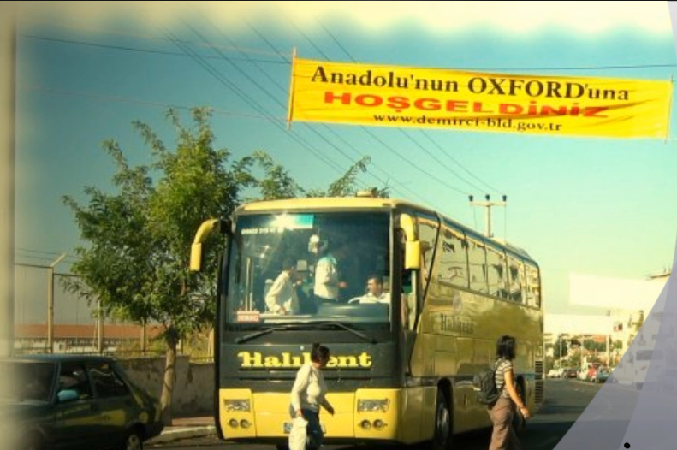
Demirci has 96 towns. Demirci is a very small borough. Demirci has a very high hill. But Faculty’s Students don’t like it. I lived there for four years. I was happy there. I remember Demirci everytime.

UNIVERSALLY FAMOUS CARPET OF DEMİRCİ
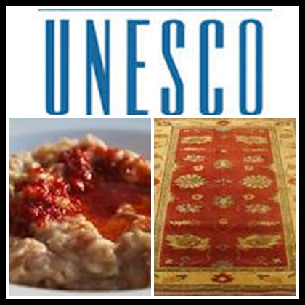
Demirci has a famous carpet factory so Demirci’s economy has developed. Demirci’s mosque wool carpets are very special in the world.
DEMİRCİ’S KEshKEK IN UNESCO
Demirci has a very delicious Keshkek so the name of Demirci’s Keshkek is in Unesco’s list. Demirci’s People make Keshkek in Festivals and Weddings.

