Newspaper Editor_Herish o.faraj Date 22-10-2013 No.1
OFMI NEWSPAPER

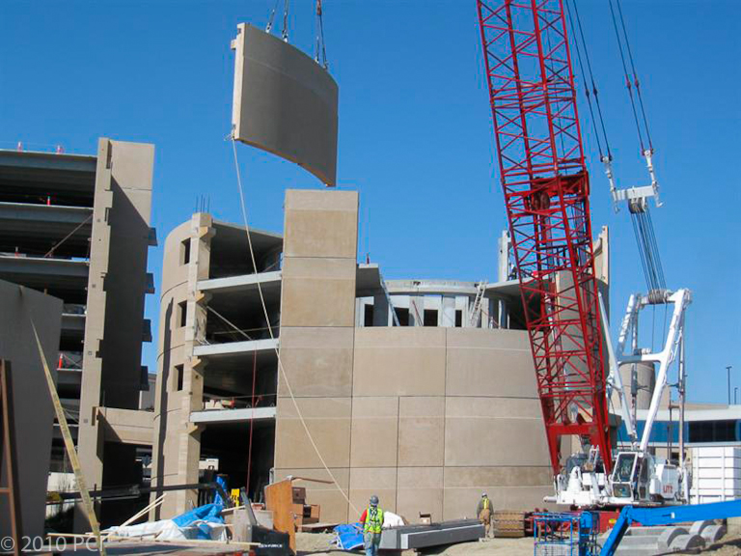
HEADLINE: _ Precast concrete ____________________________ HEADLINE: -----Prestressed concrete
Prestressed concrete is a method for overcoming concrete's natural weakness in tension. It can be used to produce beams, floors or bridges with a longer span than is practical with ordinary reinforced concrete.. Prestressing can be accomplished in three ways: pre-tensioned concrete, and bonded or unbonded post-tensioned concrete

_ Precast concrete is a construction product produced by casting concrete in a reusable mold or "form" which is then cured in a controlled environment, transported to the construction site and lifted into place..
There are many different types of precast concrete forming systems for architectural applications, differing in size, function, and cost. Precast architectural panels are also used to security walls, and some can be Prestressed concrete structural elements. Stormwater drainage, water and sewage pipes, and tunnels make use of precast concrete units.
_______________________________
_______________________________
_______________________________
_______________________________
______________________________

_______________________________________________________________________________________________________________________________________________________________________________________________________________________________________________________________________________________________________________________________________________________________________________________________________________________________________________________________________________

