RIVERS

TOPIC

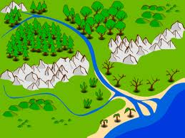

___________________________________________________________________________
___________________________________________________________________________
___________________________________________________________________________
___________________________________________________________________________
___________________________________________________________________________
___________________________________________________________________________
___________________________________________________________________________
___________________________________________________________________________
___________________________________________________________________________
___________________________________________________________________________
___________________________________________________________________________
___________________________________________________________________________

are

