Unit 1 Vocabulary Quiz 2 Name: ______________________________ Duration: 8 min Date: 18.1.2012
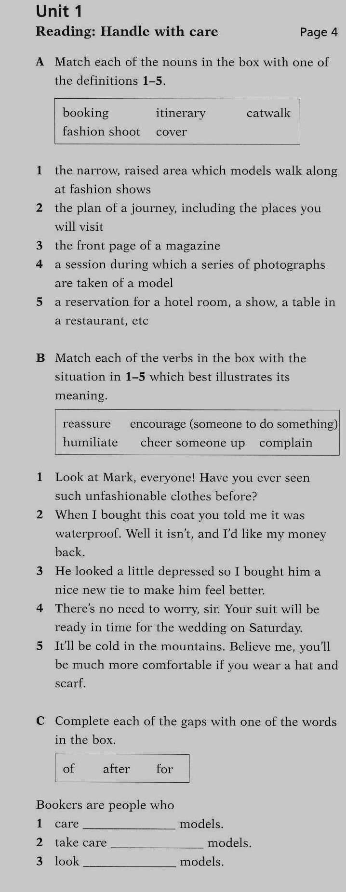

____7x5=35

- __________________
- __________________
- __________________
- __________________
- __________________

____7x5=35

- __________________
- __________________
- __________________
- __________________
- __________________

____10x3=30

- __________________
- __________________
- __________________

